Java Script – Object creation different ways



Object is Non-Primitive Data type.

Object is a collection of properties – keys and values.

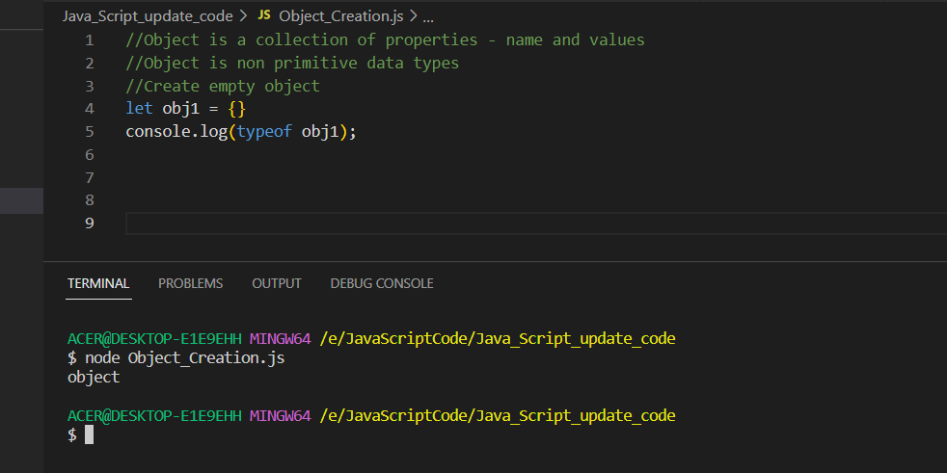

Create an object.

To retrieve the values inside the Object attributes

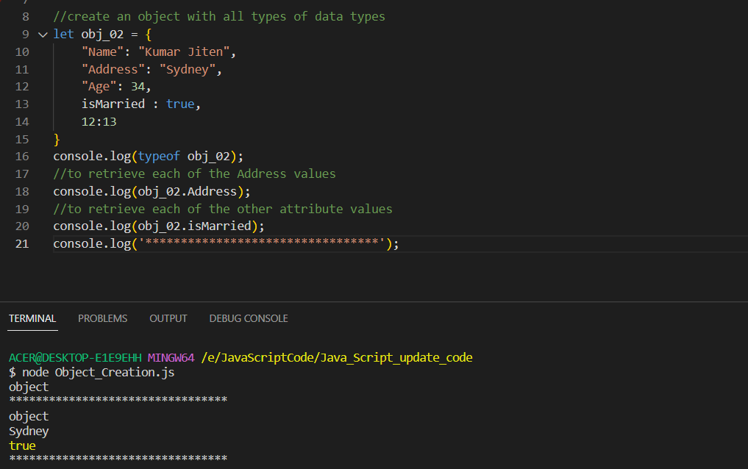

To add a new object value inside the existing object

Output

TO delete an existing object – use the delete method to use.

Output

To create a Nested Object – to have one Object inside another Object

Output

To add an array as values inside the Java Script

Output

To retrieve the nested json object values from the Json Object -use the Indexing concepts

Output

To retrieve the Array values inside the Json Object

Output

To create a function inside the object = use the function () keyword – to create and inside the function define the body to call the function

In java script we can change the **object name reference and an object is addressed by its value not by any reference**

