Java Script – Operators Examples

Different types of Operators in Java Script

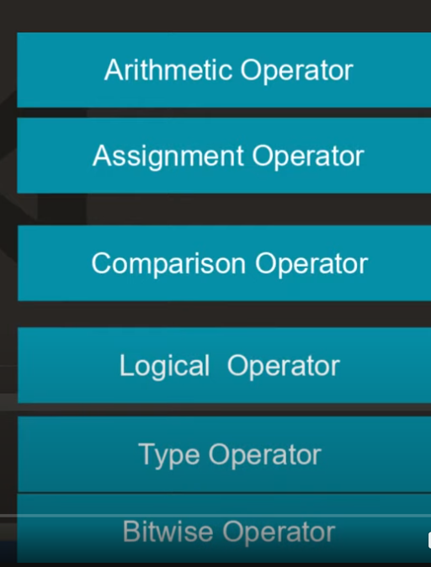

We can directly perform any operators examples in JS without declaring the variables

If we divide number by zero, we will get output as infinity

//if we divide String by zero we will get output as NaN - not a number

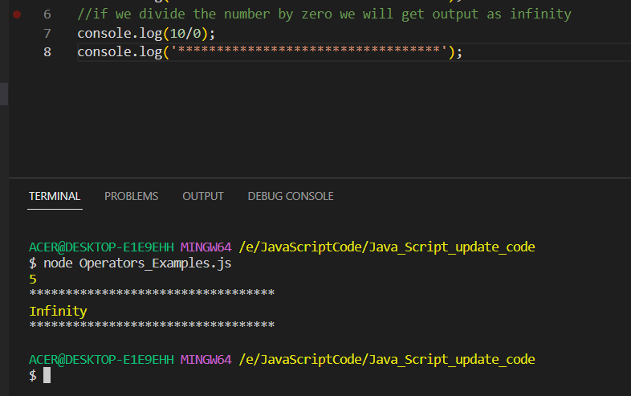

//if we divide String by zero we will get output as NaN - not a number

//suppose if we do addition with String - it will concarenate the String with the number as JS is dynamic typing language

//if we do the same things with minus Operator - String with - operator - it will give output as numeric

let result_01 = "10" - 10

console.log(result_01);

console.log('**********************************');

Output will give as zero

In Java Script we have term called coercion –





Output will come as 10 as in JS – Boolean value is treated as 1

Difference between the == and === operator (if we use the == **though the value of two variables and if its string or number it will convert the data type to the number and then do the comparison- it will do the type conversion**)

If we go ahead with the === operator, the **comparison of two values if it is having two different data type will not happen and it will return as false**.

Output

Logical Operators

Logical – AND && Operator in JS – where both the condition should be marked as true

Output

Use the OR || operator to check any of the condition is true

Lets use the NOT ! operator – which will reverse the result

Output

Output

Increment operators

Output

