Java Script String data types

**String in Java Script is Primitive Data Type**

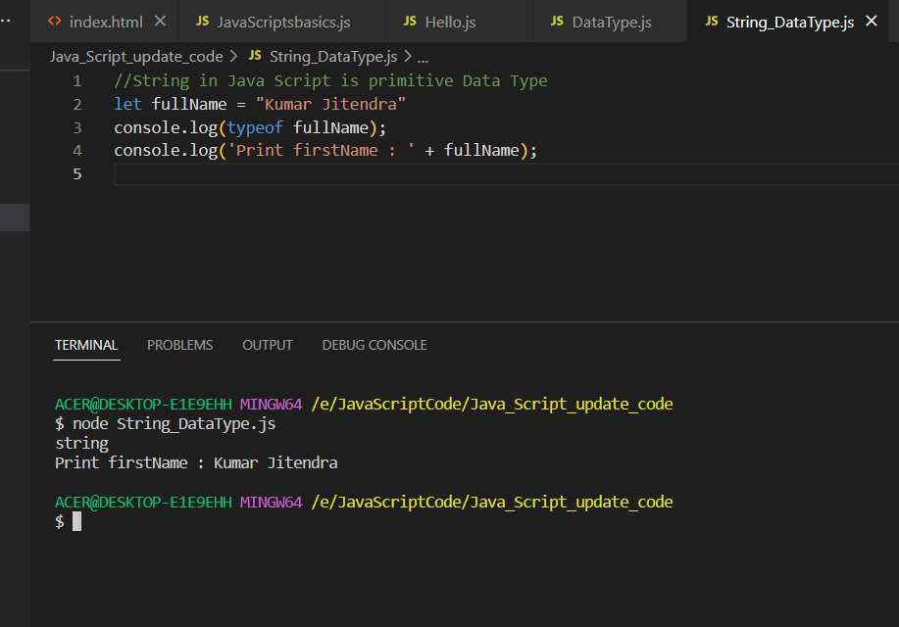

Let’s have String as an Object – which is non primitive Data Type

Output: -

All the String methods – startsWith , length, includes method

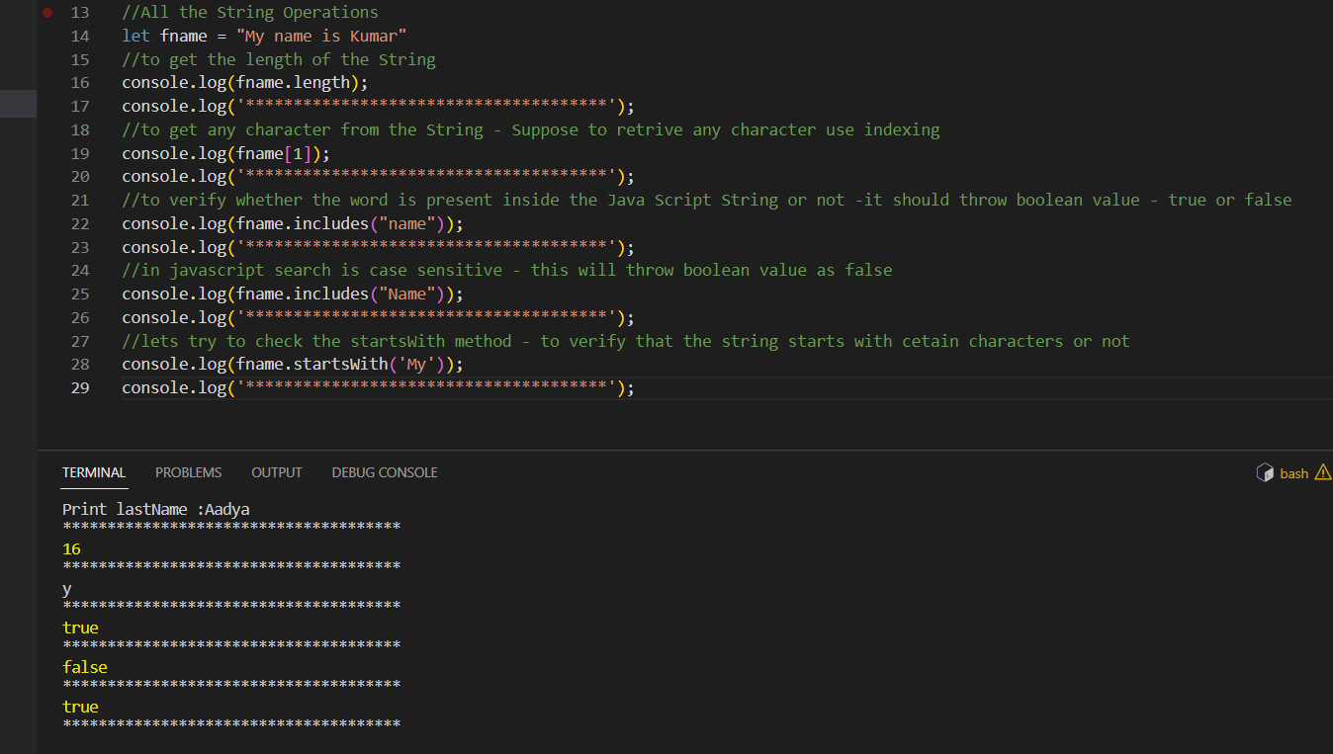

Let’s try to use the split method – which will give us the array in return

To get the second value from the array

To convert String to lowercase and Uppercase and use the trim method to remove the whitespaces inside the String.

Use the replace method to replace certain word inside the String.

Output

To convert the String to Integer using the ParseInt method

Output:-

To use the String literals – use \t for tab space and \n is used for new line and ‘ ‘ is used to give the String in single character

To use the String literals

To replace a value with new variable

Usage of slice method – to have the string retrieved from particular length to end length

Just give the start point and end point

Output

