TypeScript – Language definition

Type Script – official website

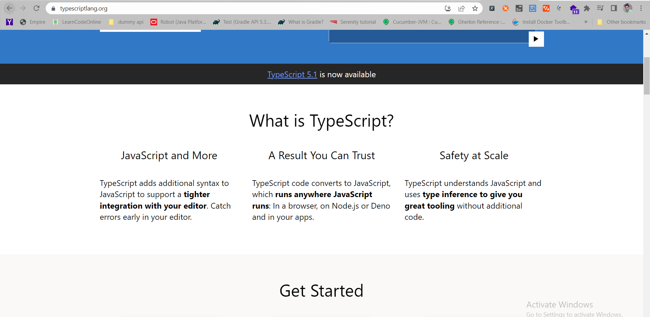

Why use Type Script

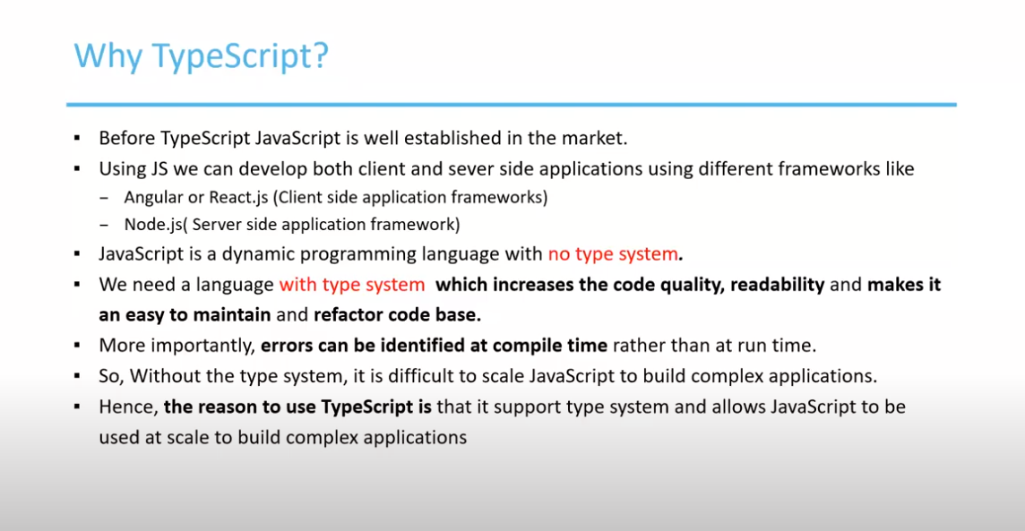

A typeScript file can be converted to a Java Script file, with the help of type script compiler – which converts the type script to the java script file

**Features of Type Script** :-

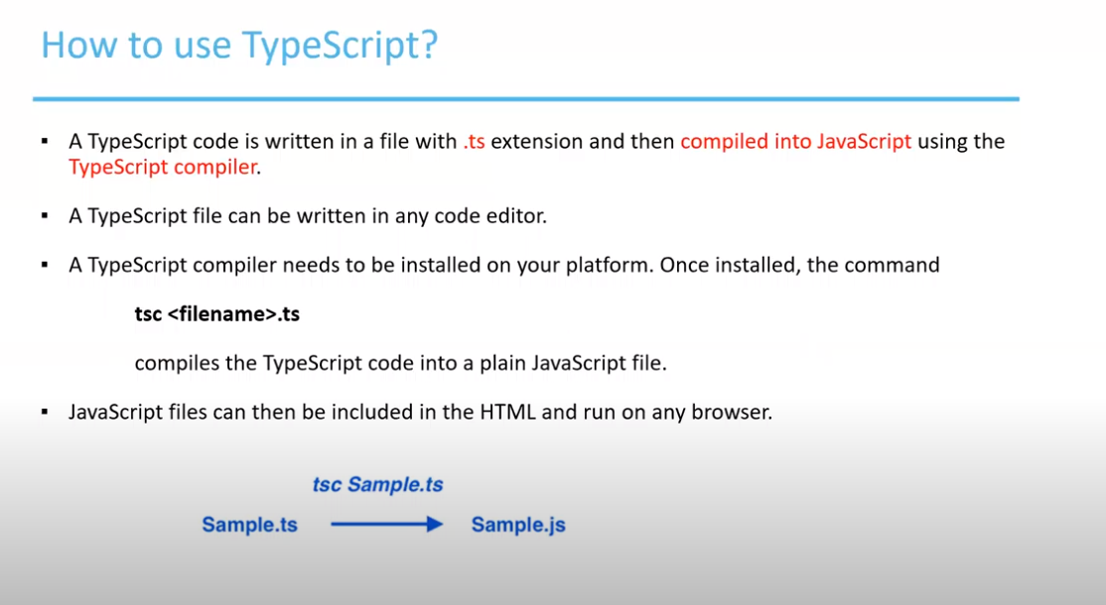

Features of Type Script

**Advantages of Type Script**

**Difference between Java Script and Type Script**

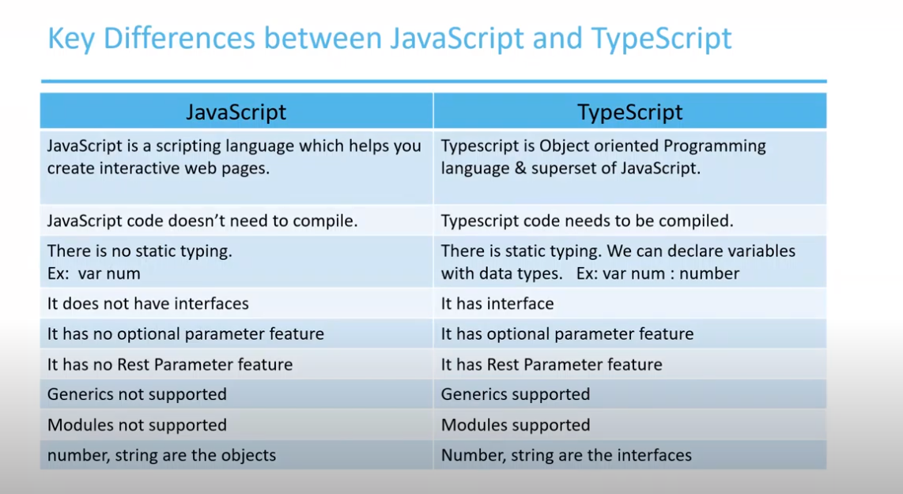

Let us install type script.

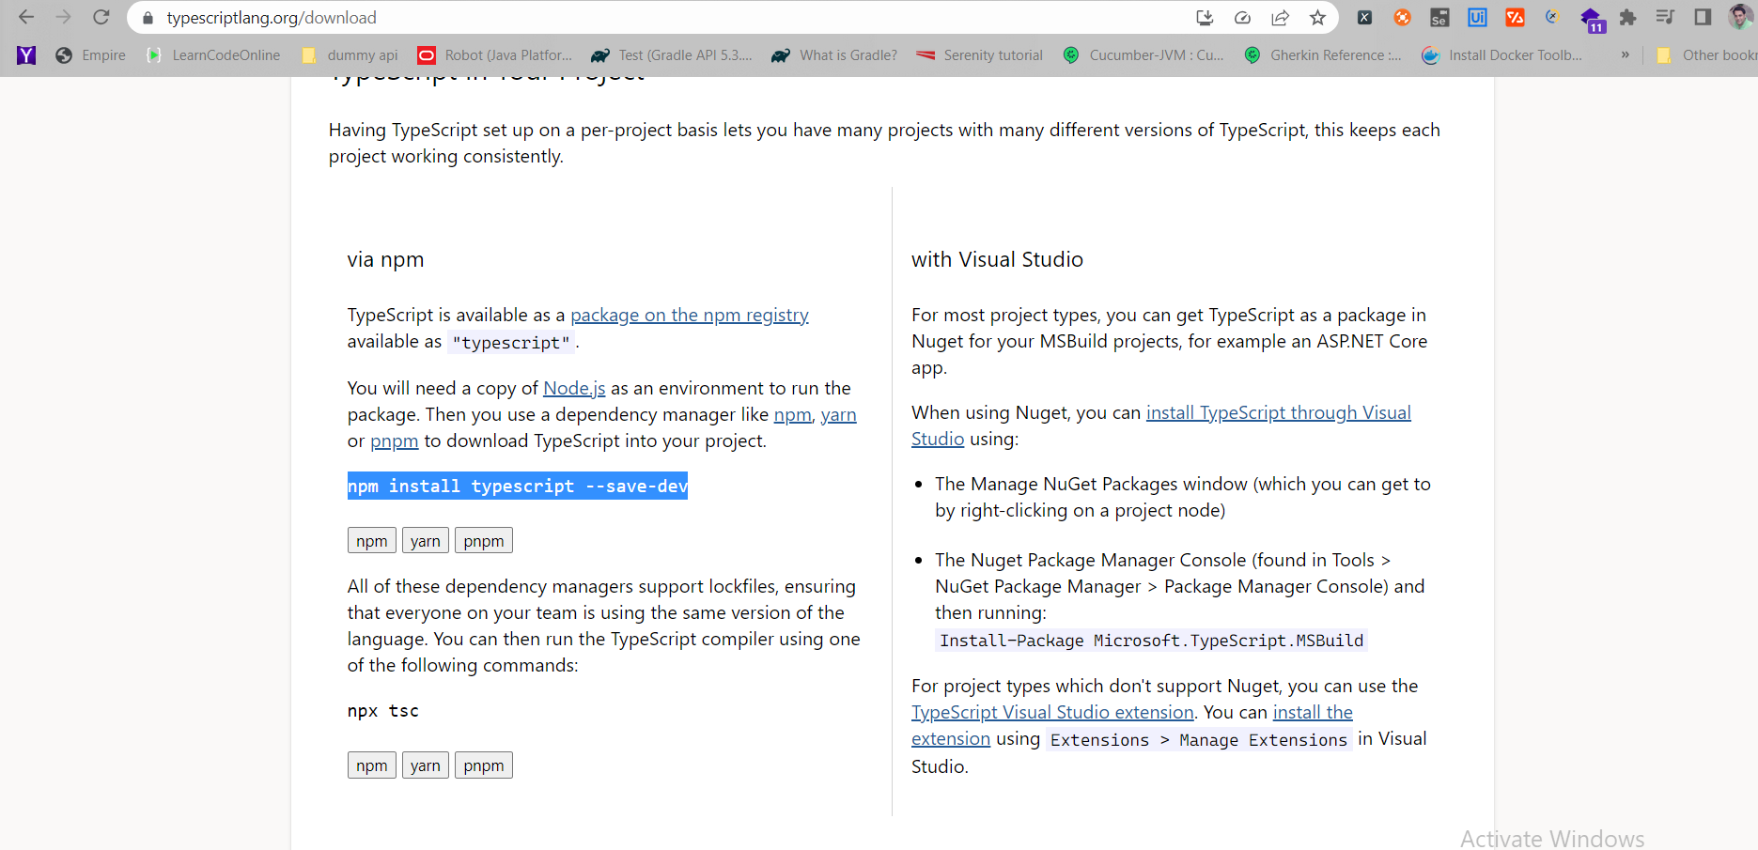

Added the typescript package and check the version by using tsc -v

Install the type script package for Visual Studio

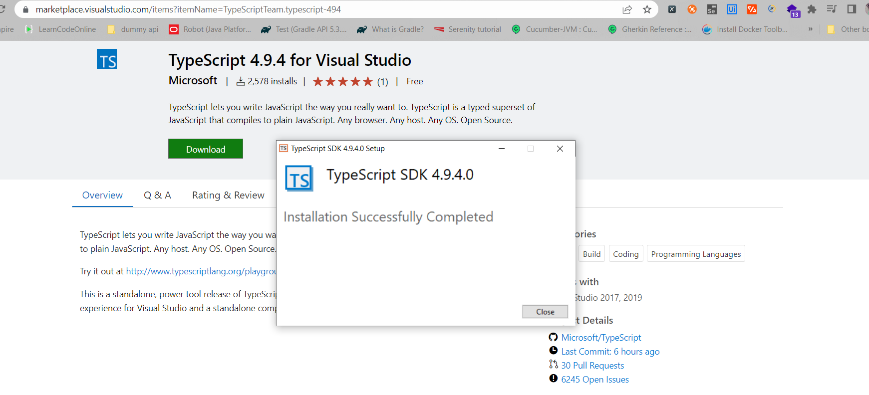

Do a tsc –edit at your terminal folder.

Tsconfig.json will be created.

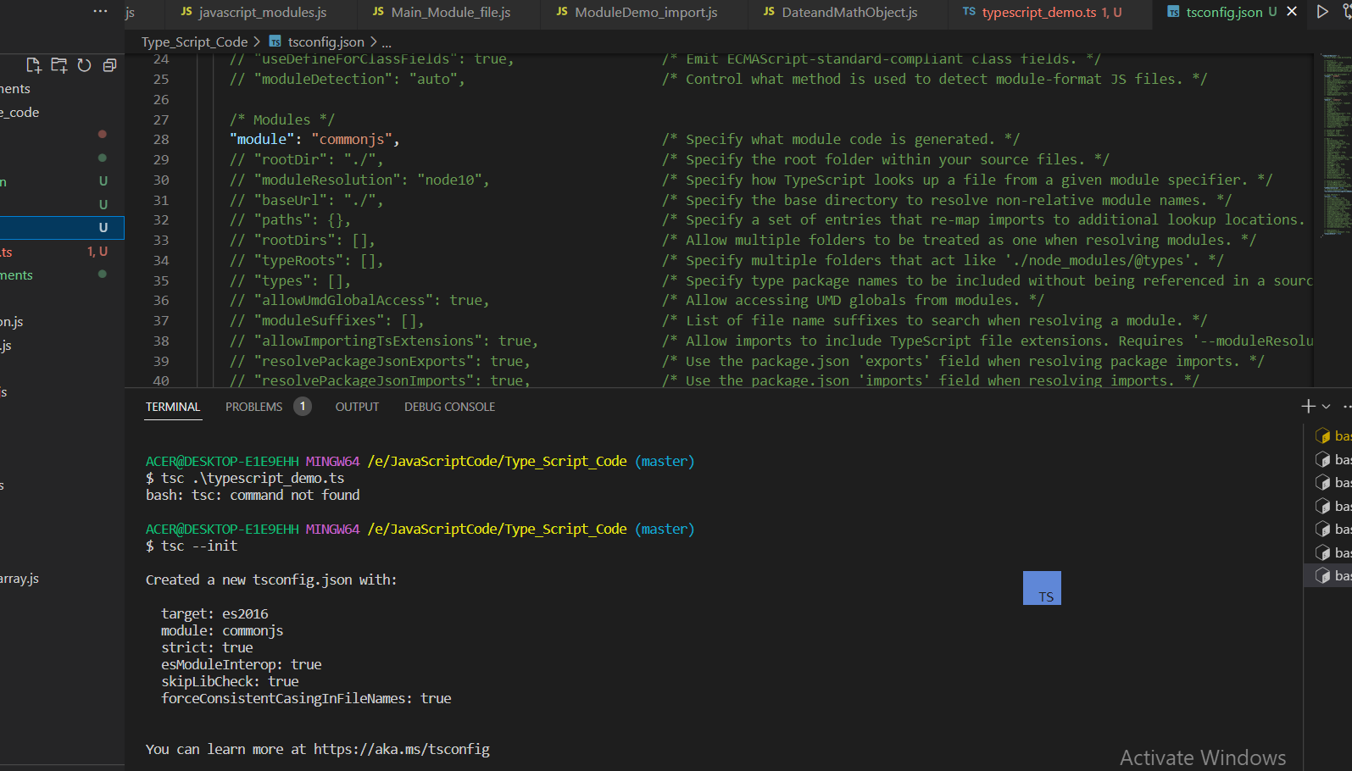

Let us write a first type script program – and convert the type script file to the java script file

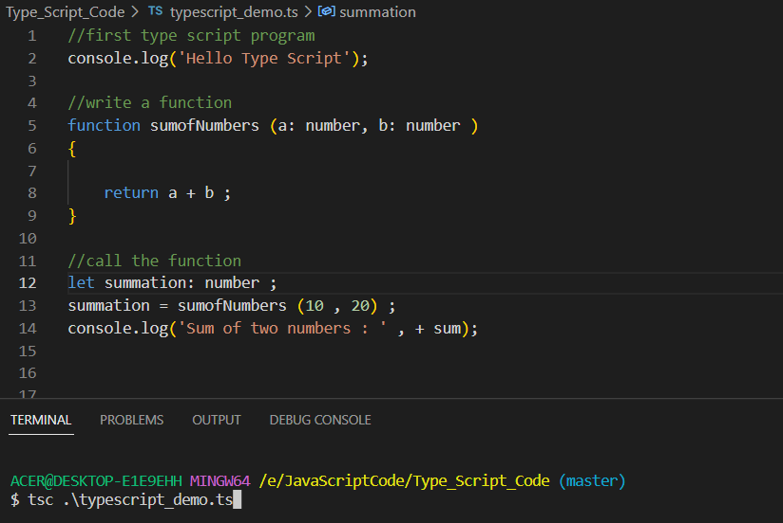

Now type tsc code to compile the type script file

Fix the error – compile error

Convert the typescript file to the java script file – by typing = tsc .\fileName.ts

Once we run the following command – a java script file is created

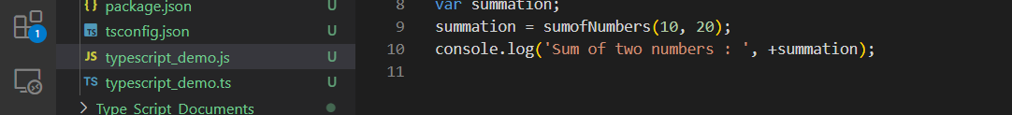

Run the Java Script file.

