Type Script Arrays Data type

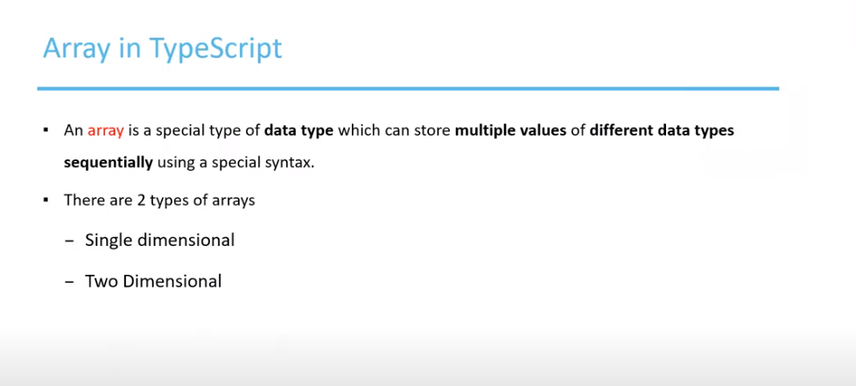

Create two-dimensional array type.

Output

In this way the two-dimensional array is stored

Using for loop to iterate over each row and column

Output

Usage for for in loop

