TypeScript -Classes and Objects

Any function created inside the class is called methods

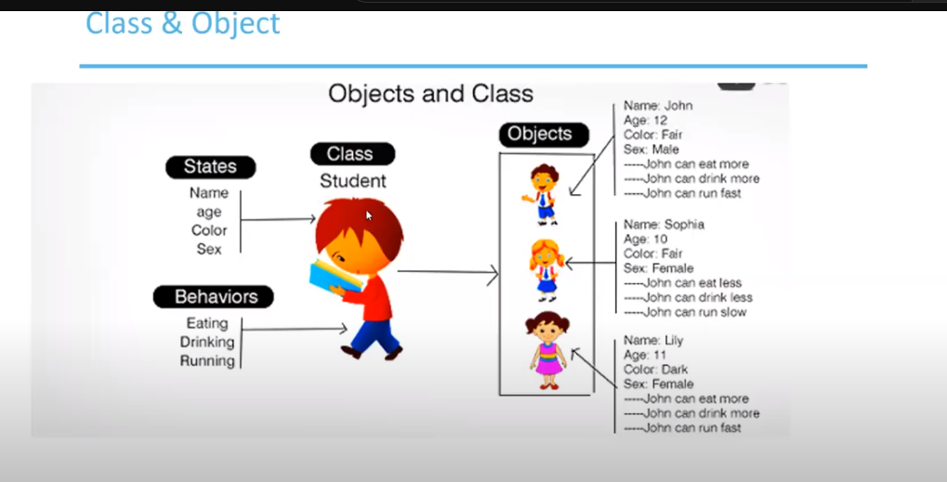

Multiple Objects can be created for the same class.

Create a class and define the variables inside the class and also create a method

Initialize the variable.

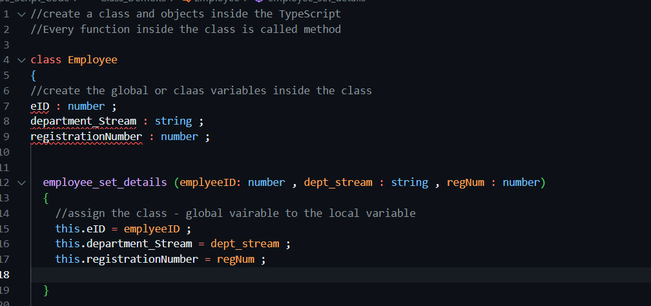

Create the object of the class and pass the values to the object.

Create a constructor of the class.

While creating the object of the class – **default the constructor of the class will be called and variables will be passed inside the object of the class**.

