Type Script – Functions

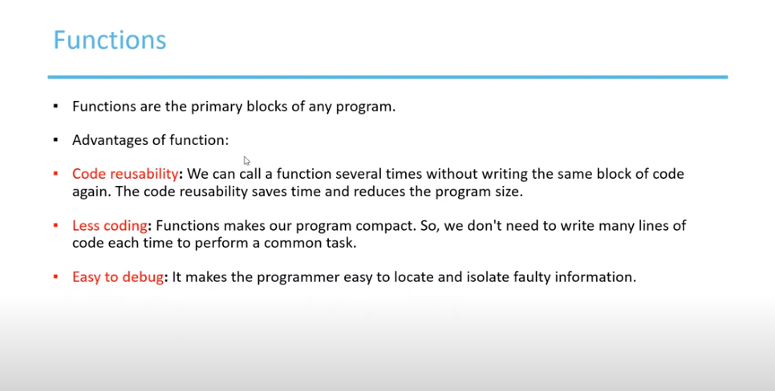

Function types

Create named function.

Anonymous function – function without any name

Output

Parameters in functions

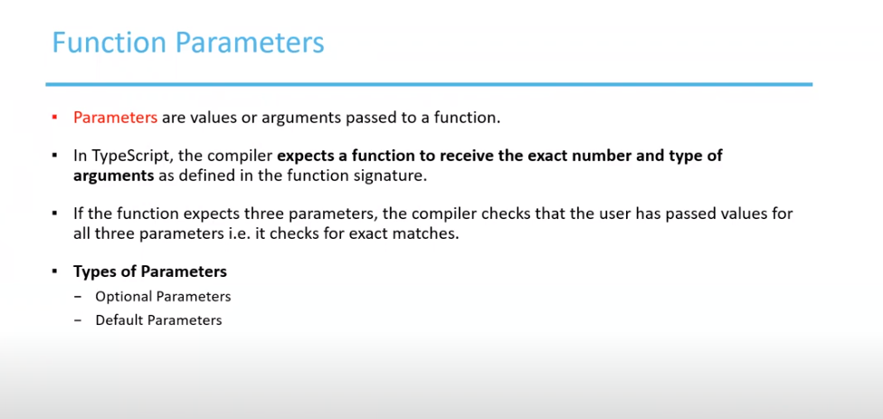

Passing Parameters inside the function

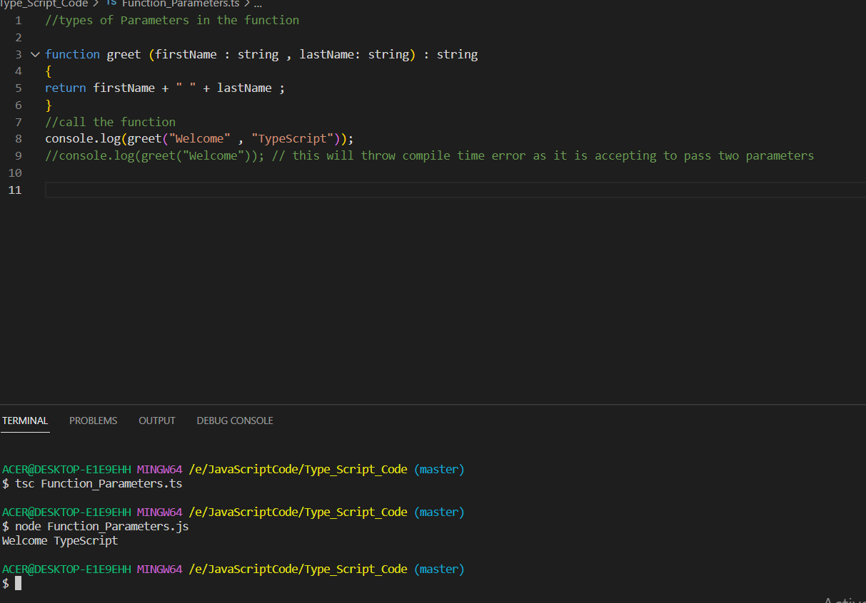

Passing Optional Parameters with the help of ? mark

Passing Default parameters to the argument

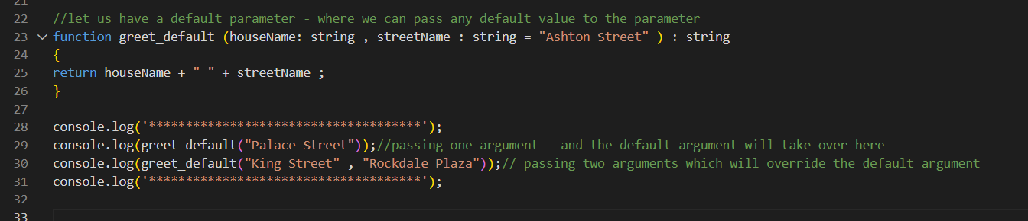

Output

Arrow function in type script

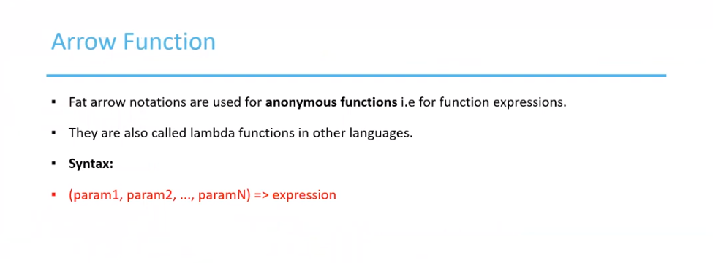

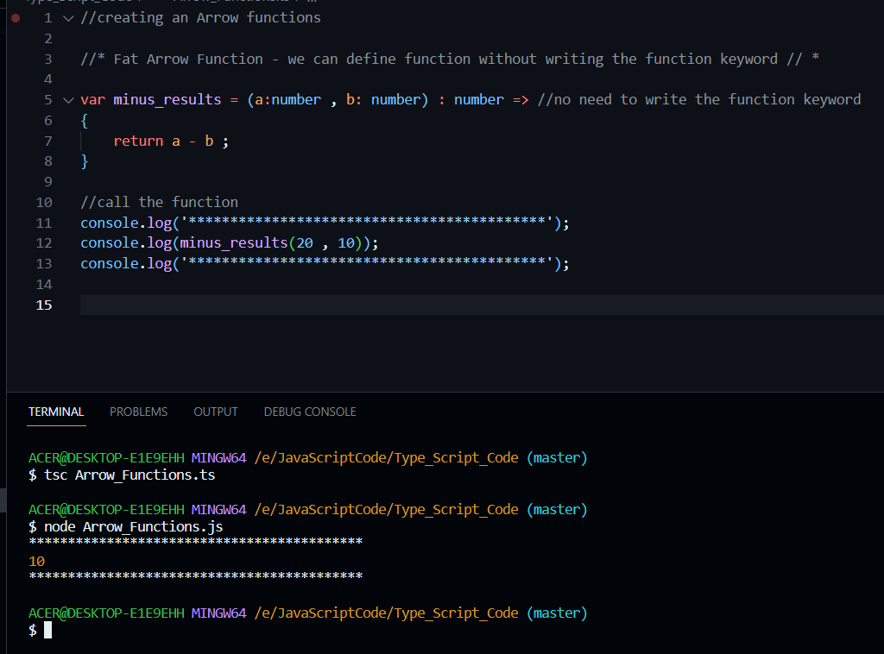

No Parameters passed inside the Anonymous function.

Output

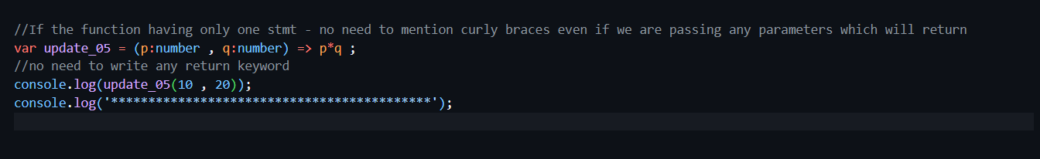

Function Overloading concepts

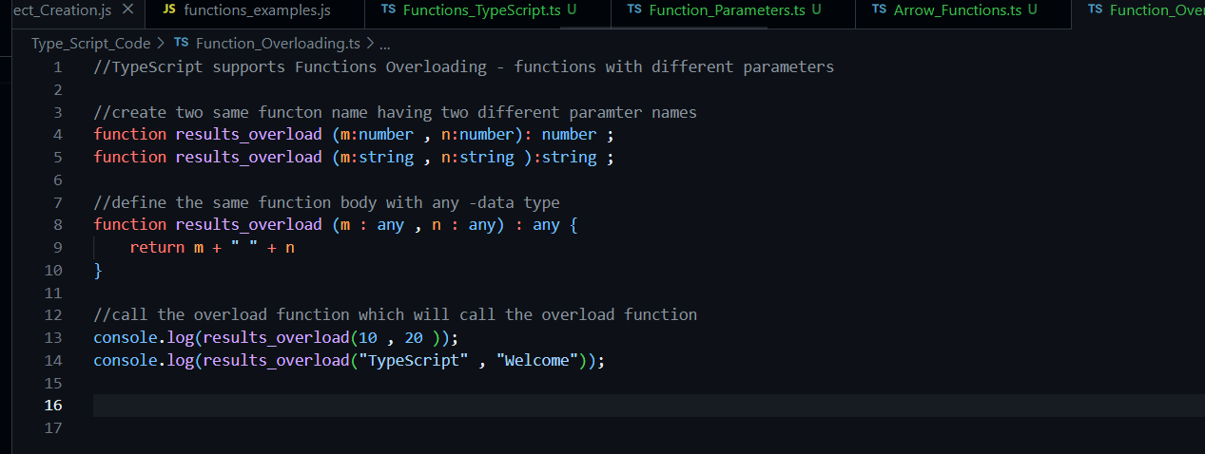

Output

Rest Parameters

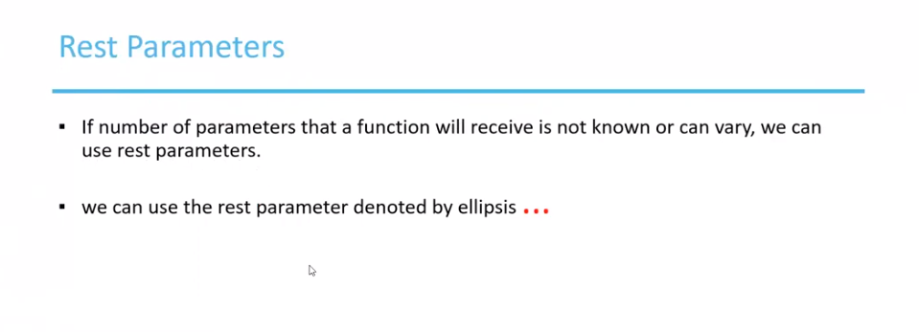

Output

