Type Script – Inheritance concepts

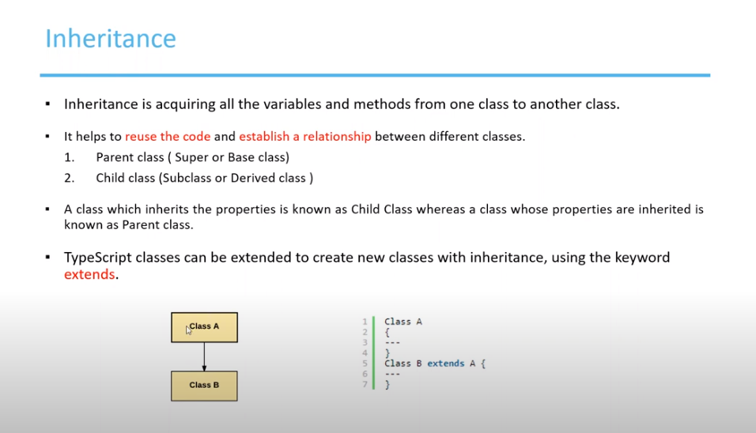

Advantages of Inheritance using example

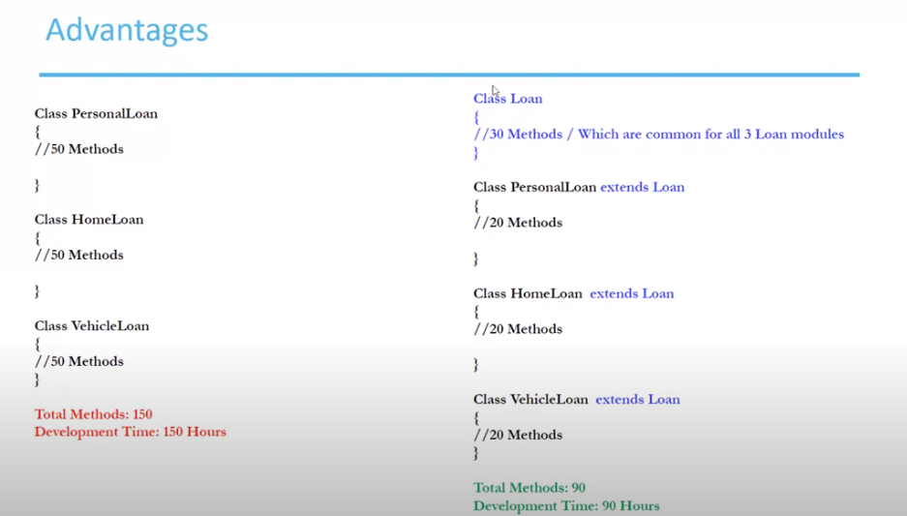

Create a class

Create a child class from the Parent class and try to extend the variables from the parent class

Now create object of the child class and try to access the parent class constructor variable methods.

Method Overriding

Create child class

Call the object

Output

