Type Script – Loop Statement

Usage of while loop

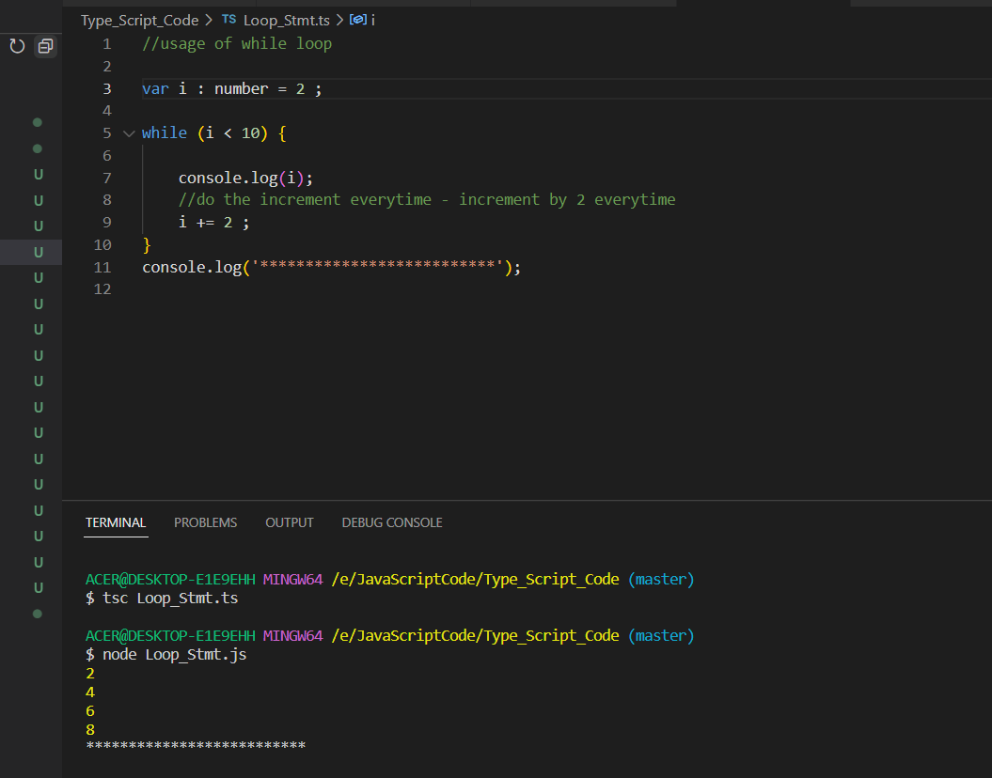

Usage of Break Statement inside the Loop Stmt

Output

