TypeScript – Modules

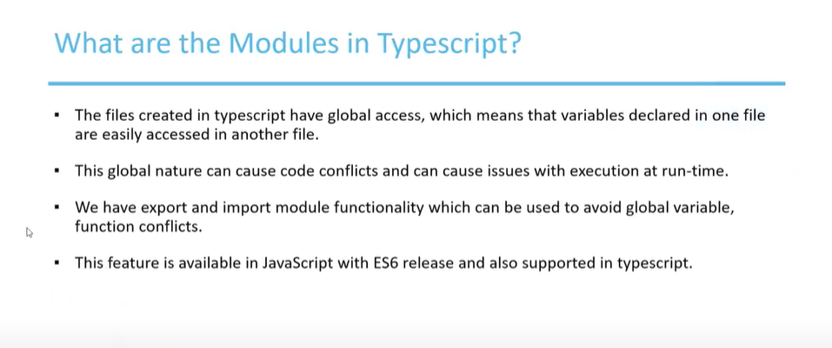

Create a module_01 – ts file and mark each of the variables, functions and the class as export – if we mark it as export – then we will not be able to use it in another typescript script file and to use it another typescript file – we need to use the import keyword

As soon as we mark the methods, functions, and the class as export – if it is reused in another typescript file it will throw an error message.

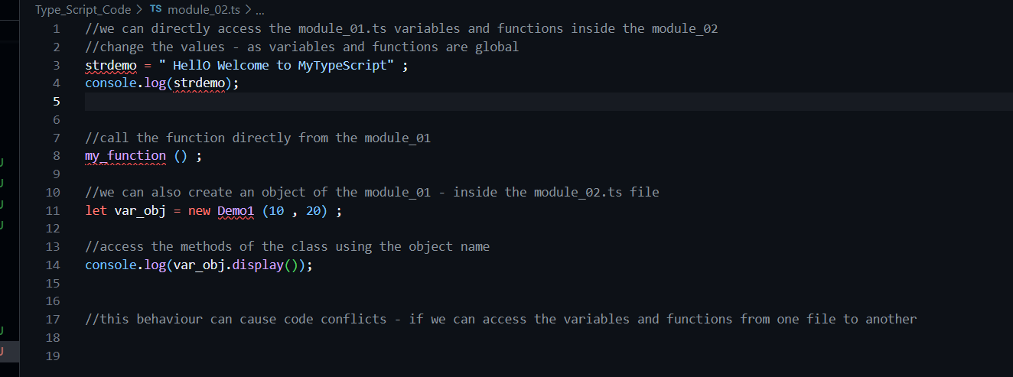

It is throwing error   


Import the string , functon name and methods from the module_01 – ts file

To compile the type script to the java script file we need to use the following commands – tsc –module commonjs module_01.ts

Let us execute the java script file.

