**Type Script – Operators**

Types of operators

Arithmetic Operators

Assignment Operators

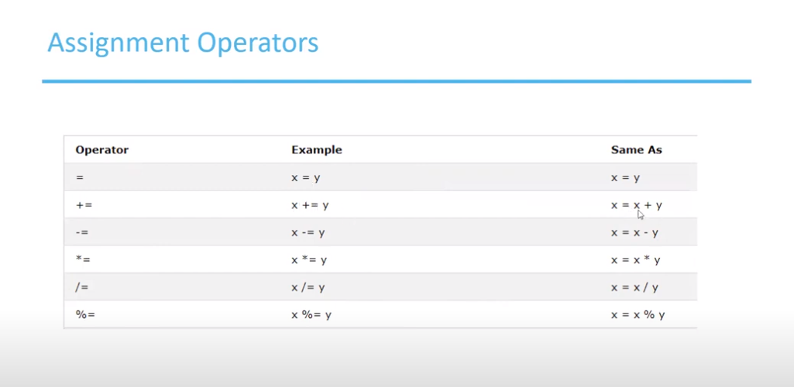

Comparison Operators

Logical Operator

Arithmetic Operators examples

Increment and decrement Operators

Assignment Operators

Ternary Operators

Logical operator

Output

