Type Script – Tuples

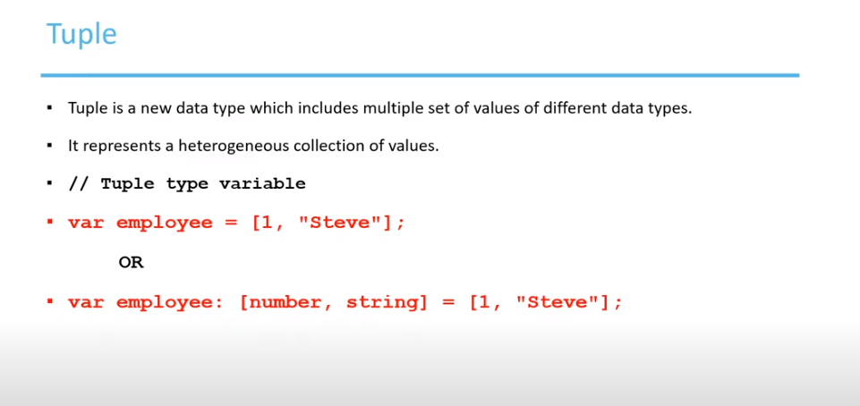

Tuple declaration

