Type Script – Variable types – var , let and const

Create a new variable.

Console – to run the type script code – we need to compile the type script code to convert to java script code

Compile the type script code and then run the java script code

Var variable scope

Variables defined inside the var keyword is available inside the function and inside the block - it is only accessed inside the function and it cannot be accessed outside the function

If we try to print the sum variable outside the function it is throwing error

Create a global variable using the var keyword which can be accessed anywhere.

Output

Let variable can only be accessed inside the block level and outside the function level we cannot access it

Let variable – it can only be accessed inside the block level and not at the function level

We can see – it is throwing compile time error.

Accessing the global variable using the let keyword.



Difference between the var and let keyword

One more thing is that the var variables can be redefined and updated – whereas the let and const keyword variables cannot be redefined or updated.

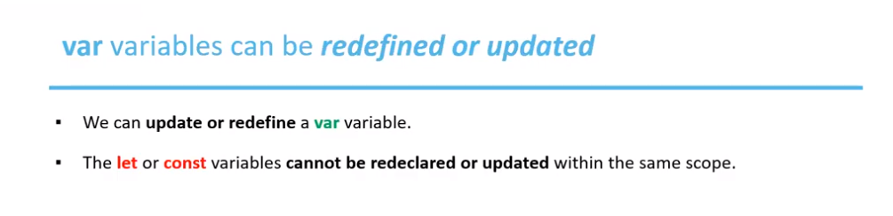

Const variable

