WebDriverIO -Set up.

[WebdriverIO · Next-gen browser and mobile automation test framework for Node.js | WebdriverIO](https://webdriver.io/)

Install yarn.

How to know where the npm package is getting downloaded

C:\Users\ACER\AppData\Roaming\npm\node_modules – this is the path where all the node packages gets installed

Following is the path where all the dependencies get downloaded for the node package manager

Why WebDriverIO

Install WebDriver IO

Give the folder name where we want to install all the dependencies.

Select local

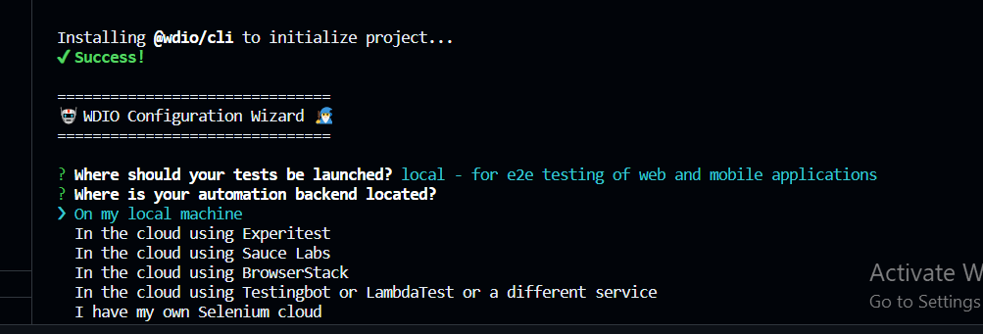

Select on my local machine.

Go for mocha

Select typescript

For page object select yes

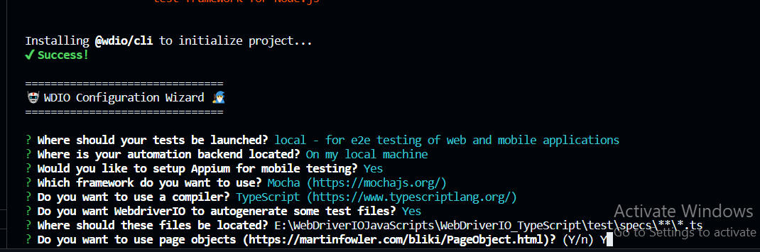

Which reporter to select

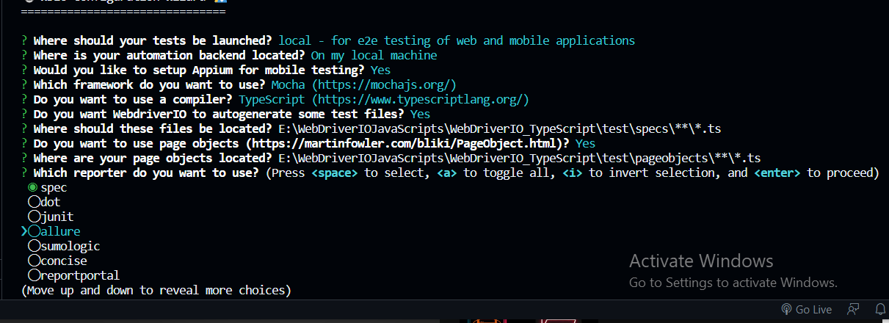

Select spec and allure – do multiple selection using space keybar

Don’t select any wait plugin.

Use chromium driver

Select npm packages to start the installation

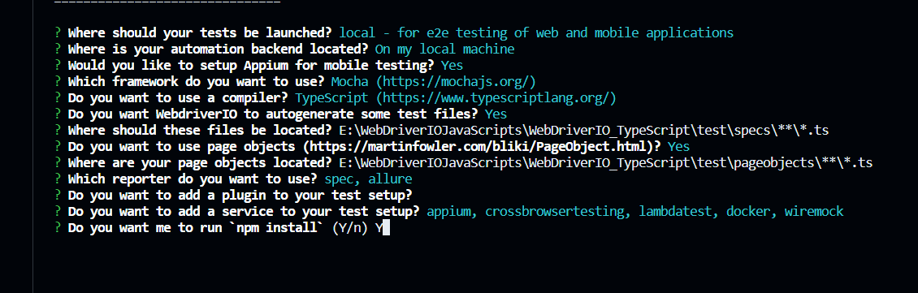

Project is successfully set in my local

Run the sample tests

Sample Script got executed – wdio run

Once the project is created – sample package.json file is created

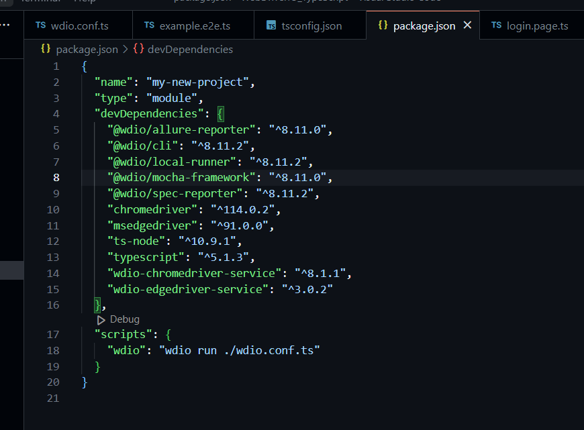

Inside the WDIO – conf.ts – It specifies the wdio runner which spec file to be executed.

Capabilities – it defines the browser where the scripts need to be executed

Install the selenium standalone server

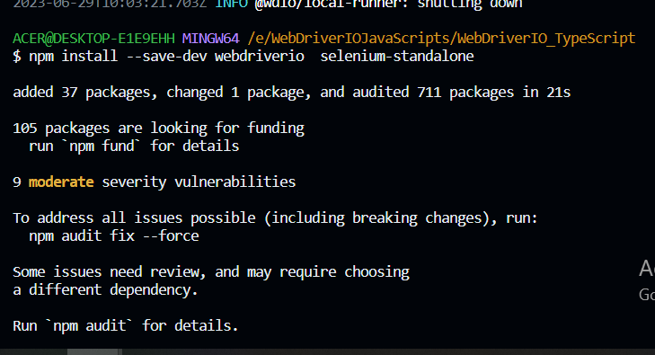

Install all the selenium standalone drivers.

$ node_modules/.bin/selenium-standalone install

Let us start the selenium standalone server.

Selenium grid started on the following port -http://192.168.1.117:4444

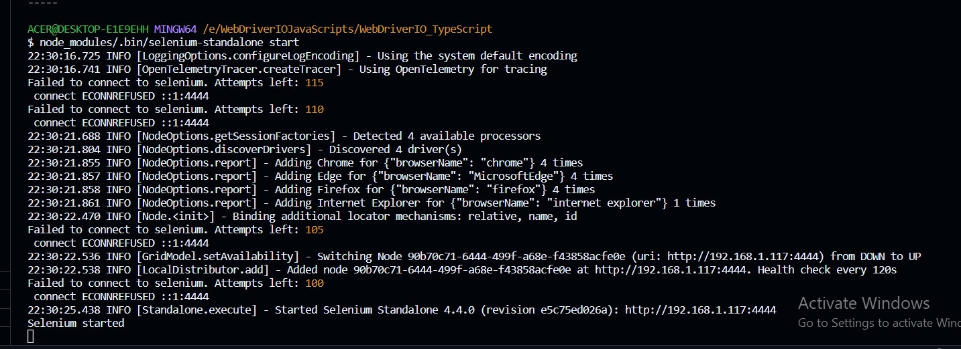

In the node js project all the dependencies will get downloaded inside the node_modules folder

Add a .gitignore file – to mention two of the files which will be ignored

Package.json file – it will have all the dependencies and the scripts section will have the conf file – wdio which will get executed.

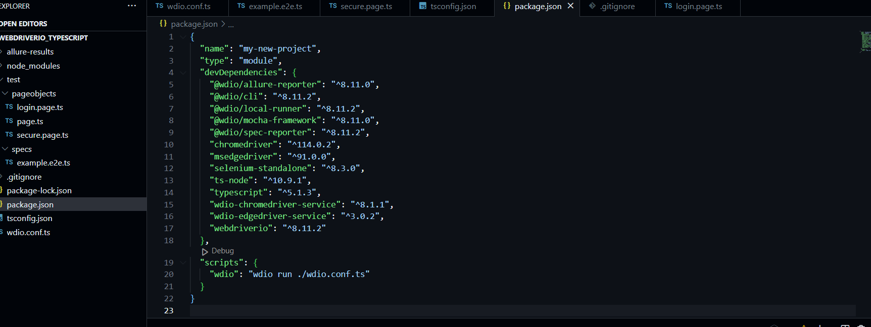

Open the wdio.conf.ts file it will have the spec file which needs to be executed

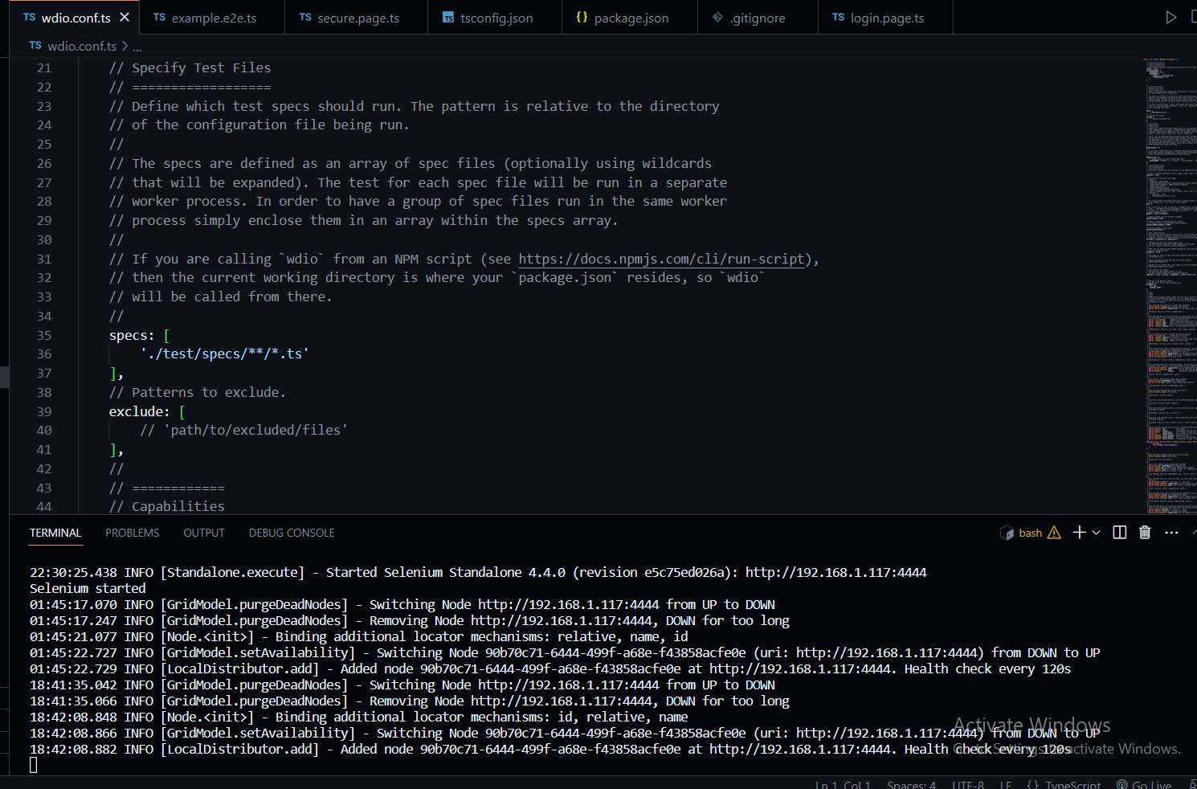

Explore tsconfig.json file – if it’s a typescript project

