Python – Assert keyword

Assert < condition>

If condition is failed – then we can type optional message

It will throw assertion error

Compare two Strings – and its case sensitive –

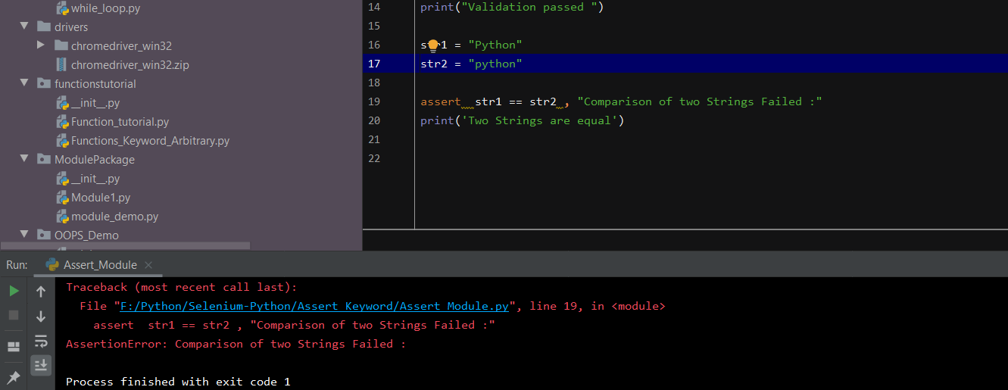

Assertion inside the list

