**Python – Behave BDD**

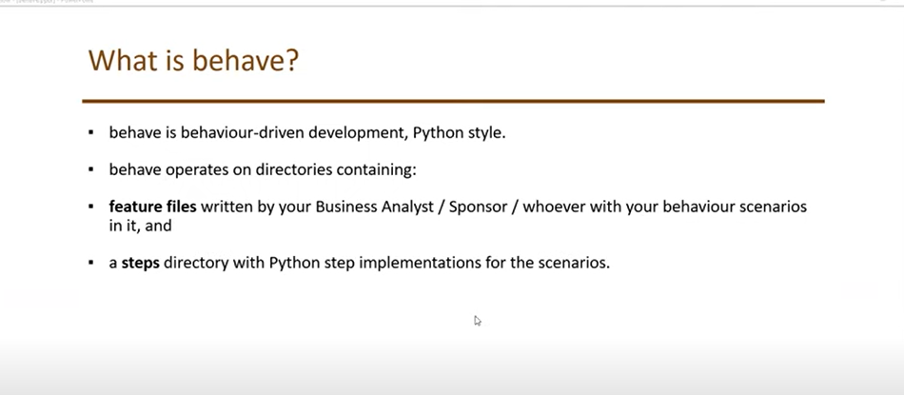

<https://pypi.org/project/behave/>

Install Behave package: -

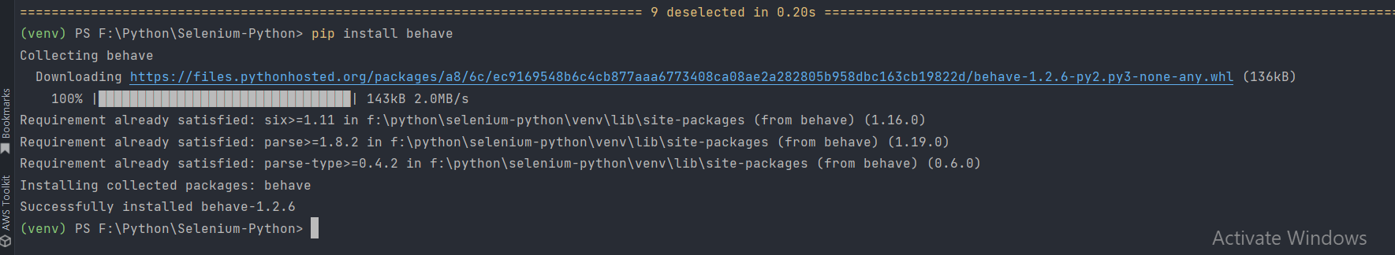

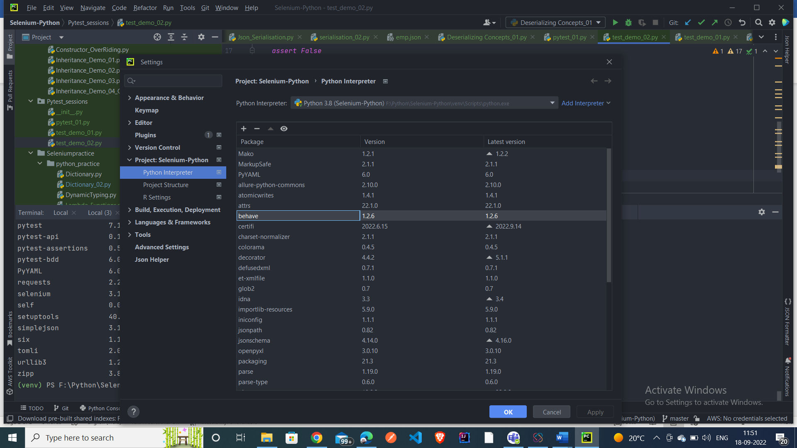

Create a new directory – feature and inside feature create another directory – steps

Create Scenarios under the Feature files

Run the Feature file to generate the stepdefinition files

It will generate the step defintions files

Copy paste the step definitions file under the step definition py file

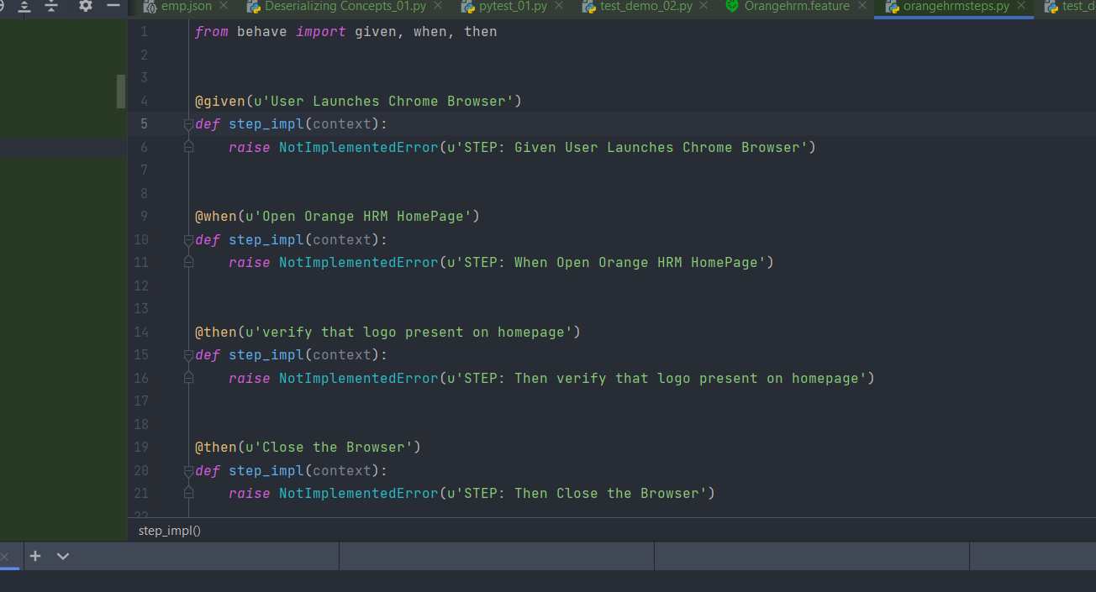

Instead of giving the chrome driver path everytime – copy paste the chromedriver.exe file under the Scripts folder – python location

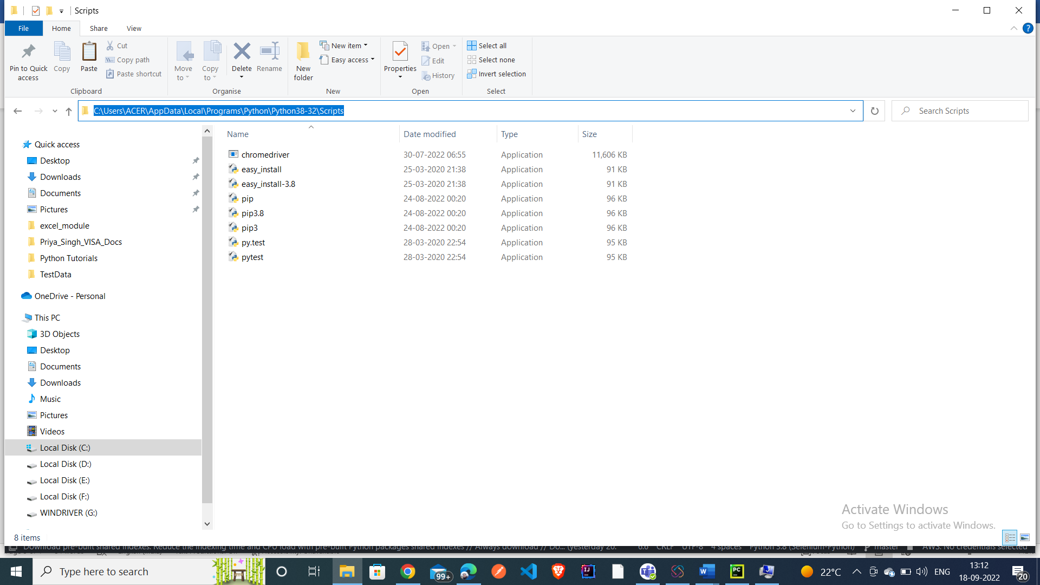

Make sure the path is already added in the system vriables – PATH

Now directly give **the Chrome Driver – no need to give the driver path now**

Now run the Feature file –

Scenario Outline Examples:

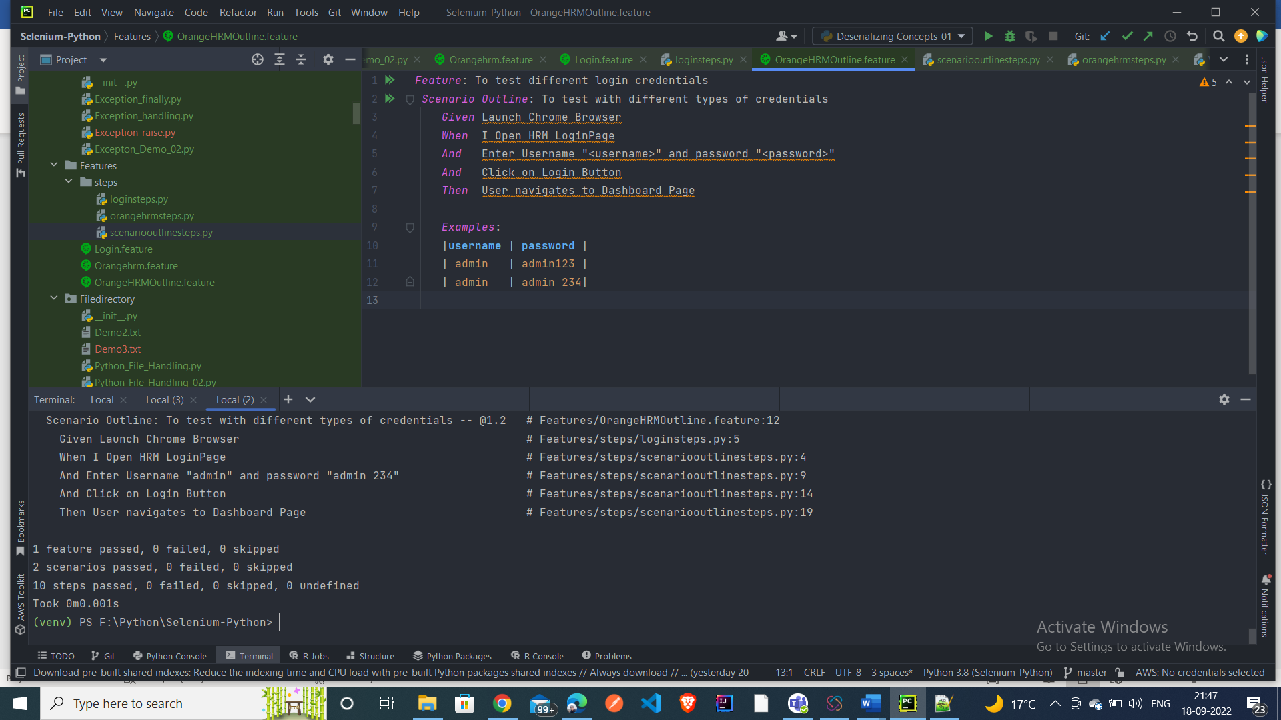

Step definitions file

