**Python – Dictionary Data Type**

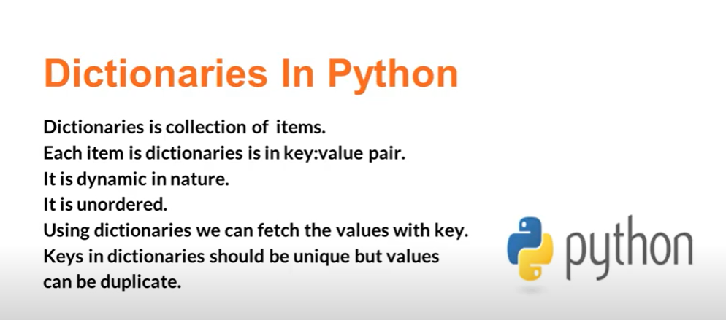

**Imp Point** – Key should be unique, and va**lues can be Duplicate – and Dictionary can have any Data Type value as Key and Value pair**.

**Syntax for creating the Dictionaries in different ways**: -

First Syntax is **used to create the Dictionary with key and value pair**.

Second Syntax is used to **create dictionary inside the dictionary Class Constructor**.

Third Syntax is used **to create Dictionary – when we pass List and inside the list, we pass key and value pair as Tuples**: -

**First Syntax**: - To create the Dictionary **with the key and value pair and trying to fetch the particular key value**:-

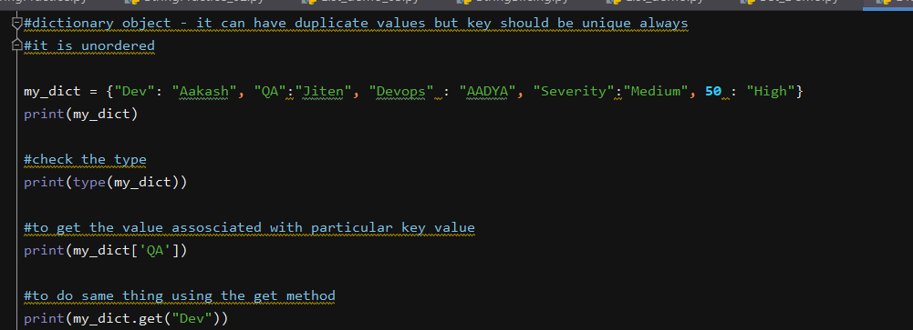

**Output – It will fetch the value associated with the key value**:-

**Second Syntax of Creating the Dictionary** – passing the **Dictionary values inside the Constructor**: -

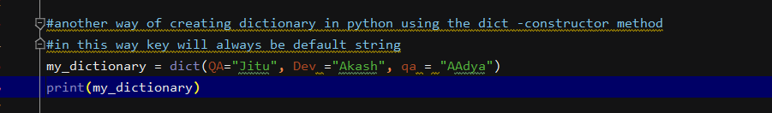

Output: - 

**Third Syntax for Creating the Dictionary**: -

Passing the **list of values – as tuples inside the Dictionary Constructor**: -

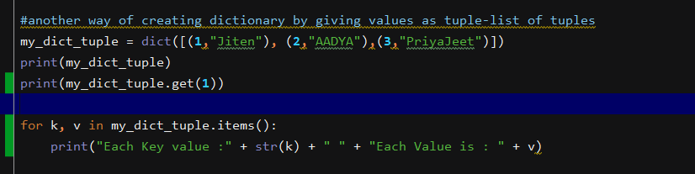

Printing **each Key and Value Pair**: -

Output: -

**Now if we want to get all the Key values and all the Value Items from the Dictionary**: -

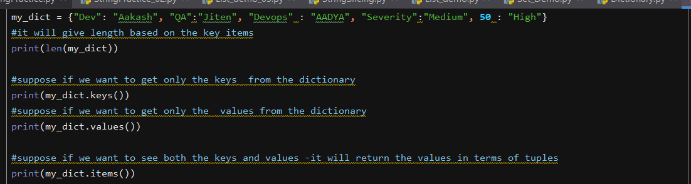

**Len – Method** it will give the length based on the number of Key Items.

**Keys – it will give all the keys** – associated with the Dictionary.

**Values – it will give all the Values** – associated with the Dictionary.

**allItems – it will give all the Key and Value Pair combined**.

Output :-



To **create List of Values inside the Dictionary**: -

To **retrieve the list element inside the dictionary – Indexing can be used for the element to retrieve**:

**Output**: -

Create Dictionary **inside the Dictionary**: -

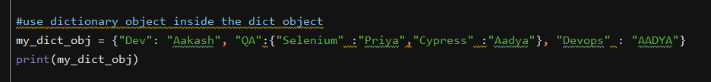

Inside the Dictionary we **are having another Dictionary**: -

To fetch the **element inside the Dictionary of Dictionary**: -

With these **two ways -we can retrieve the elements inside the Dictionary of Dictionary** –

Output: -

TO **add an additional element inside the Dictionary**: -

Give the **key name which we want to add inside the Dictionary having a value associated to it**: -

The key – **Manager having value as Jitu will be added inside the Dictionary**: -

**Output**: -



Even now we can update the old key value with new key value: -

Output: - **Jitu will be replaced with new value – Jeetu**



To Delete **the Particular key Item**: -

Output: - **Devops Key value will get Deleted**: -



To Delete **the Last Item of the Key – Value pair**: -

Output: - **Last Key and Value pair will get Deleted**: -



**Tuples – Data Type in Python**: -

Only Difference **between tuples and List is that Tuples is Immutable – we cannot insert any element inside the Tuple, whereas in List – we can append and insert any new values inside the List**.

**Create the Tuple and retrieve the element inside the list based on the Indexing**: -

Output: -

To create the **tuple by passing the tuples value inside the Tuple class – Constructor**: -

**Output**: -



To **count the element inside the tuple or find the Occurrence of any character inside the Tuple**: -

**Slicing** – to get the data from range: -

Output: - It will start from the first element -not from the zero Index



We cannot **insert any elements inside the Tuple, as Tuple is immutable** – we cannot insert any element inside the Tuple: -

It will **throw type error**: -

To convert tuple to list: -

Simply **pass the Tuple values inside the List – constructor**: -

Output: -

In the same way we **can convert Tuple into the Set – but Set will not allow Duplicate Values**: -

Output: -



If we give **single value inside the tuple it will behave as String** – and if we calculate the length -it will give the **whole length of the String**: -

**Output**: - It will **behave as String and when we calculate length it will give total length as 8 characters**: -

If we give more **than one value inside the Tuple** – it will behave as **tuple and not as a String and give the correct length**: -

**Output** – here the **length function will return as 2**.



To create the **list of tuples and to give Multiple Tuples values inside the List**: -

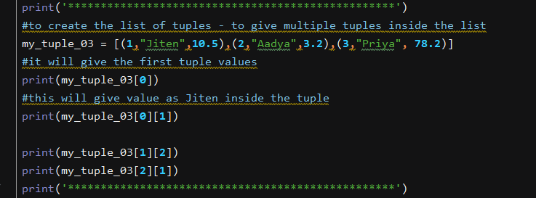

To fetch the **value using the Index Parameters**: -

**Unpacking the Tuples** – Assigning each variable value inside the tuple: -

Output: -

