**String – Data Type**: -

#String is a class in Python having sequence of characters and it starts with "" and ''

**Every Data Type in Python is a Class**

\\ - it will remove double quotes

\t – it will create space

\n it will create new line

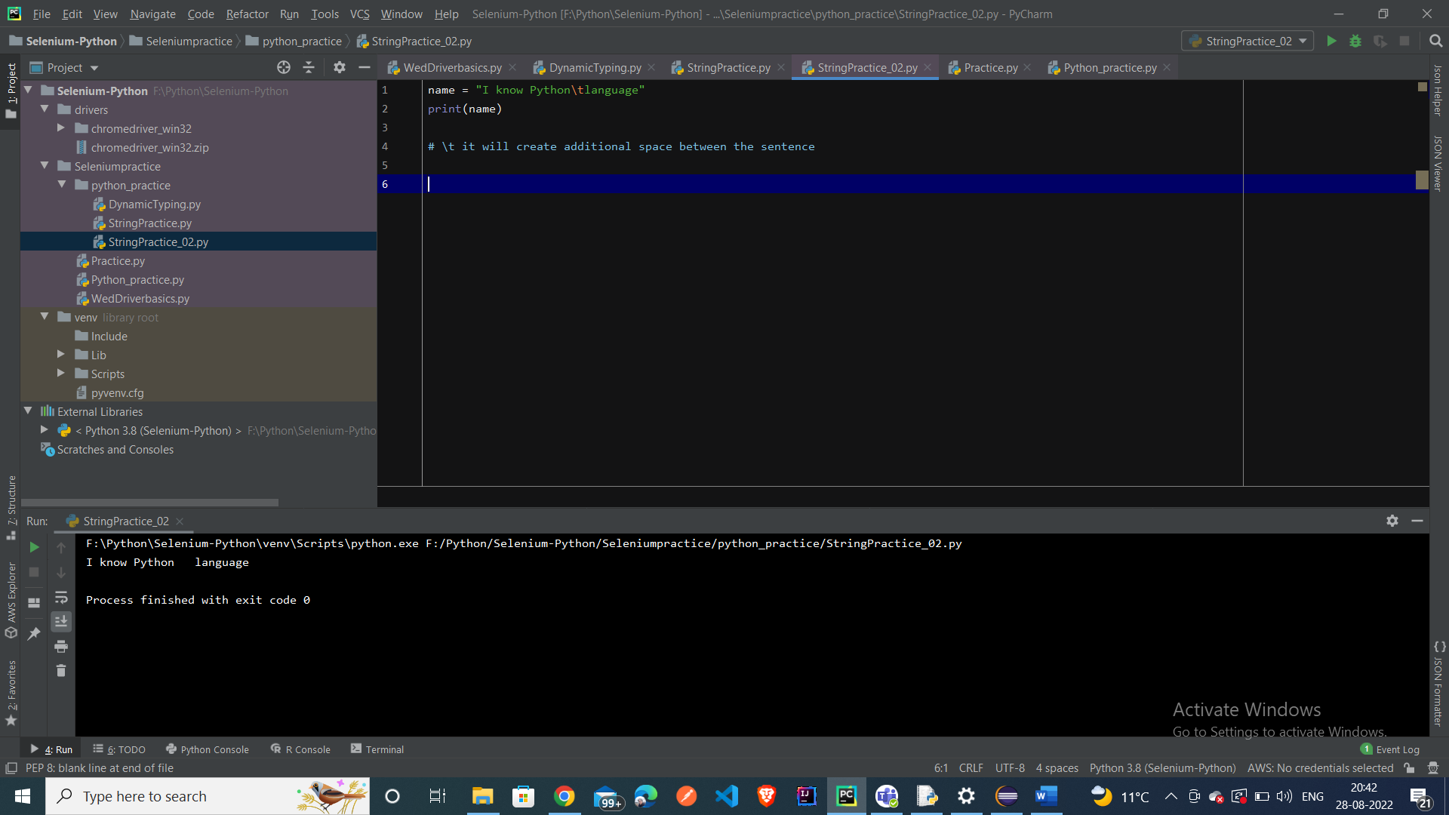

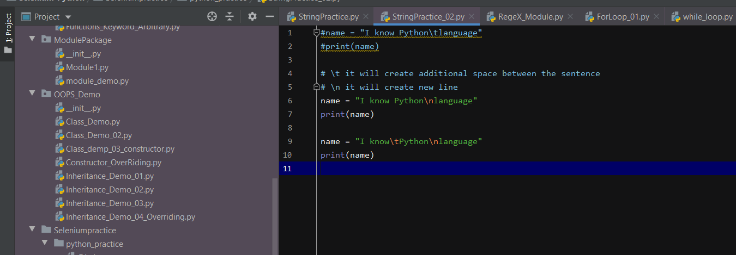

String class methods – len – it will give the length – index – it will give the position length inside the string – **It will give output length as 14**

Index – Method to know the index of position of character inside the String – it will Output as 2

**Replace Method** – to replace any character inside the String

**Split Method** – to split the **string based on any character or the white spaces**: -

It will store each element as List

To check if the String is in **Lower case and Upper case:- (isLower and isUpper)**

To **count each character** inside the String: -

**Format Method of the String** – it will replace each {} – inside the String with new String

We can do the same thing by **using the key and value pair**

We have **the f method to replace the String with {} and {}**

In String – **strip method is there to remove the white spaces inside the String**: -

String – Indexing Concepts: -

String = “ PYTHON “

**Indexing of the Characters inside the String**

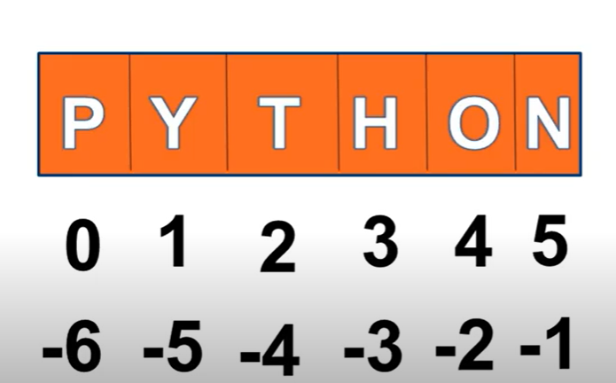

It will give Output as P only

**Slicing** – It will give the specific words from the String

It will give output as Jitendra

To reverse the String

Output – String Reverse

**List – Data Type**

**List – can store Different types of Data Elements**

**Add Two List Elements :-**

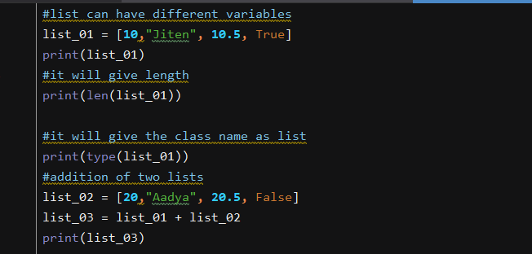

**TO create list in another way by passing the list values inside the List class – constructor**.

**Index** – to get the **specific position inside the list – first element will start with 0th Position**

**Count method** – it will give the **number of occurrences of each element inside the List**

**Slicing – to get some specific element from the list**

Replace – **to Replace the Element inside the List**

Output – **It will replace the first element of the list with new value**

**Append – Method** – It will add an additional element inside the list.

It will add new element inside the List

**Insert Keyword** – It will add the **2nd Index value with new element**

Output =-

**Extend Keyword** to combine two list values: -

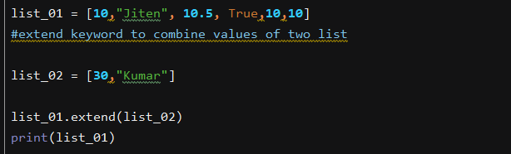

Output:- 

**Pop Method** – to remove the element inside the list – if we give Index value as blank – it will remove the last element inside the list

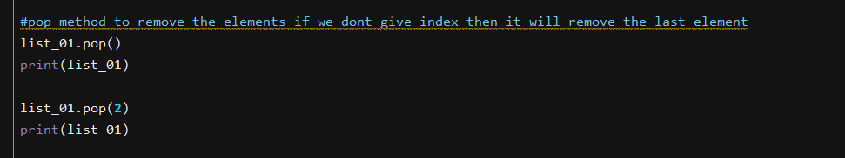

**If we give the index – it will remove the specific element inside the list**

**Reverse**: - To reverse the elements inside the list.

**It will reverse the list**

To create list of elements inside the list **– inside the list – we are having the list with another list** :-

TO access the **specific element inside the list – if we want to access the Selenium value from the list**

**Set**

**Here 10 will only come once – as Set cannot have duplicate elements**.

Output - 

It is also unordered and it doesn’t follow any order .

**Second way of creating set is by passing the element inside the set Class Constructor**:-

**Addition and Removal of element inside the Set**

