Python – Date and Time Module

**Code to get the current date and time**

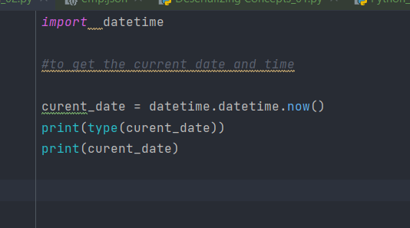

**Getting the current date and time**

To print the current date – time ,month , year , hour , seconds , minutes

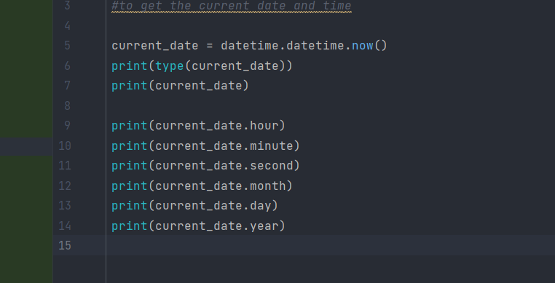

Strftime – **useful method to change the format of the returned string**.

<https://strftime.org/>

Output: -

To convert the date to specific format

Output :-

Let’s create a new function and try to **call the function**: -

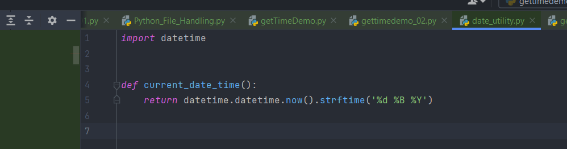

Call the function **from the Module**

Get the time difference between the two dates

Output

Get the time in hours,minutes,seconds and milliseconds

Output:-

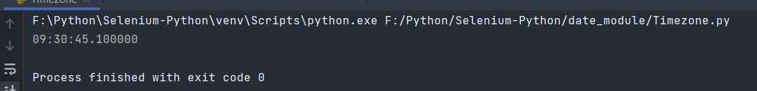

Let’s pass **the entire date**

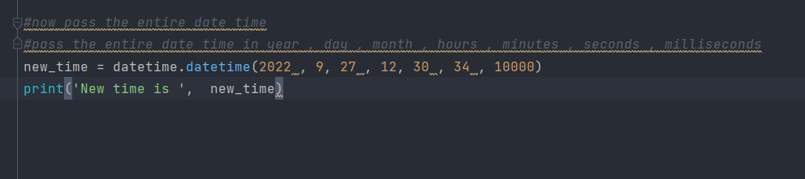

Output: -

Now from new_time – lets get the specific date and time

Output :-

Let’s try to increase the number of hours by **using the time delta method – and use hours = 24**

Output

Output

Install pytz



Time zones

Output

Converting the string date to the date time object

Using strptime – we can easily convert the string to the date time object

Output

