**Python – excel Module (Read and Write)**

<https://www.python-excel.org/>

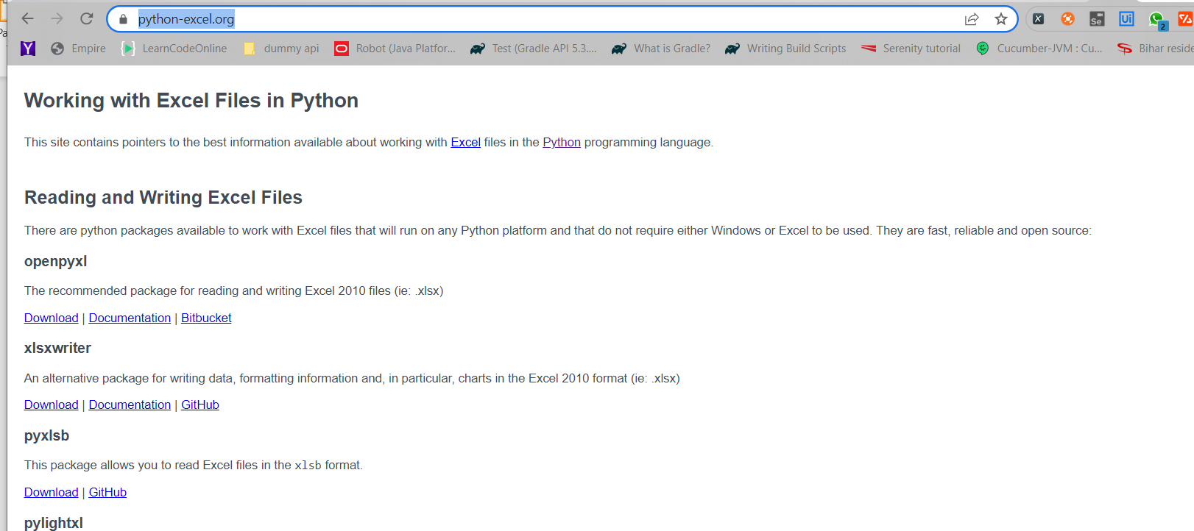

Openpyxl – library to work with excel

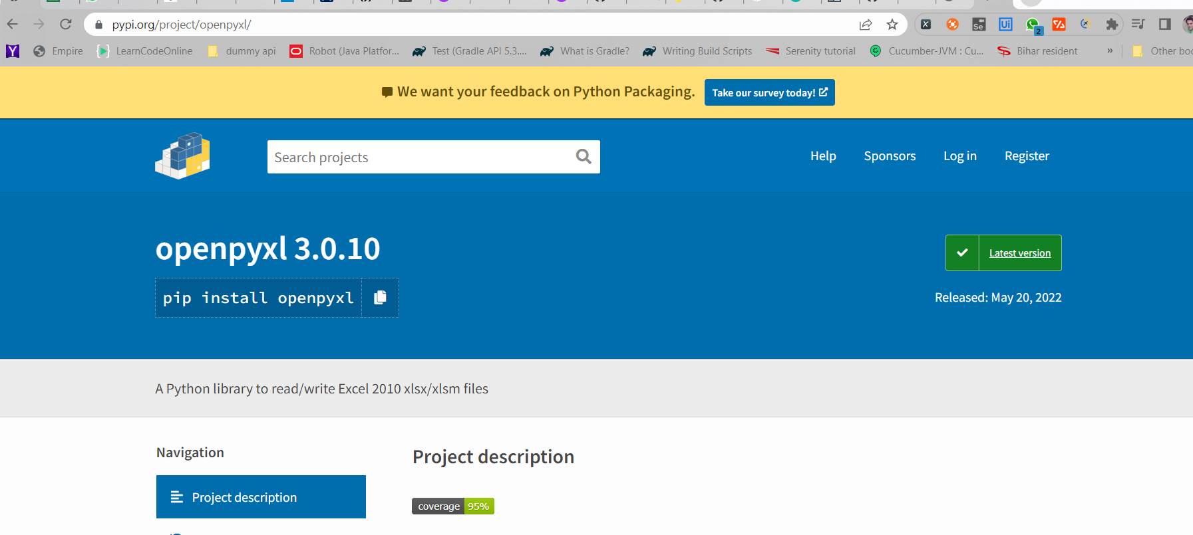

**Install the openpyxl package**

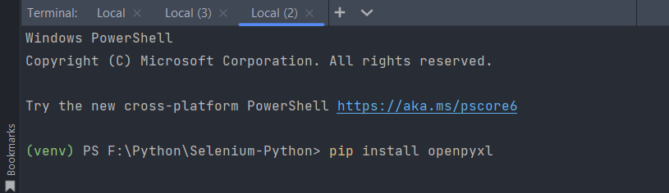

**Package Installed**

**Lets import the openpyxl package ant try to import the workbook**

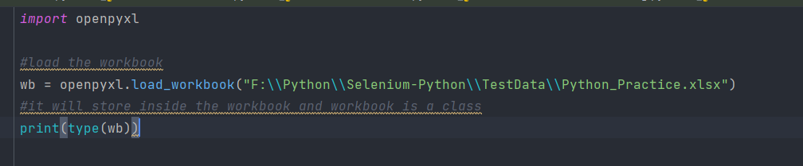

**It will return as workbook – workbook is also a class**

**TO get the number of Sheets available in the Worksheet**

**Output : -**

**It will return as List – of all the sheet names**

**TO get the active Sheet in the excel:-**

**Output:-**



**To open the Sheet -particularly inside the Excel: -**

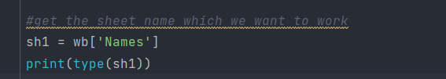

**Output:- sh1 is also a class – Worksheet**

**To get the value from the sheet for the particular sheet: -**

**Here in the excel A2 is Kumar Jitendra – and it should fetch the same value with the code: -**

**Alternative way of doing it by calling the sheet and cell value from the workbook**



**Option 2 – Another way of retrieving the value from the excel – by using the row and column – cell index number:-**

**Output:-**

**Retrieve the value from another sheet**

**Output :-**

**Another way of doing it by passing the row number and column number directly as key and value**

**To know the number of rows and columns available in the worksheet: -**

**Output: -**

**To write the data at the particular cell inside the Excel – give the rownumber and column number value -it will edit the values**

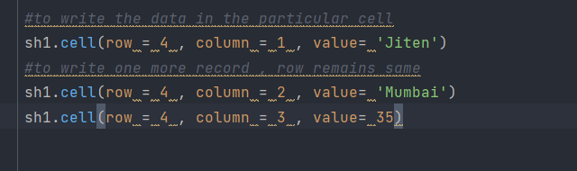

**Save the Workbook to another file location: -**

**It will create another workbook having new changes**

**We can see new Workbook is created :-**

**We can see new row is created having the new values: -**

**Let’s try to create new workbook and write new values to the excel and save the workbook: -**

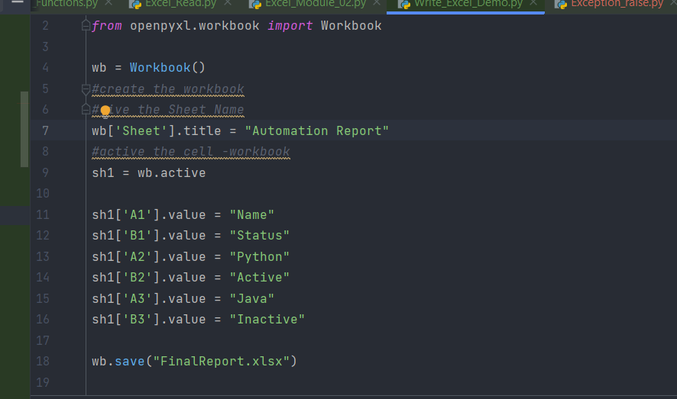

**Lets run the code – new Workbook will get created**

**We can see new Excel workbook got created inside the package:-**

**Open the Excel**

**Now let’s do colour code – the row in the excel sheet: -**

[**https://htmlcolorcodes.com/**](https://htmlcolorcodes.com/)

**We have colour code for each of the colors available :-**

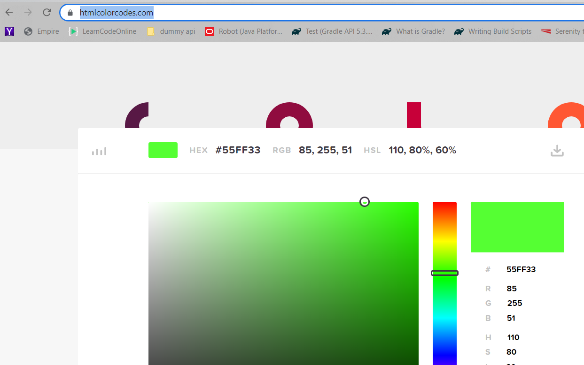

**Let’s copy the colour code for each of the colours**

**Let’s import the pattern fill module from the openpyxl – styles package**



**Add the PatternFill – method to fill the colour cell with the colour**

**Save the workbook in new location: -**

**Cell is filled with the colour**

**To update multiple records inside the excel**

**Create the list of tuples – and try to iterate inside the tuples of list**

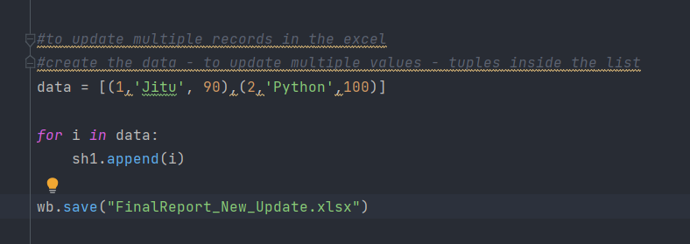

**After writing the data – save the excel in new location**

**New Excel will get created**

**We can see list of new values is updated inside the excel**