**How to perform read and write operations in python**: -

It will open the file and read the file:- (as r signifies for reading the file -reading mode )

If we hover **the open method – we will find all the operations associated to it** :-

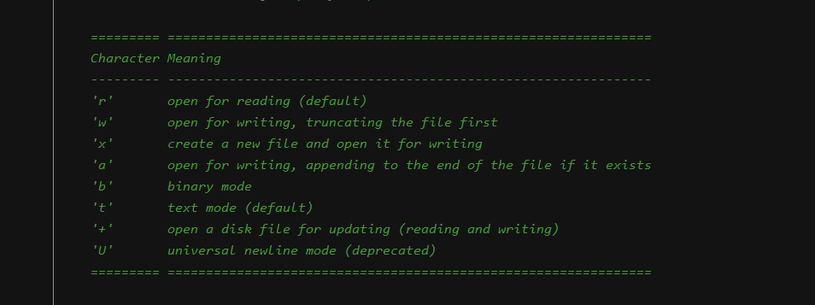

We have **various methods – f.mode – to check the mode – f.closed – to check whether the file is closed or not** :-

**f.closed** -> method will give the status of the file whether its closed or not .

Output:-

Now do the same operation with the **help of context manager with the help of with block**:-

**With block** – we don’t need to **specify the file – close operation – as soon as we come out of the with block – file is automatically closed**: -

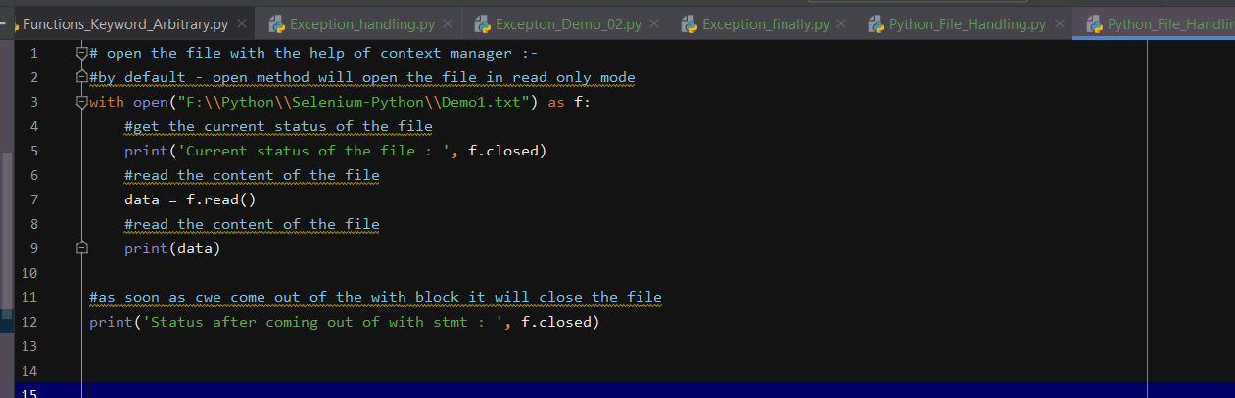

Output: -

In Python we **have os module – which will return the current directory path**: -



Output: - It will give the current directory path: -



Now **write the file to another file**: -

If we **give w – mode – it will write the file** – if the txt file is not present – it **will write the file content**: -

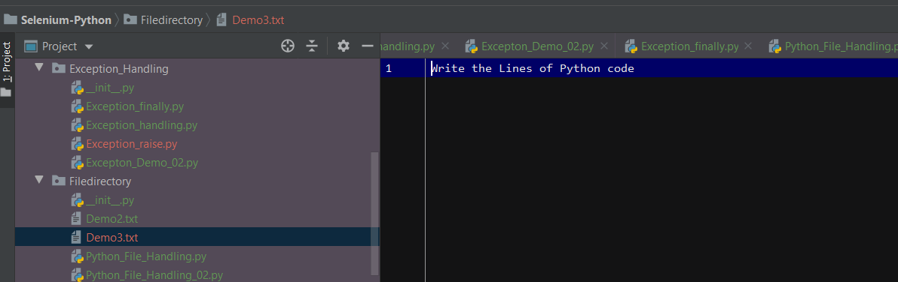

TO append the content at the end of the file – for that we need to use append mode – a

Open the file:-

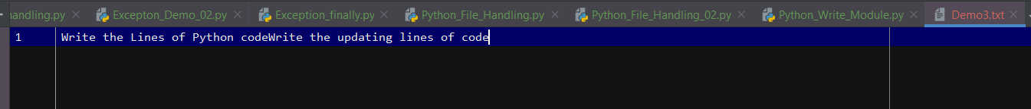

If we give - \n it will append the sentence in new line:-

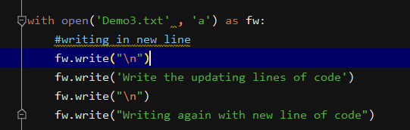

Output: -

If we give - \t – it will add spaces between the lines of code: -

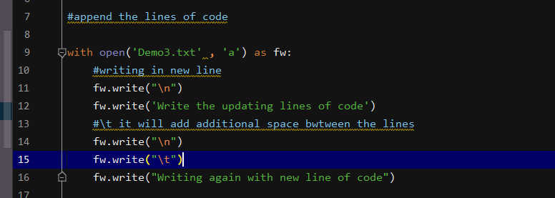

Output: - Extra lines of spaces will be added

Over ride the **content of the file with new line:-** (use ‘w’ as mode ):-

Output :-

