**Python – Functions – Tutorials**: -

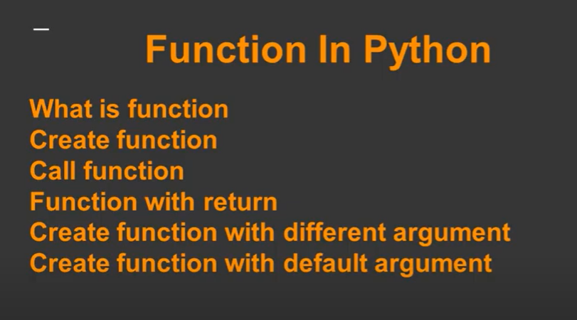

**Definition of Function**: -

**TO create function without Argument**: -

**To create function with argument**: -

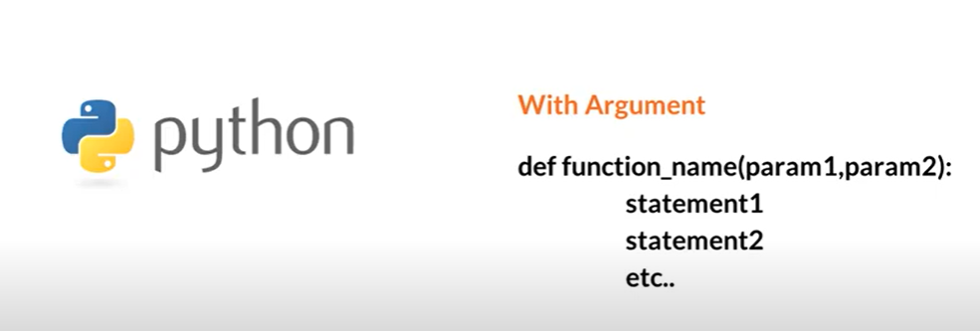

**Function with Default Argument:** -

**Function with Arbitrary Argument** – When the number **of parameters is not fixed, then we use arbitrary Arguments – it will take tuples as parameter**: -

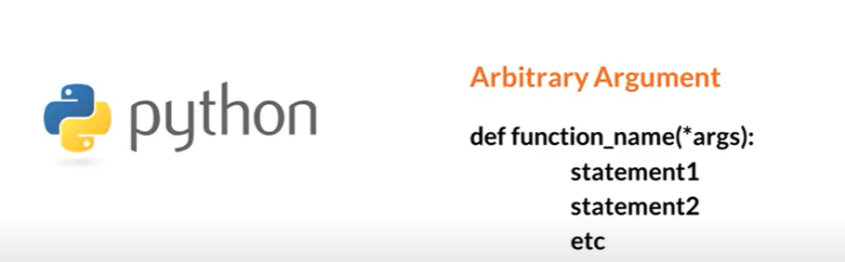

**Function with Arbitrary Keyword Argument** – When we can pass argument in the form of key and value pair – that is **called Arbitrary Keyword Arguments – it takes dictionary values as key and value pair**: -

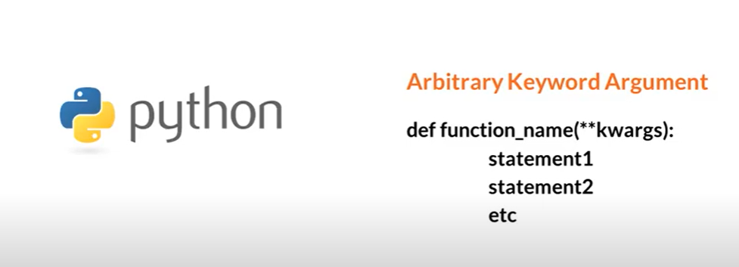

Let’s try to **focus on each – function – module**: -

Function **without any Argument**: -

**Now call the function**: -

**Output**: - After the function **is called – it will give the results in the console**: -

To **write a function which returns the results**: -

This function **returns the result – sum of two variables**.

**Call the function** – store the results of the function in **an external variable**: -

**Output**: - Console and print the result: -



**Function with Parameters**: -

Call the function – **Output will be generated on the console**: -

To **showcase one example – developed a function which takes parameter as list of values** – which will give the list of even numbers from the list of parameters given: -

Call the function which will give the list of even numbers from the list: -

Output: -

Output:- Even List – of Numbers :-

**Example of Arbitrary Arguments** – where **we can pass any number of parameters as tuples values**: -

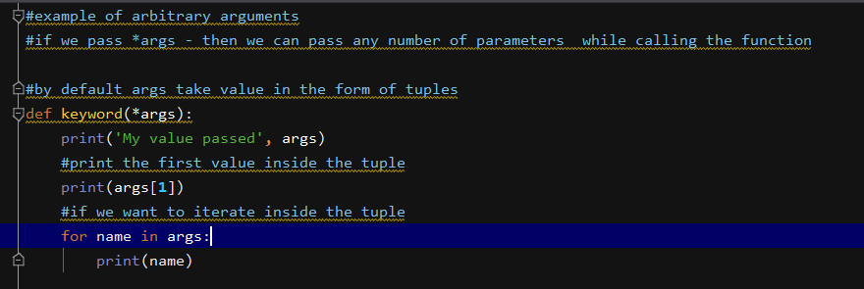

Here **\* args – denotes we can pass any number of parameters and it will act as tuples of values**: -

Now **call the function – where we can pass any number of parameters**: -

**Output**: -

Create a function – which will give the **maximum of amongst all the members passed as tuple**: -

Call the function:-

Output: - It will **give the sum of all numbers**: -



Pass **Arbitrary Keyword Arguments** – where we can pass **arguments as Dictionary – key and value pair**:

**Call the function – it will give the values associated with the keys**: -

Output: -

Now in the function pass both the **\*args and *kwargs as parameter values – in the function we can pass parameter as Tuples and Dictionary as key and value pairs**: -

Call the function: -

Output:- **In this way we can pass tuples as *args and **kwargs as key and value pair** :-

