**Python – OOPS Concepts**

What is Object: -

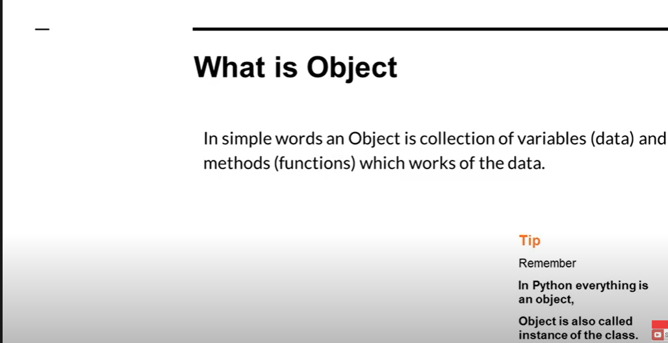



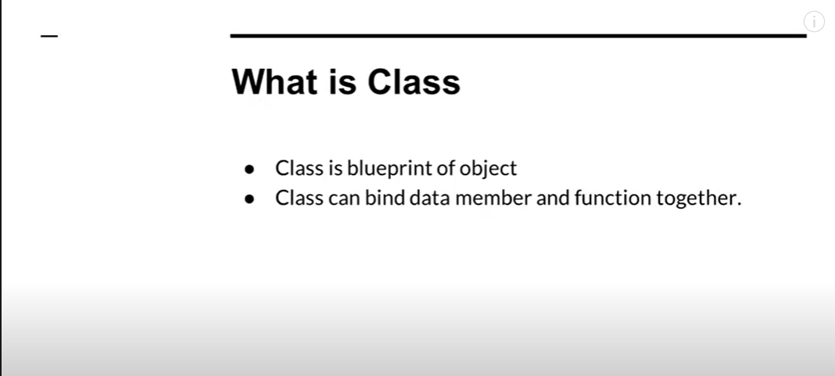

Define the class and how we create object of the class

Now create object of the class and with the help of object we can call the method name

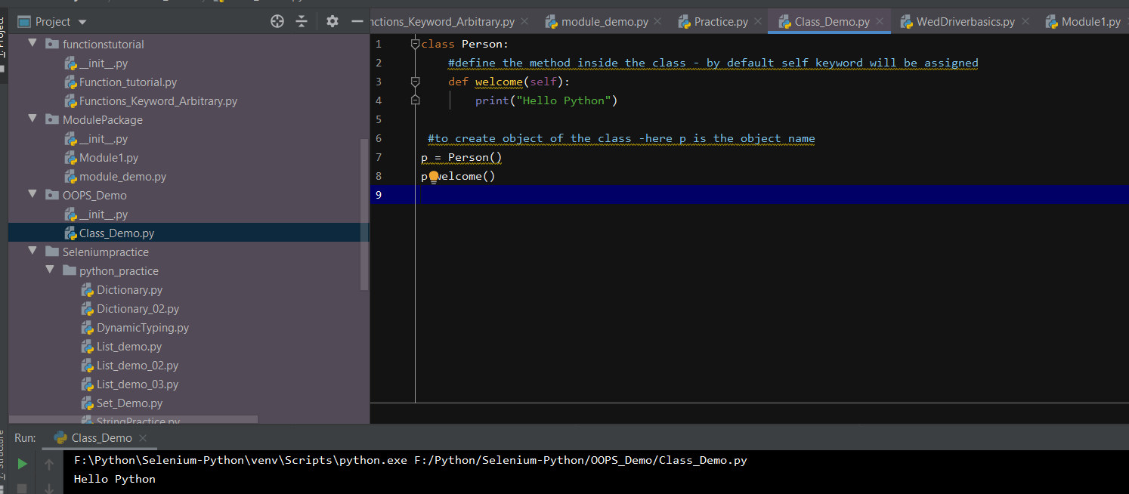

Difference between Functions and Methods

**Function is created outside the class, and it is called directly – whereas the Method is created inside the class and the methods can be accessed with the help by creating object of the class**

**Methods will have self-keyword as default mentioned in the parameter and Function will not have any default keyword**

Now create method inside the class – having two parameters – one with the self-keyword – and two numbers

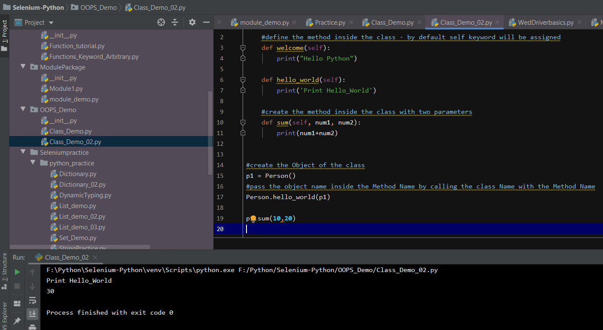

**Meaning of Self keyword** – self Is the Instance of the current class

It is not mandatory to write – the keyword self – this self can be anything we can write – it is just used to refer the current instance of the class

**Create the Object of the class – and assign different variables and try to access the variables**: -

**With the help of getatrr** – method available in python – we can access the **method variable names**:-

Output:-



Now lets have a break point to check how python object is storing the values :-

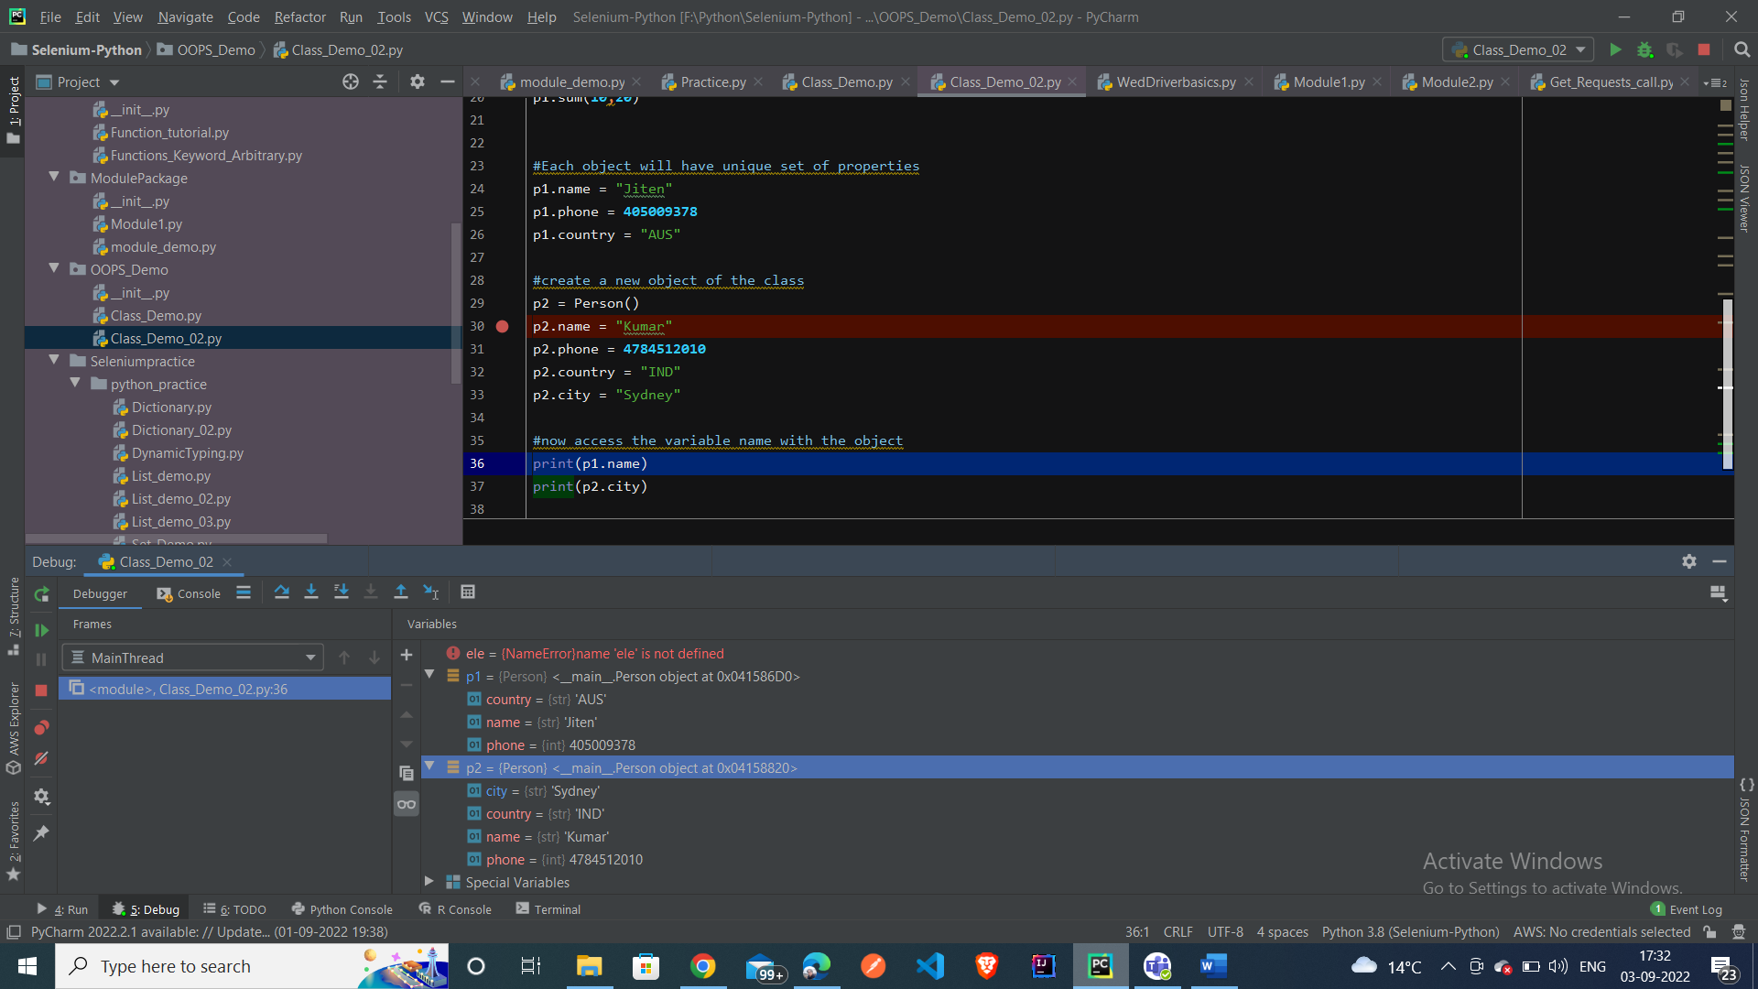

Here we can see the two different object – p1 and p2 is storing the values

**TO create Constructor of the Class** – how to pass the variables inside the Constructor

* Create the constructor of the class by passing def __init__(self):

Now write **statement inside the constructor – when we create object -by default method inside the constructor will be called and invoked first**

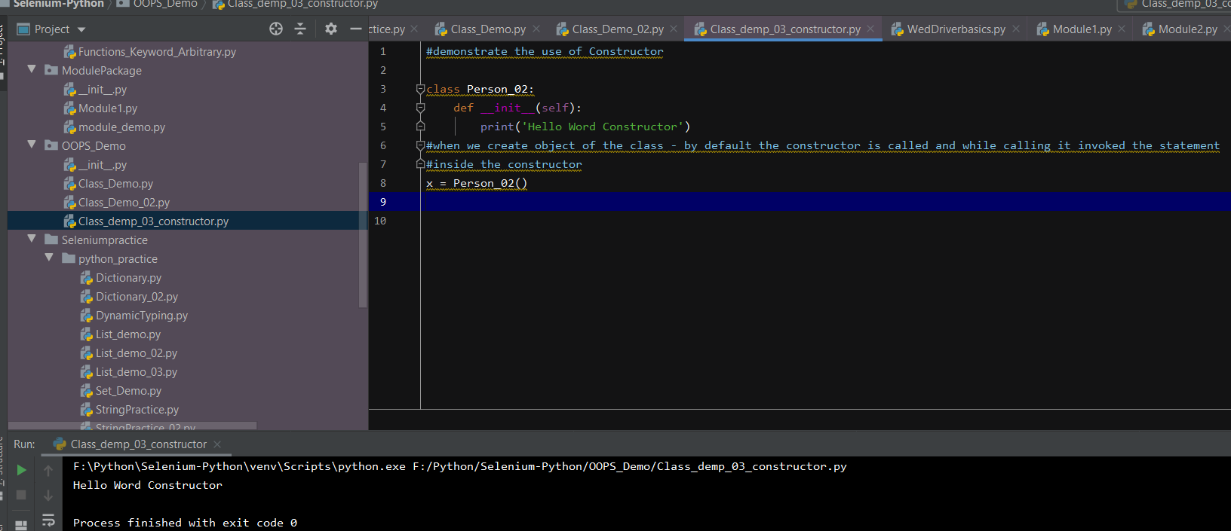

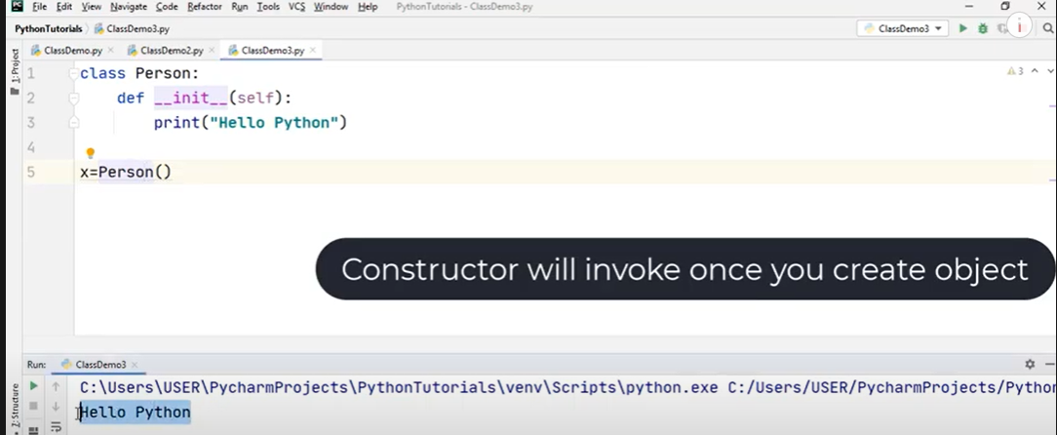

Now try to create constructor and pass two Parameter values inside the Constructor

Parameterized constructor – passing two values

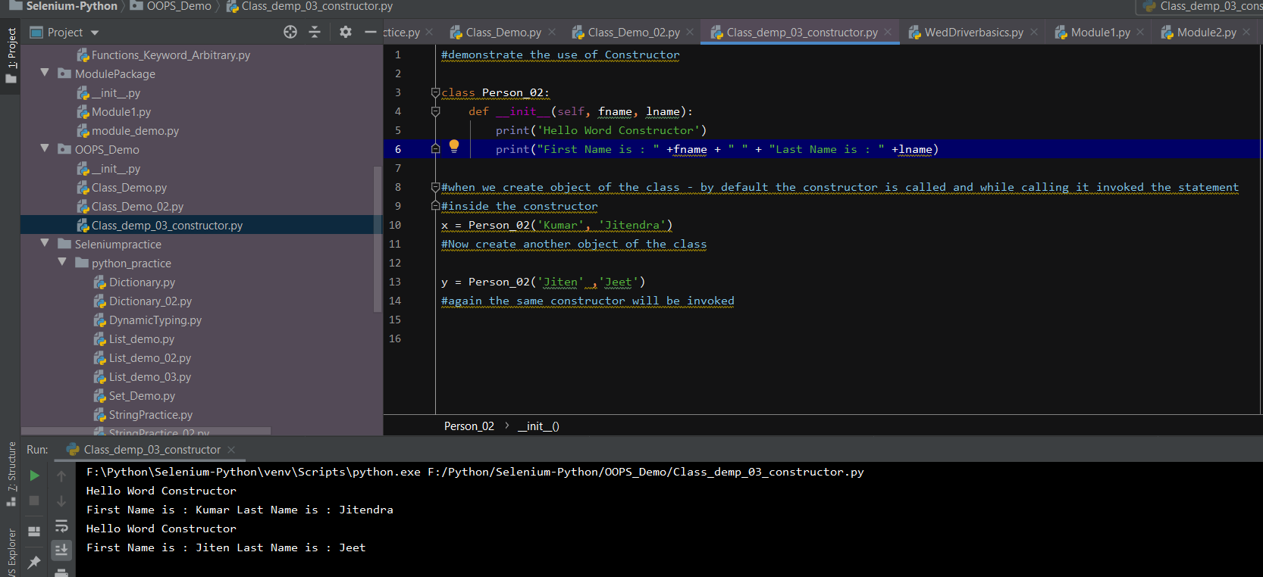

Even we can assign different variables name inside the keyword by using the self keyword:-

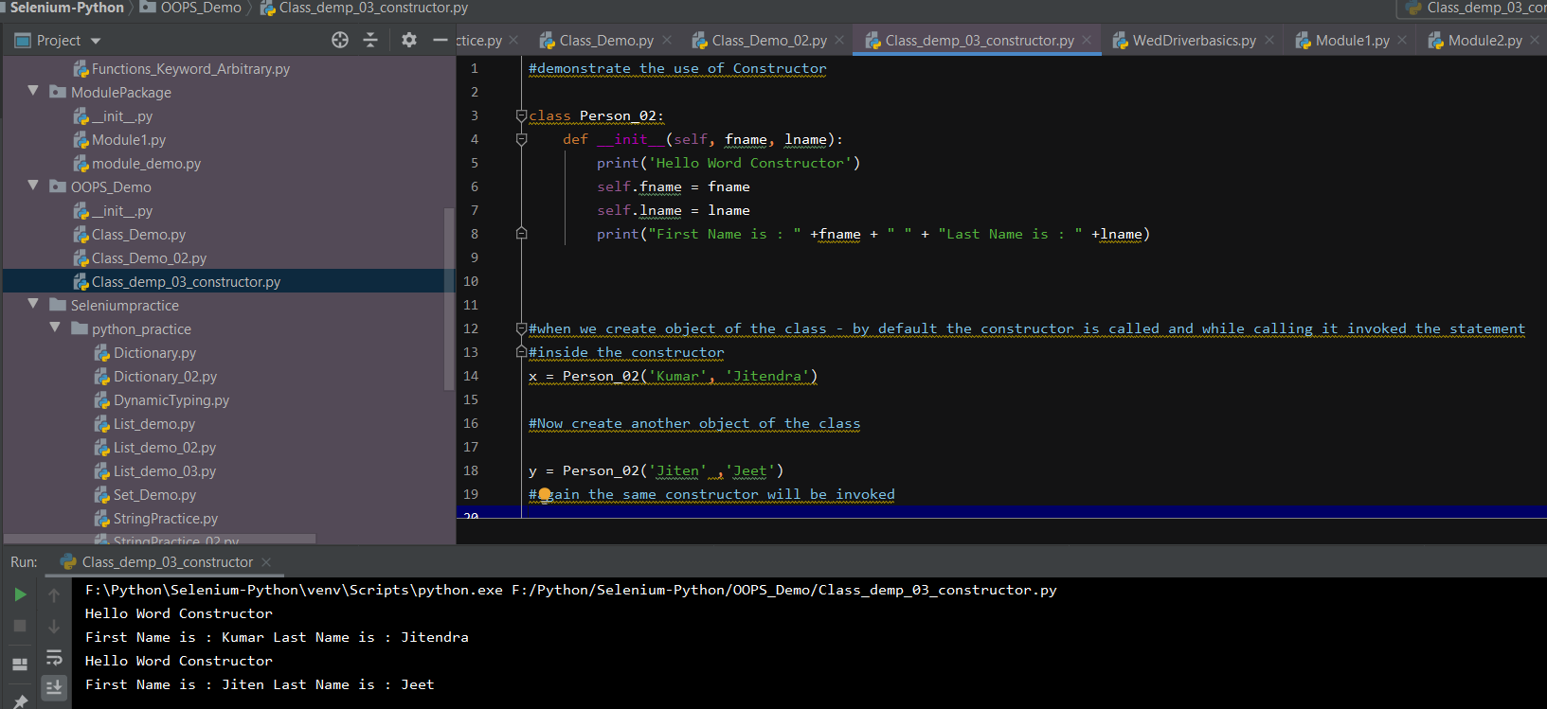

Let’s create another sum – method inside the class and pass two values

Using the self-keyword, we can assign different values to the parameters

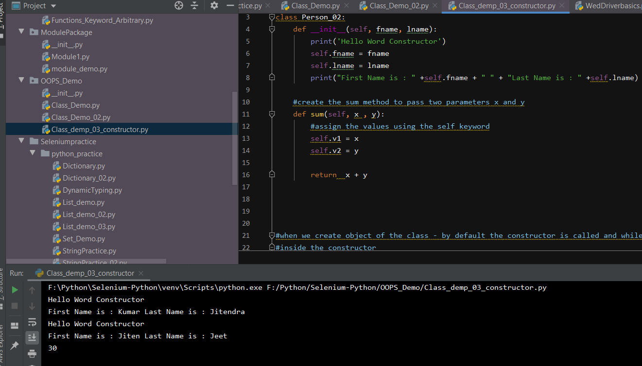

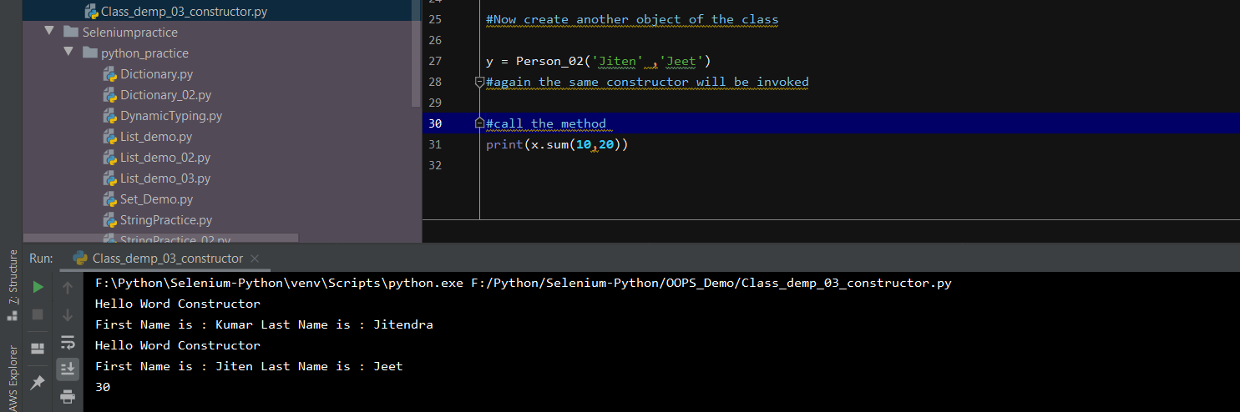

If we debug and go inside the function, we can find what is the value passed inside the function

