Constructor Inheritance

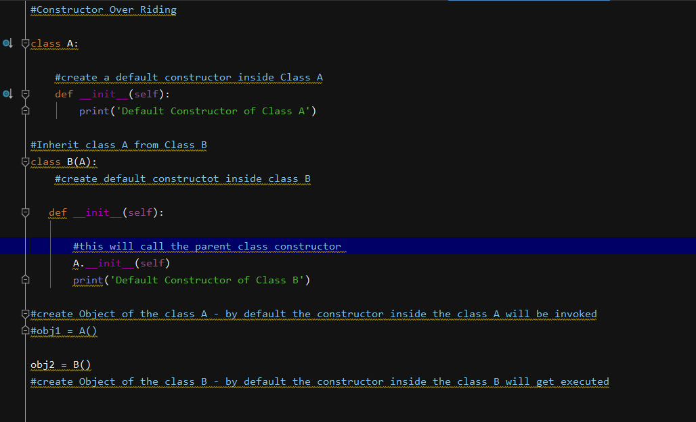

A.init_(self)- this will call the constructor of the Parent class

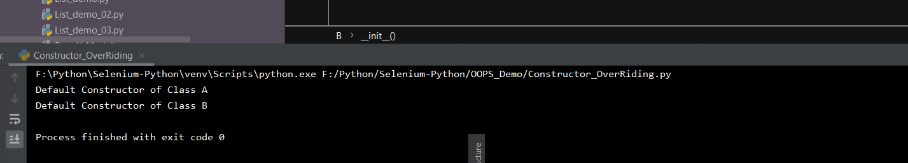

Another way of doing it is by using **the super keyword**

**Super keyword will always represent the constructor or method from the base class**



