**PYTHON – OOPS (Inheritance Concepts)**.

There are 3 types of Inheritance in Python: -

* Single Level
* Multi-Level
* Multiple

Single Level Inheritance

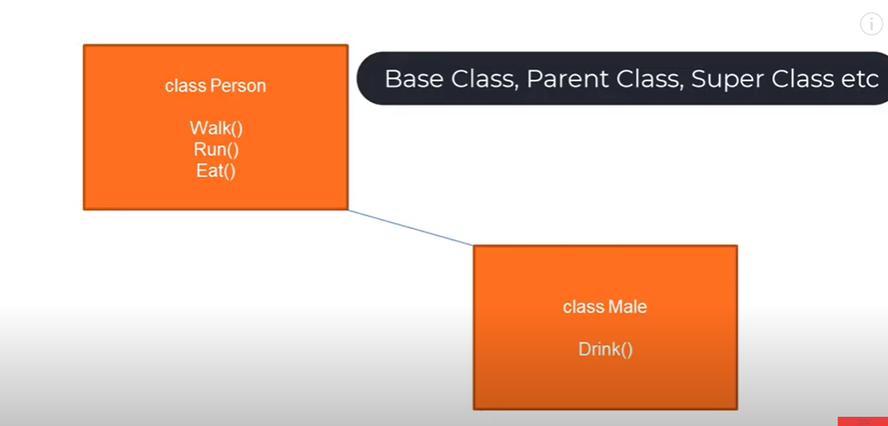

Class Male Wants to extent the Properties of the class Person by inheriting the Properties of the Class Person

Here the **Base Class is Person Class which can be called as Base Class , Parent Class or Super Class**.

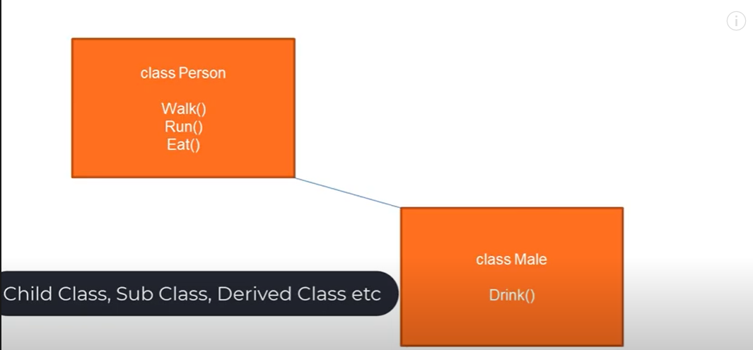

**Class Male can be called as Child Class, Sub Class and Derived Class**

**Now Create two class with one Method Each and create Object of the each class to access the Methods :-**

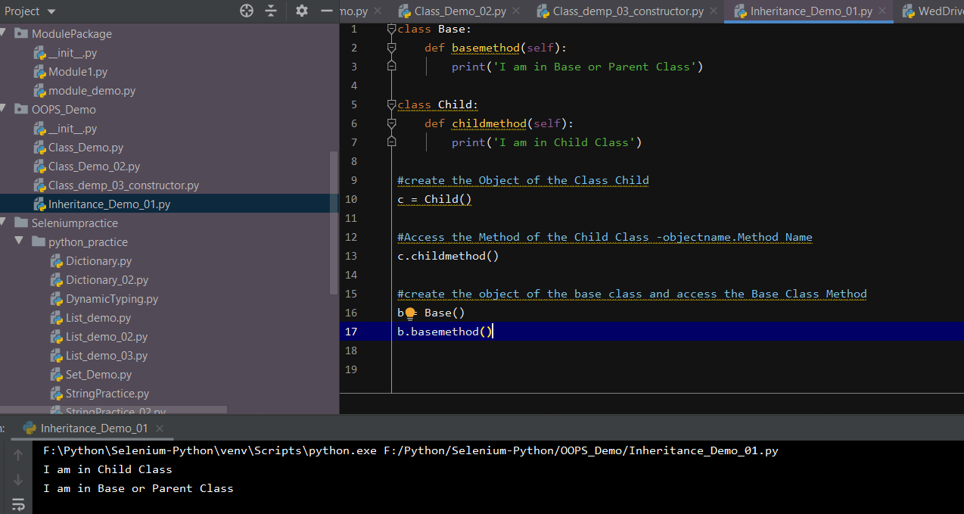

**Here we are creating Object of the Base and Child Class – to access the methods – this we are doing it every time**

**Example of Single Level Inheritance:-**

**Now to Inherit – the Child Class from the Parent Class – following syntax needs to be followed :-**

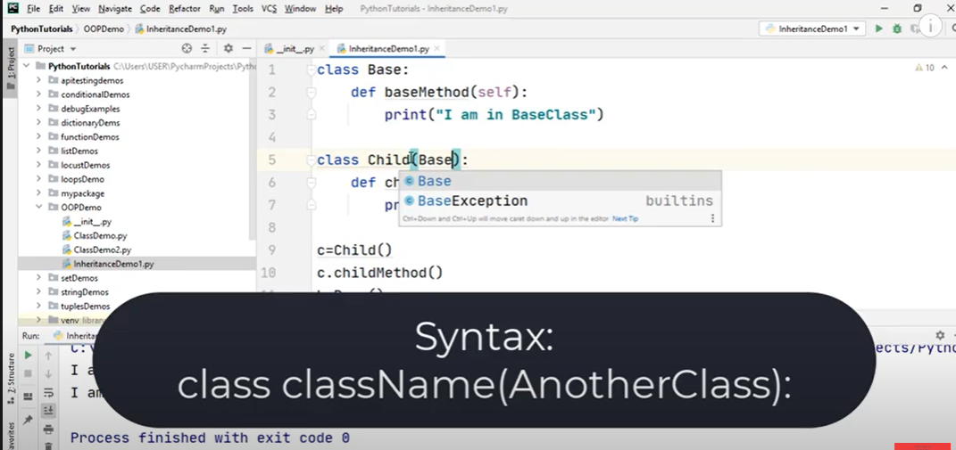

**Once we Inherited the Child Class from the Parent Class – we will be able to access the Parent Class Methods from the Child Class**

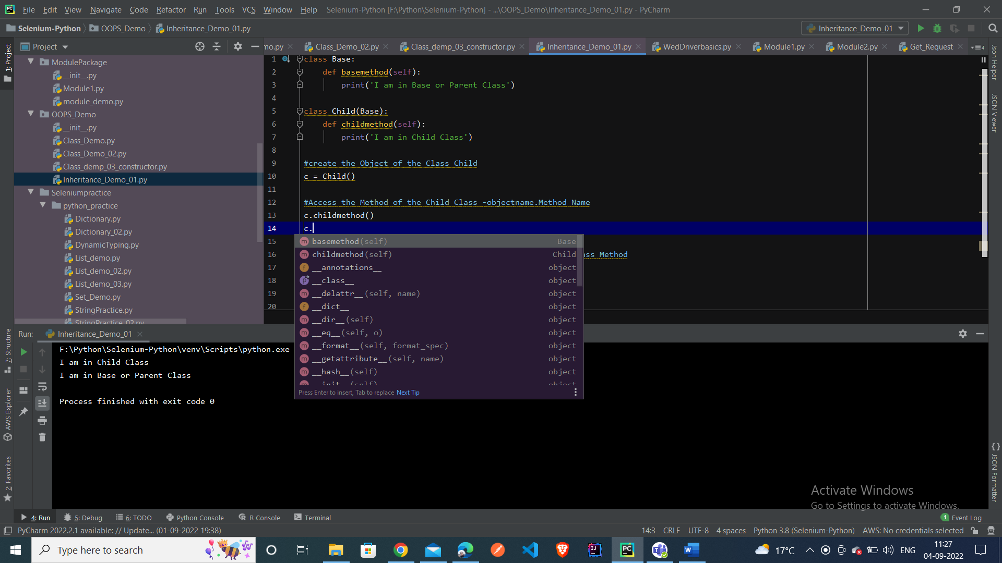

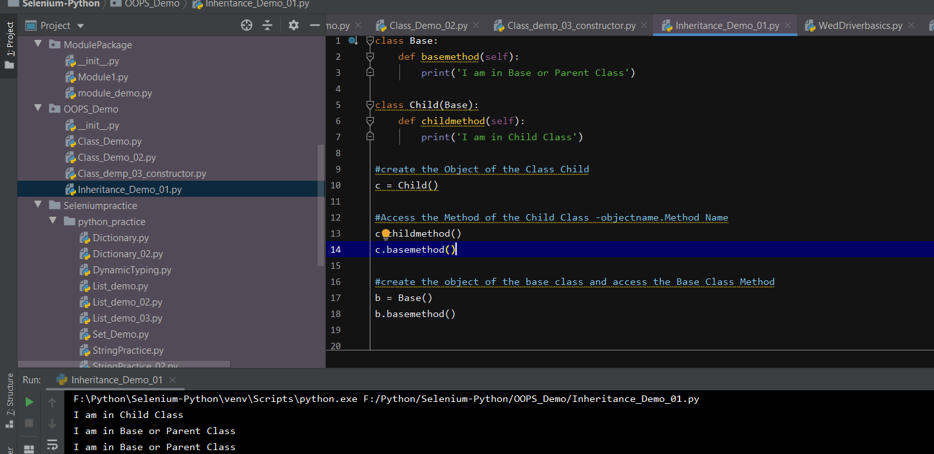

**Now with the c- child Class Object we are able to handle the Parent Class Method and use it**

**In Python – by default each and every class Inherits the Object Class**

**Suppose if we define single variables inside the Base Class and the Parent Class – and when we extend the Child Class with the Base class – we can access both the variables from the Child and Parent Class**

**Multi – Level Inheritance: - Where each class in Python extends series of Class – (multiple classes – it is called Multi Level Inheritance.**

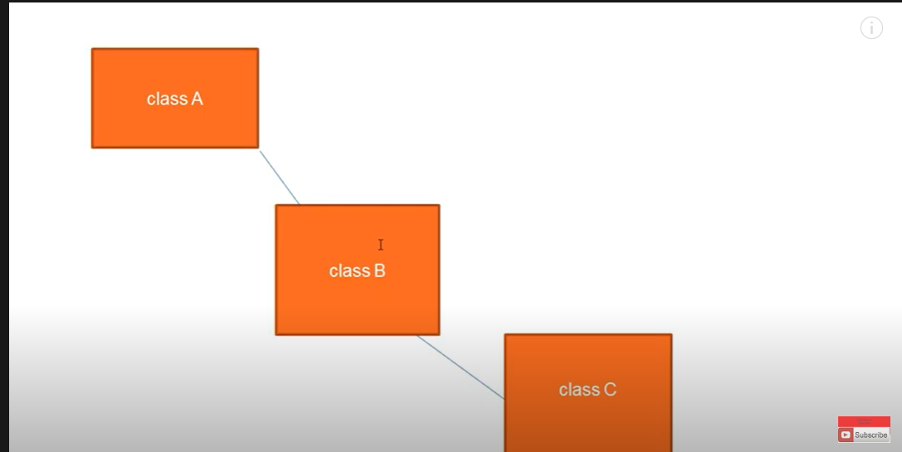

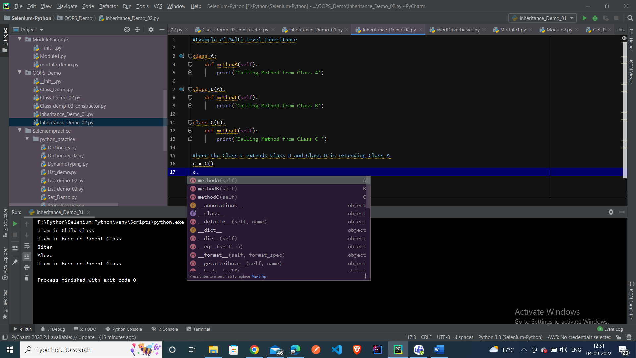

**Here we created 3 Classes – and defined the method in each of the classes**

**Class C extends Class B and Class B extends Class A**

**With the Object of the Class C – we can access all the methods defined in the class A and Class B**

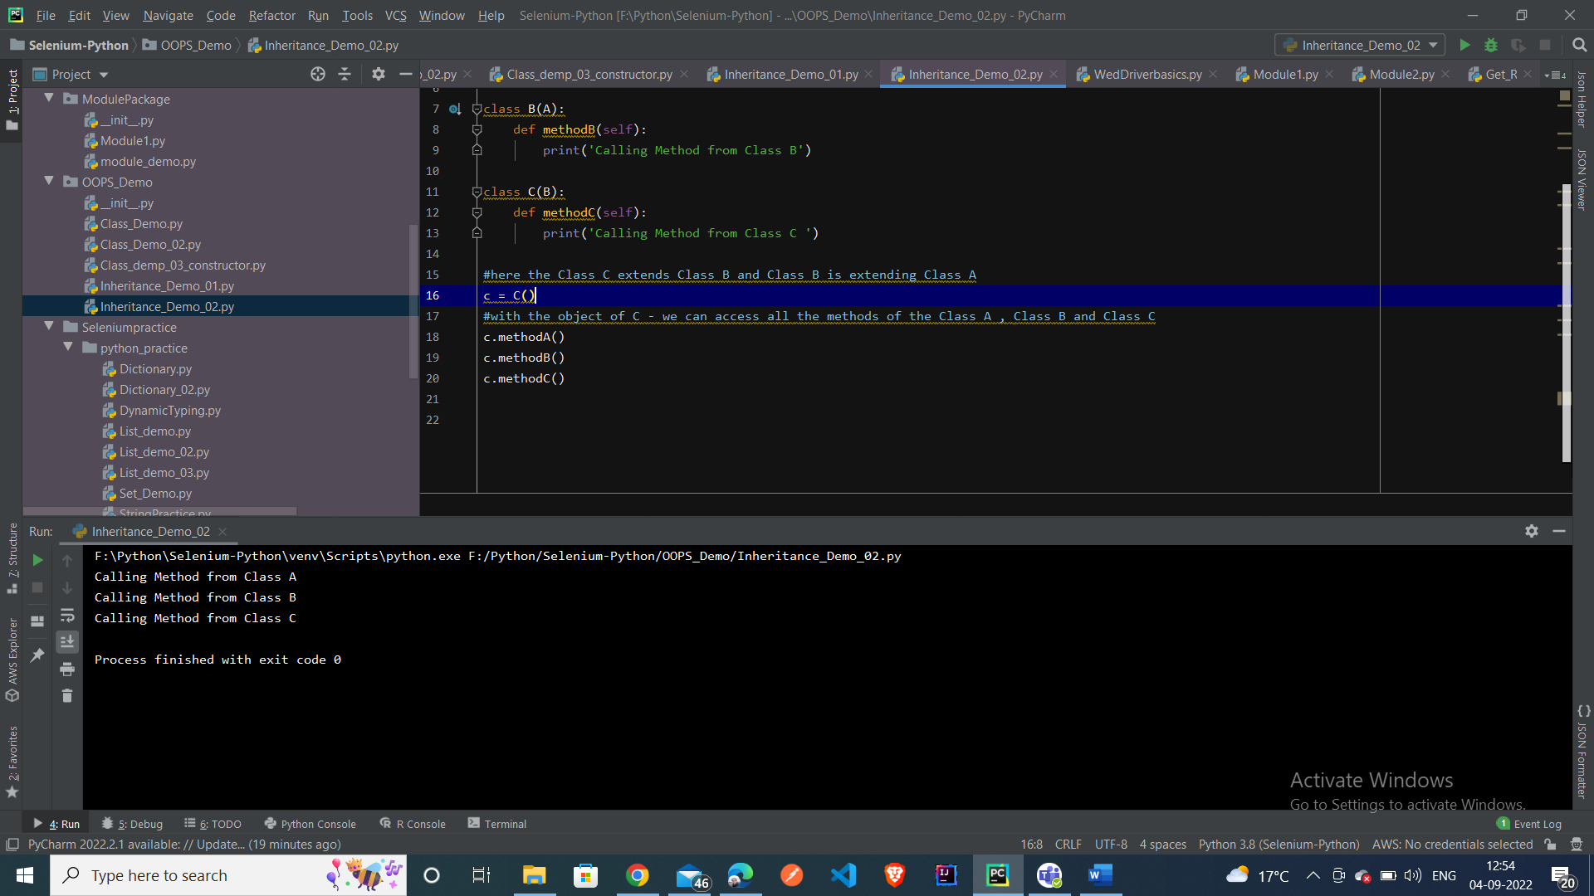

**Beauty of Pycharm – its showing the different class Inheritance**

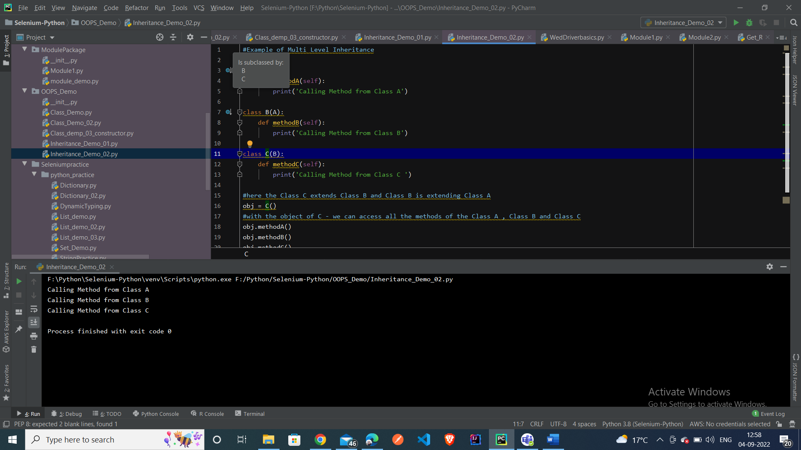

**Method Over -ride – When we try to create same method inside the Parent class and child class and we try to create object of the Child Class and try to access the methods of the child class – it is called Method -Over riding**

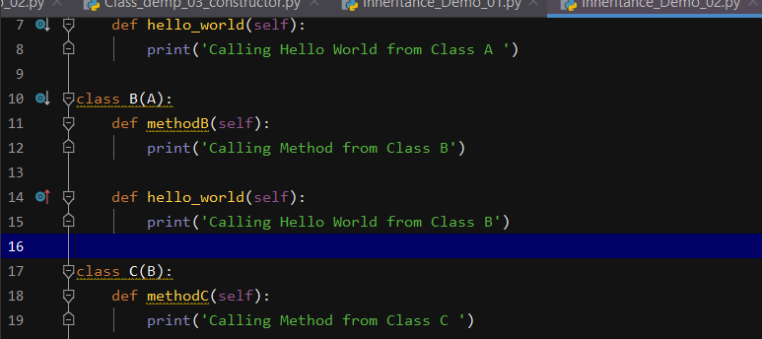

**Here we can see – hello_world method is present in both the classes A and Class B and we are trying to access the methods from the class C –**

**Here the child class Method will get executed**

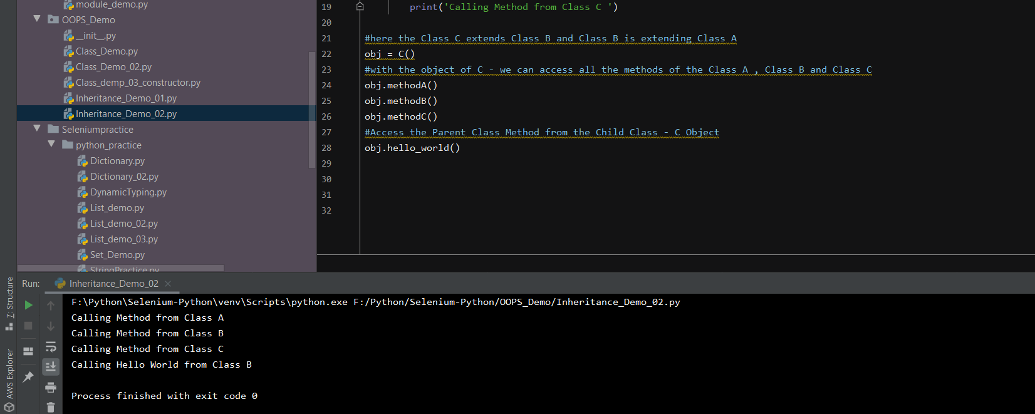

**Example of Multiple Inheritance – When a child class is extended at the same time or parallely by two Parent Class :-**

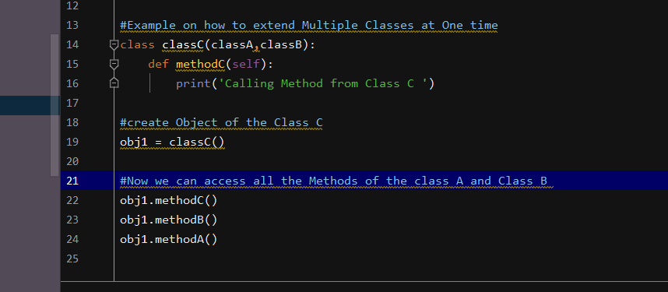

**With this we can extend two classes at one Point of time**

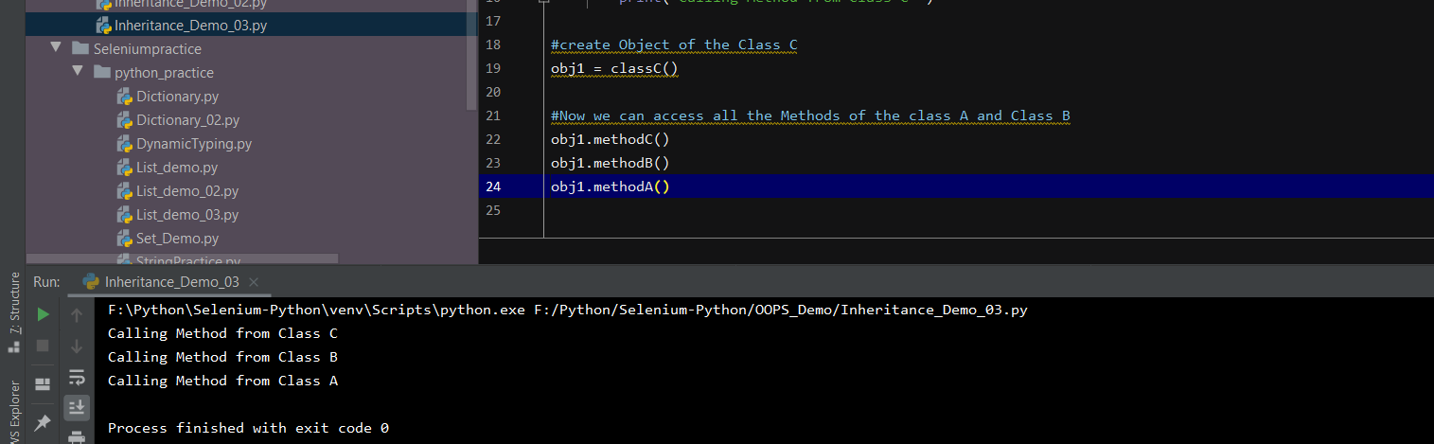

**MRO – Method Resolution Hierarchy – is the order in which Python looks for a method in a hierarchy of class as :-**

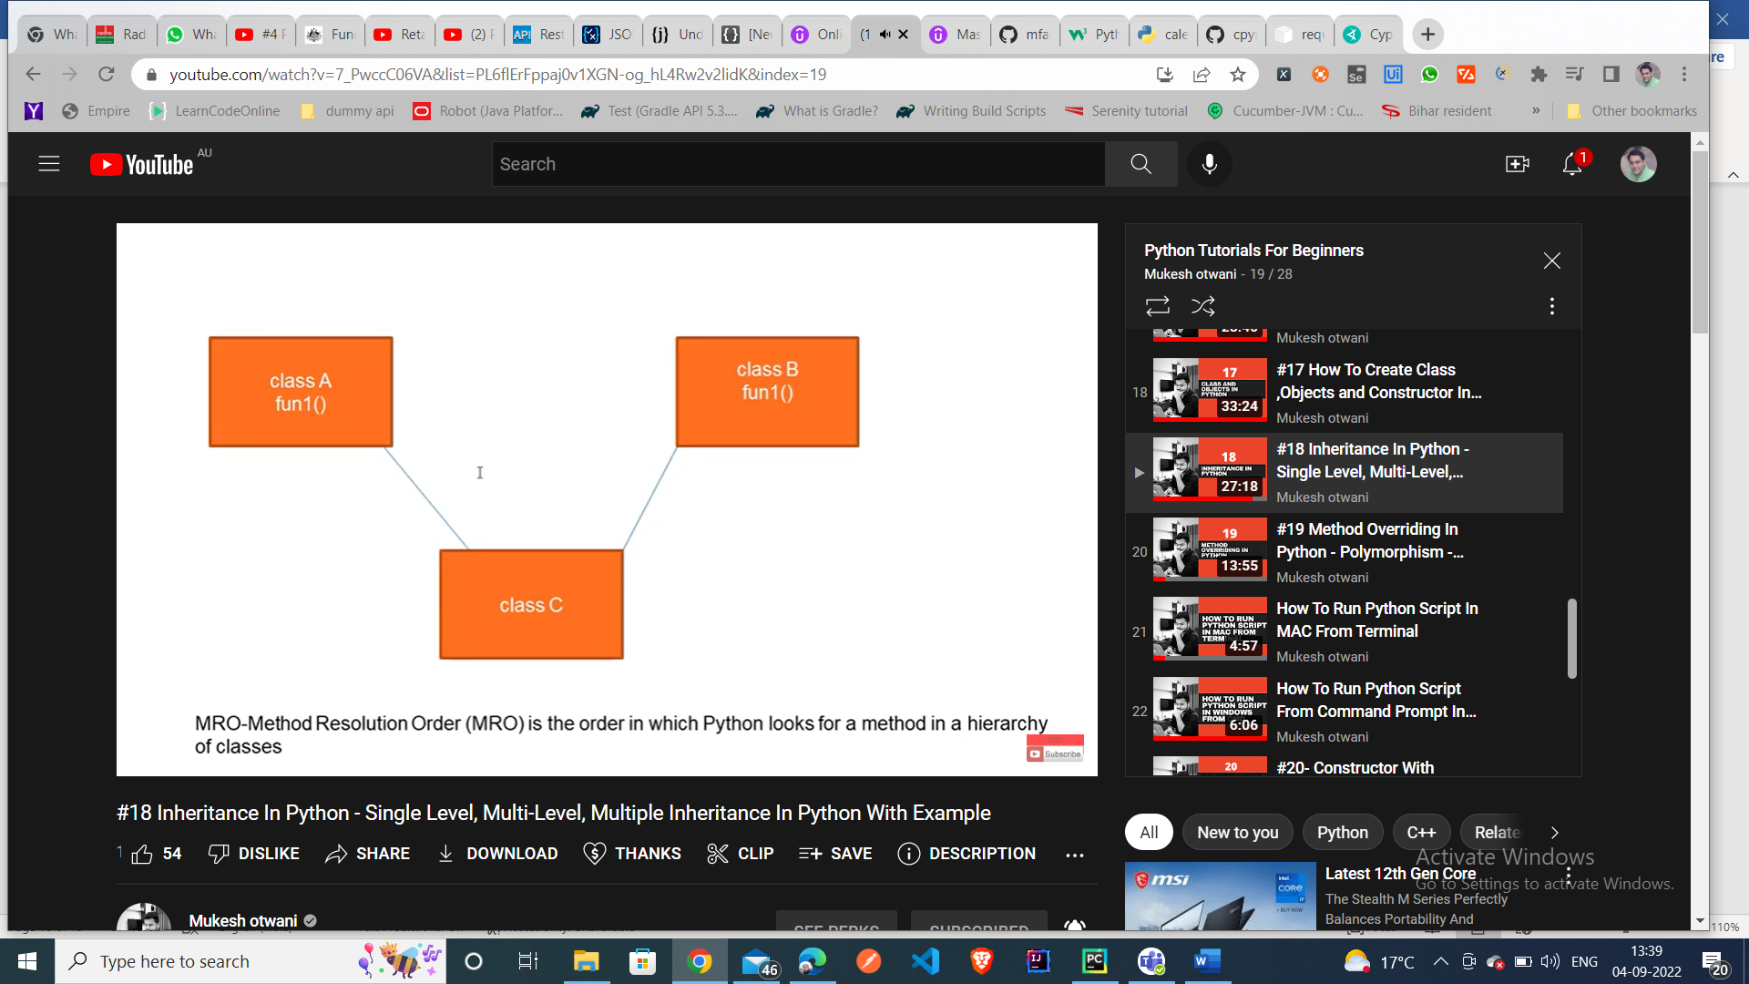

**If we type classC.mro – then it will give the sequence of the class in which order the classes will be called – it will give us the priority order in which the class will get executed**

