Method Overriding Concept –

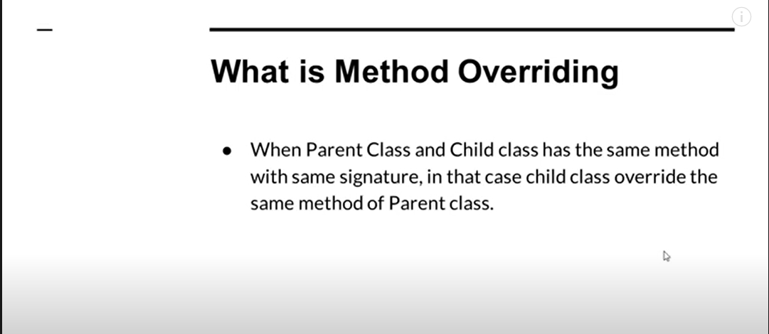

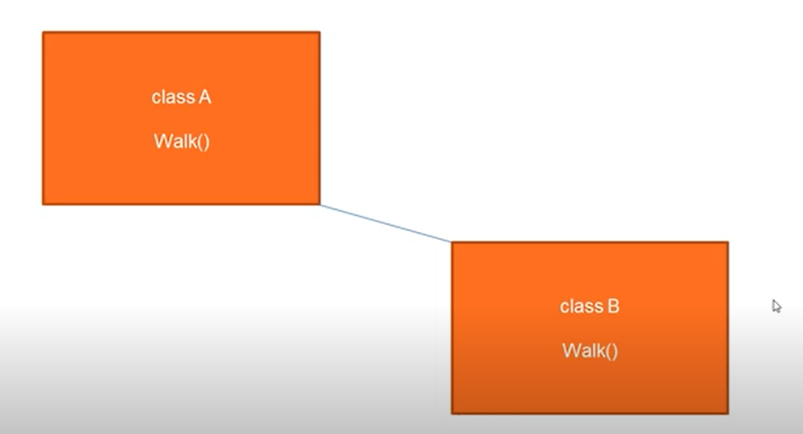

Class A and Class B has the same method – when we create object of the child class – child class method will override the parent class method

Here if we create Object of the Child Class – child class Object will override the Parent class Method

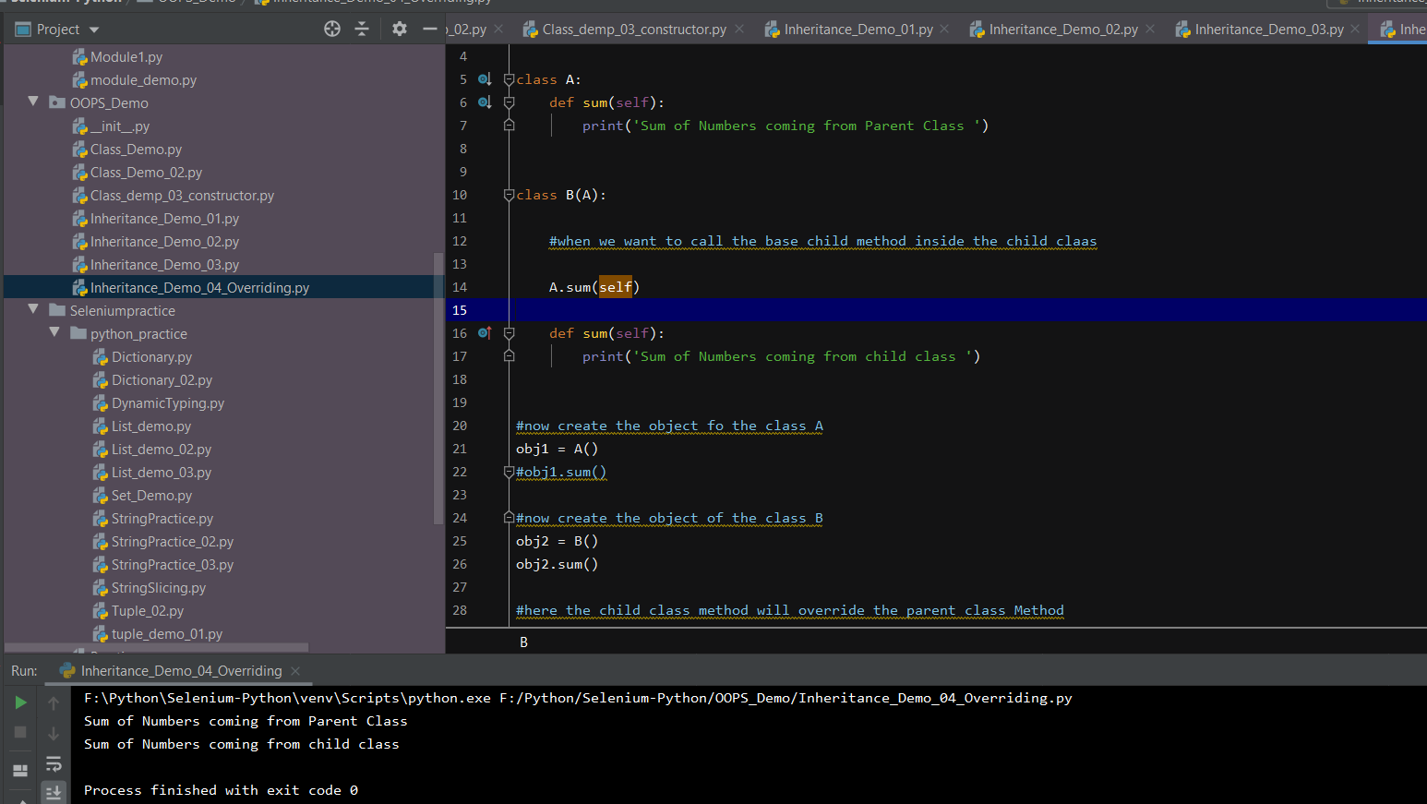

Alternatively, we can call the parent class method – by using the super keyword – which will call the parent class method

