Python Operators: -

Reference Document: - <https://www.w3schools.com/python/python_operators.asp>

Arithmetic Operators:-

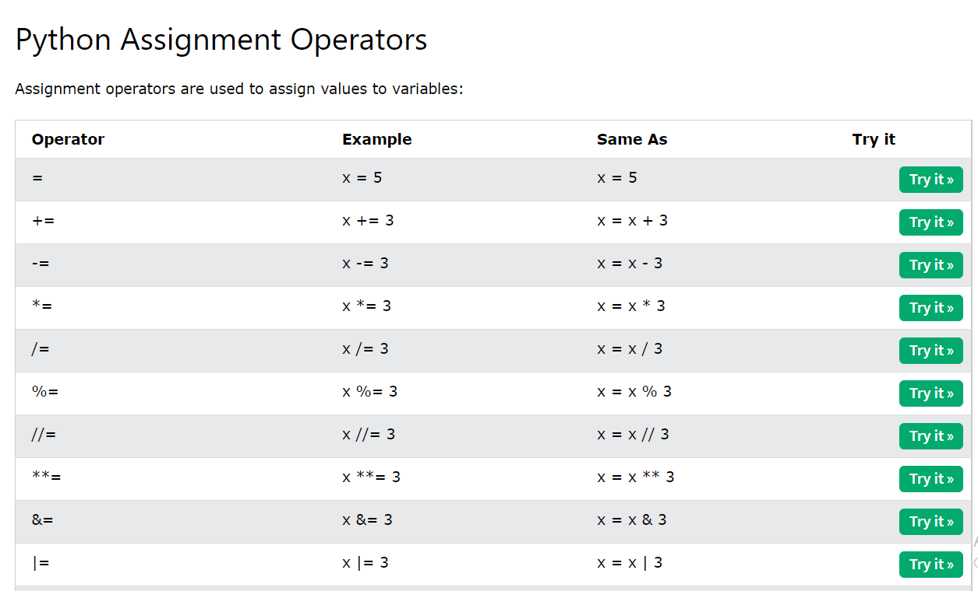

One Example of Not Operator – it will reverse the result –

**Example of Not In Operator**: -

When we want to check the String inside the list which is not present

**Condition – if condition**

**Check the if -else condition**

**If – elif condition and else condition**

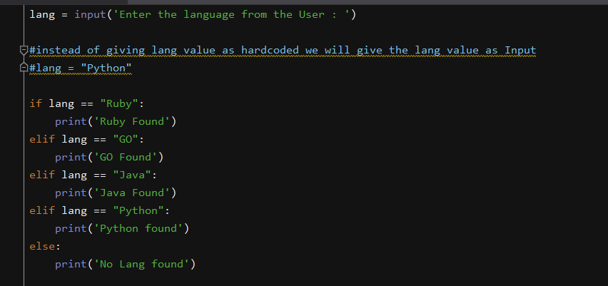

**Multiple – IFS Condition**

**For Loop – Condition with If Condition**

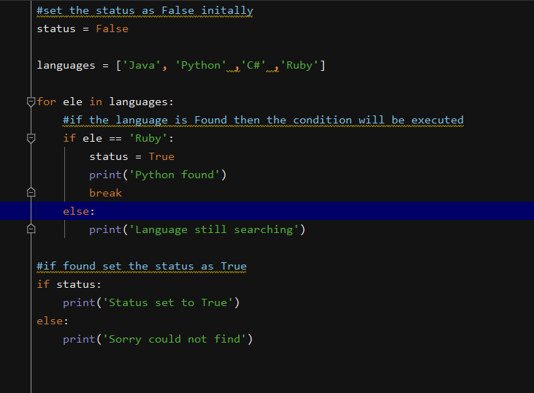

**For Loop :-**

**While Loop**

**It will evaluate the condition – until the condition is evaluated as true**

**Below Example is of While – loop with else condition**

**Break and Continue Statements**

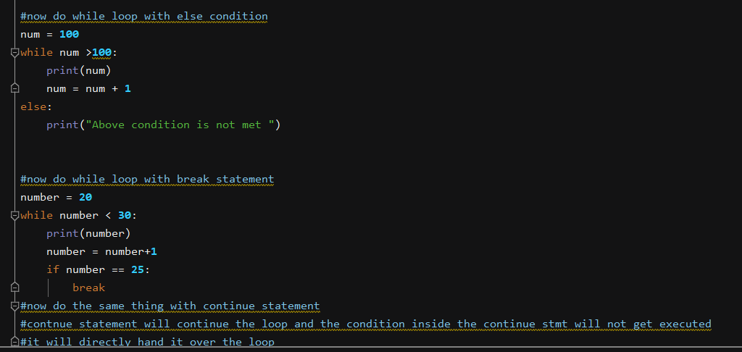

**Continue Statement – with While Loop**

