Python – pytest Tutorial

Pytest is already installed



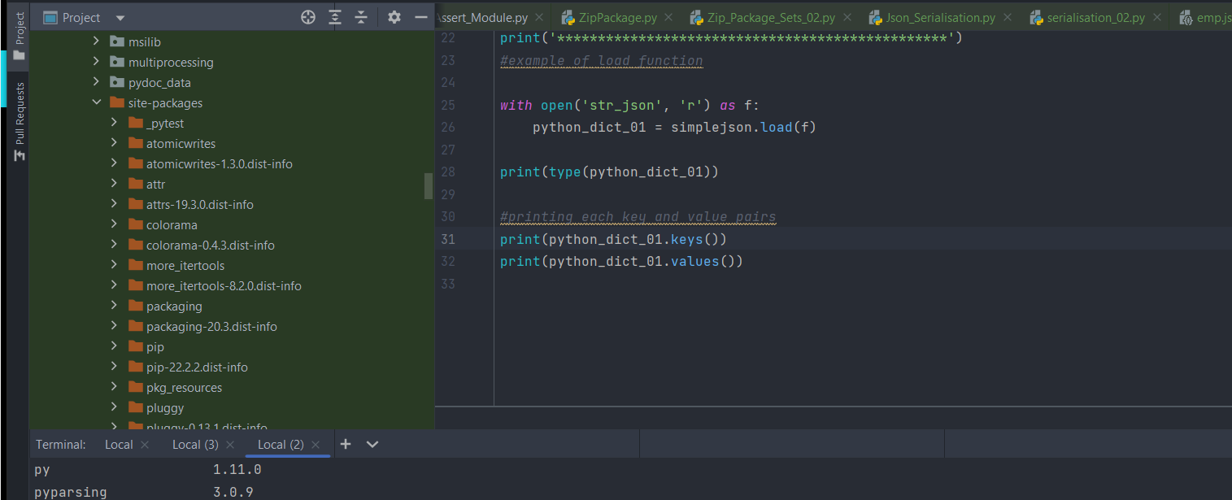

**Pytest module is present under site-packages folder**:-

Define all the methods under the test module: -

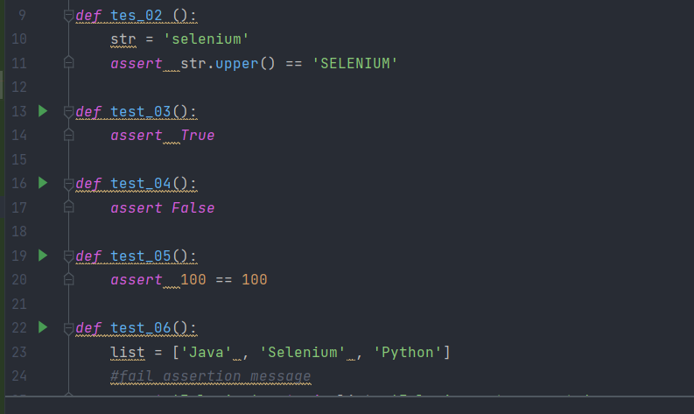

Run the tests – by typing pytest

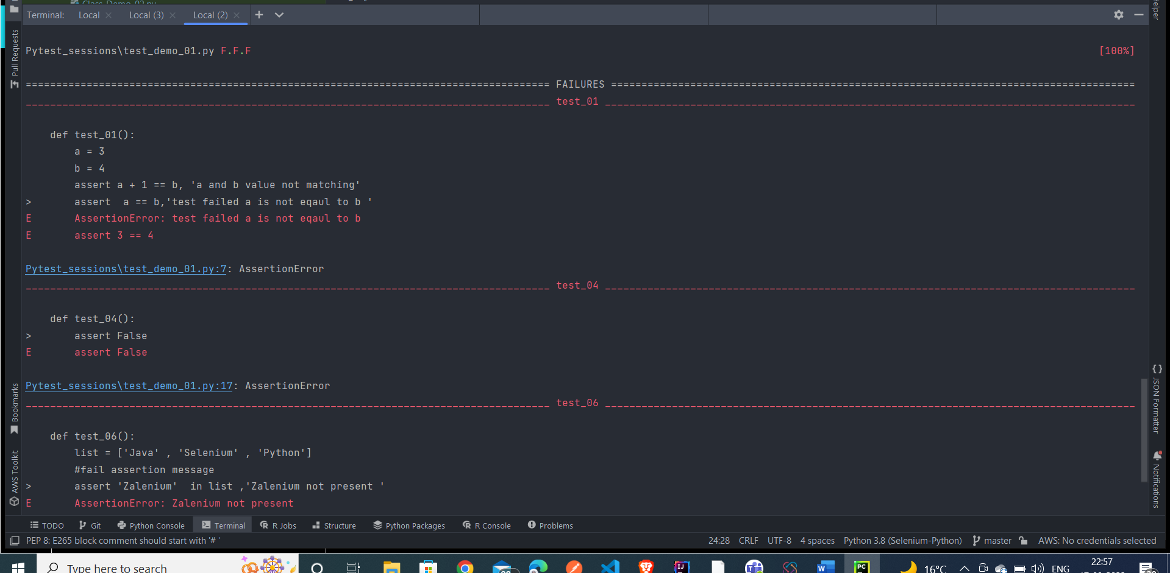

Here F – denotes failed test - **failed test methods will be seen**

Now create **another test – and import the same test methods inside it**

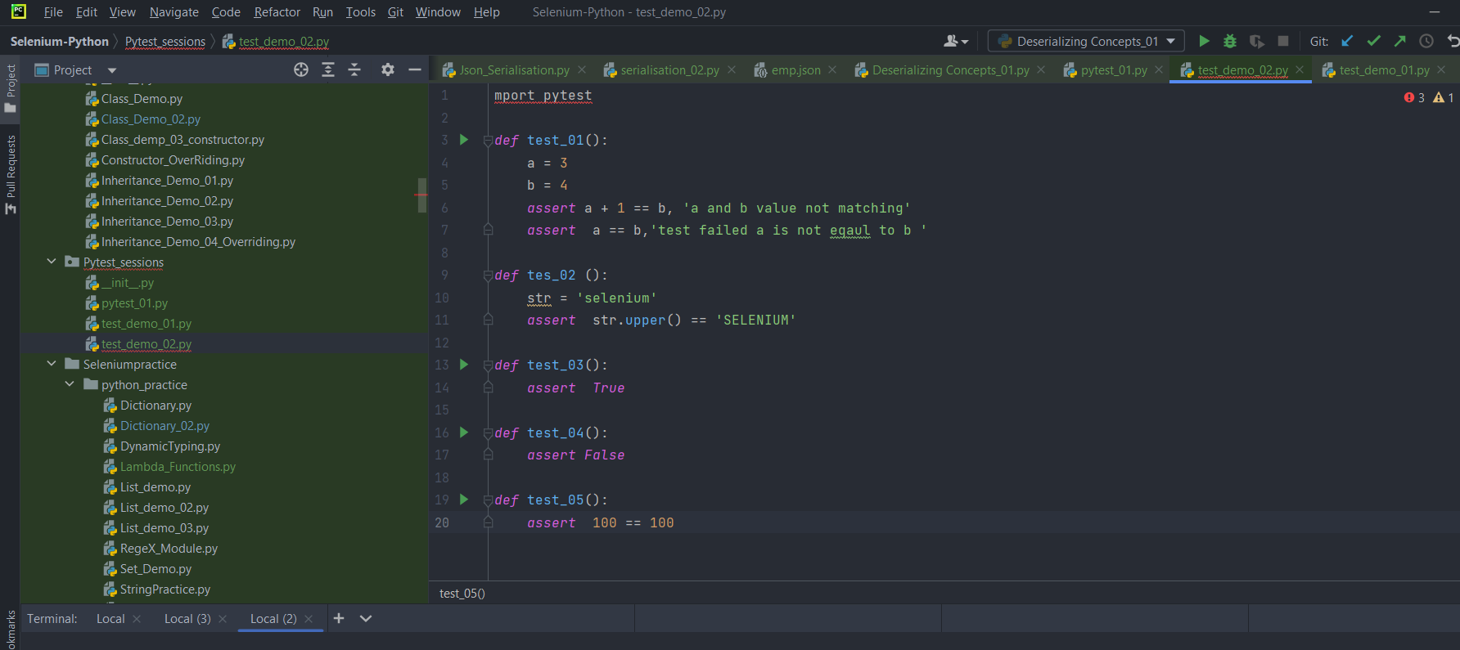

Now if we run the py.test – it will show the failed methods in the assertion page

Py.test – it will execute all the methods

If we want to execute specific module, then we need to mention the package name

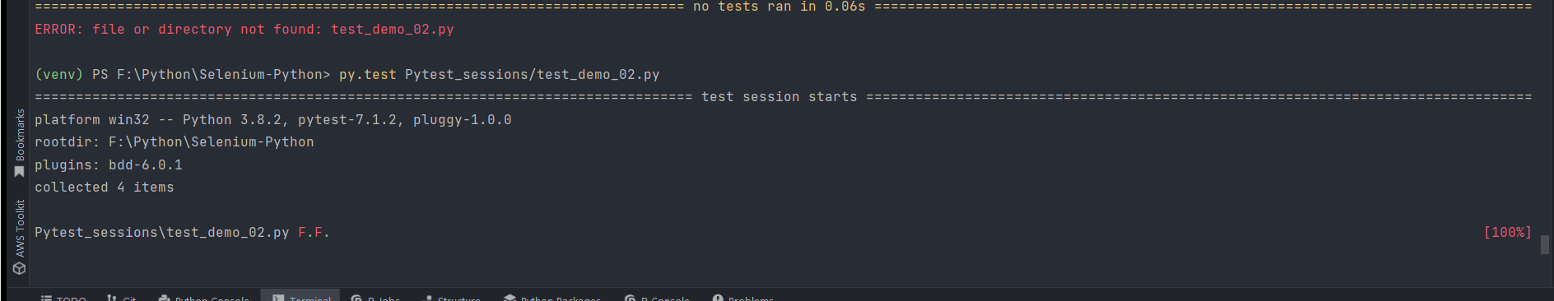

Add two methods

