Python – Read Excel using the Pandas Library

Install Pandas Library: -

Install numpy Library: -

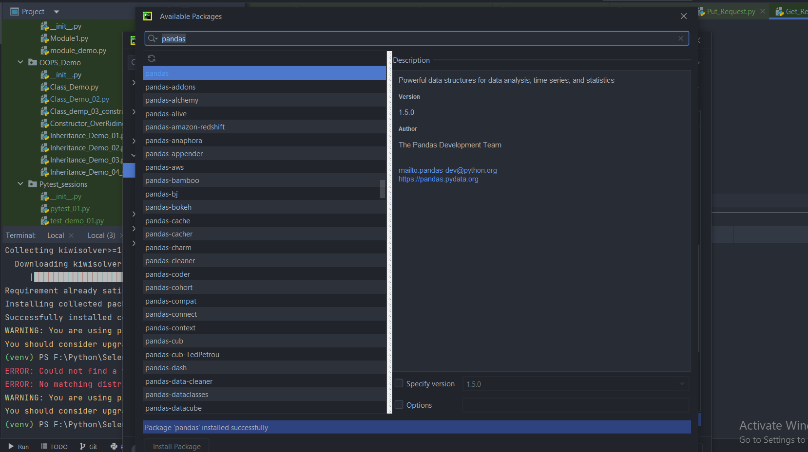

Numpy Installed successfully

Install the matplotlib library package

Try to use **pandas – library – dataset function**

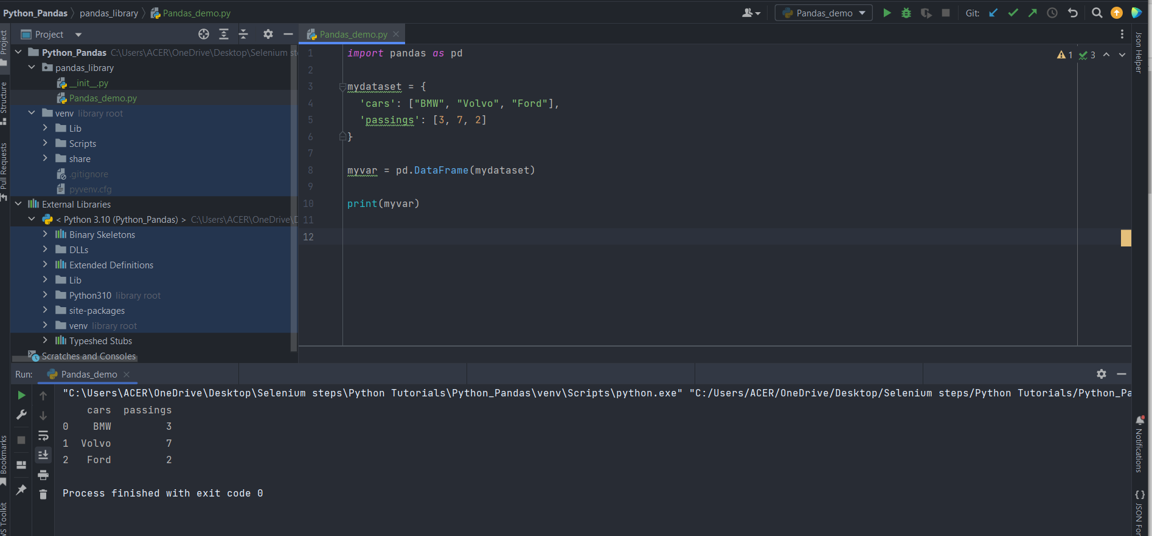

To get the pandas version

Series - A Pandas Series is like a column in a table.

It is a one-dimensional array holding data of any type.

Output:-

To read the json and print it as data frame

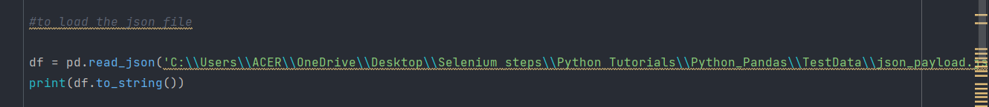

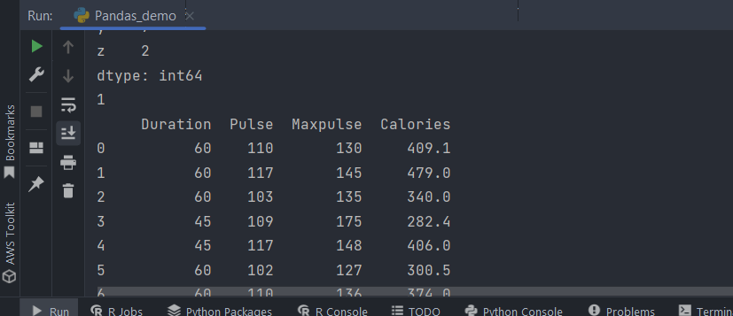

It will print the json into the Data Frame

**Let’s load the JSON as Dictionary Object**

Output: -

**Python – Pandas Basics** for reading the excel: -

**Link for more details**

<https://pythonbasics.org/read-excel/>

If we try to read the excel without installing the xlrd package we will be getting error:-

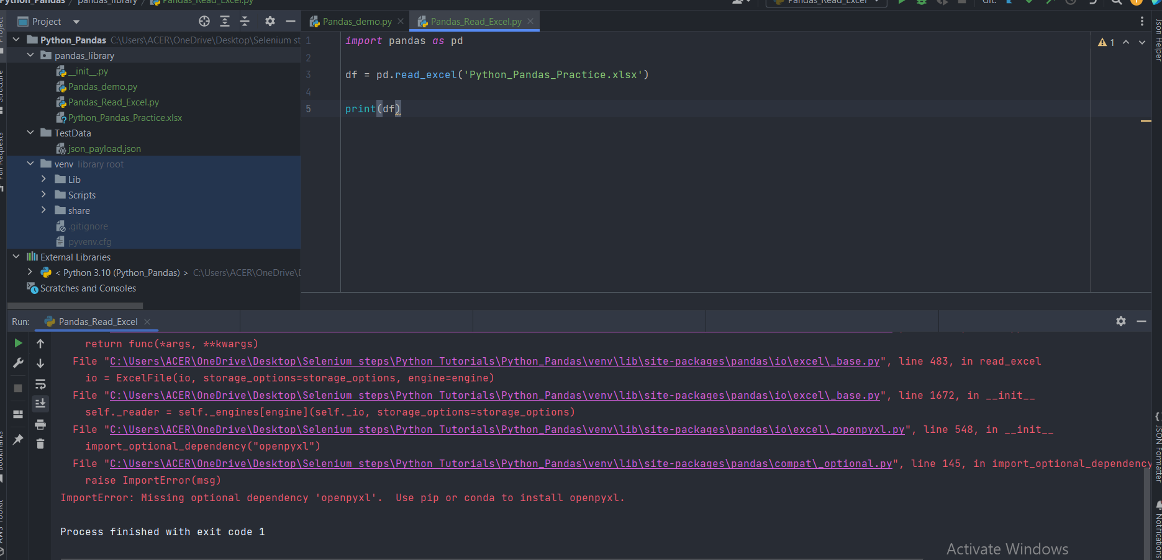

**For reading the excel with pandas** – **xlrd library should be installed**

Xlrd package installed successfully

After the xlrd package, install **the openpyxl library too for reading the excel**

Now with the help of **read excel method – we can read the excel file easily**

Let’s give the sheet name – and read the specific sheet details

Output – It will print **the sheet as data frame**

Now lets get the value of the city column

Output:-

Let’s try to get the value of the city – Barbados – we just need to pass the index value as 01

Output: -

Load All the Sheets – in one go

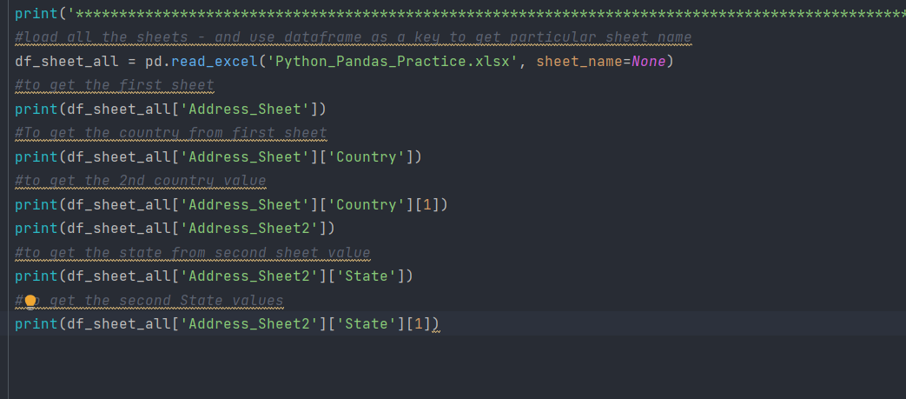

Get all the values – Output

**Write Excel Data – with the help of Pandas Data Frames**

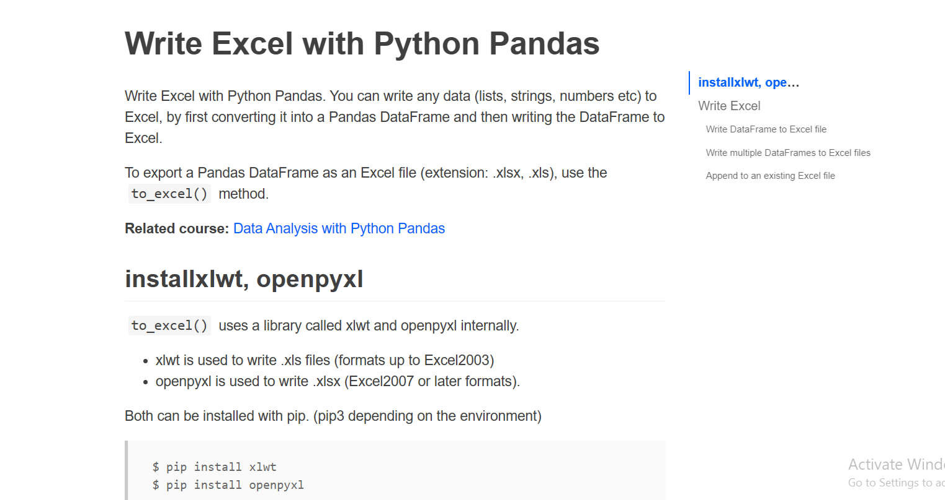

Pass the data which we want to **write as Data Frame and specify the column names which we want to write**

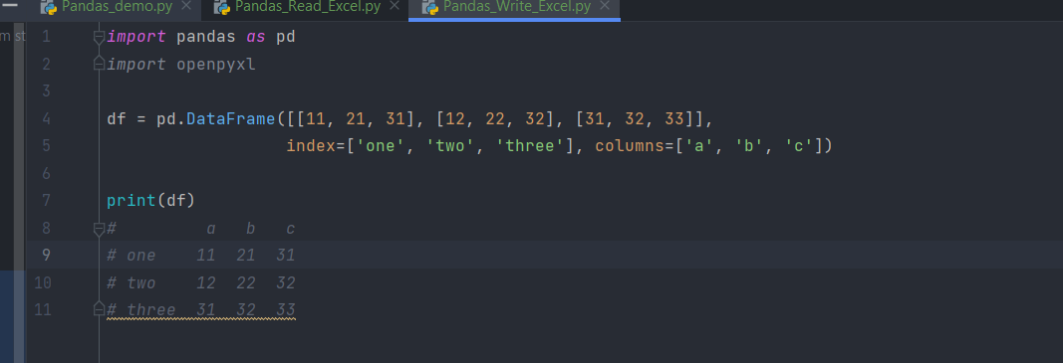

Output :-

Let’s write the particular data Frame inside the Excel using to_excel method

Df -has so many methods to play with – to convert to excel , json ,csv

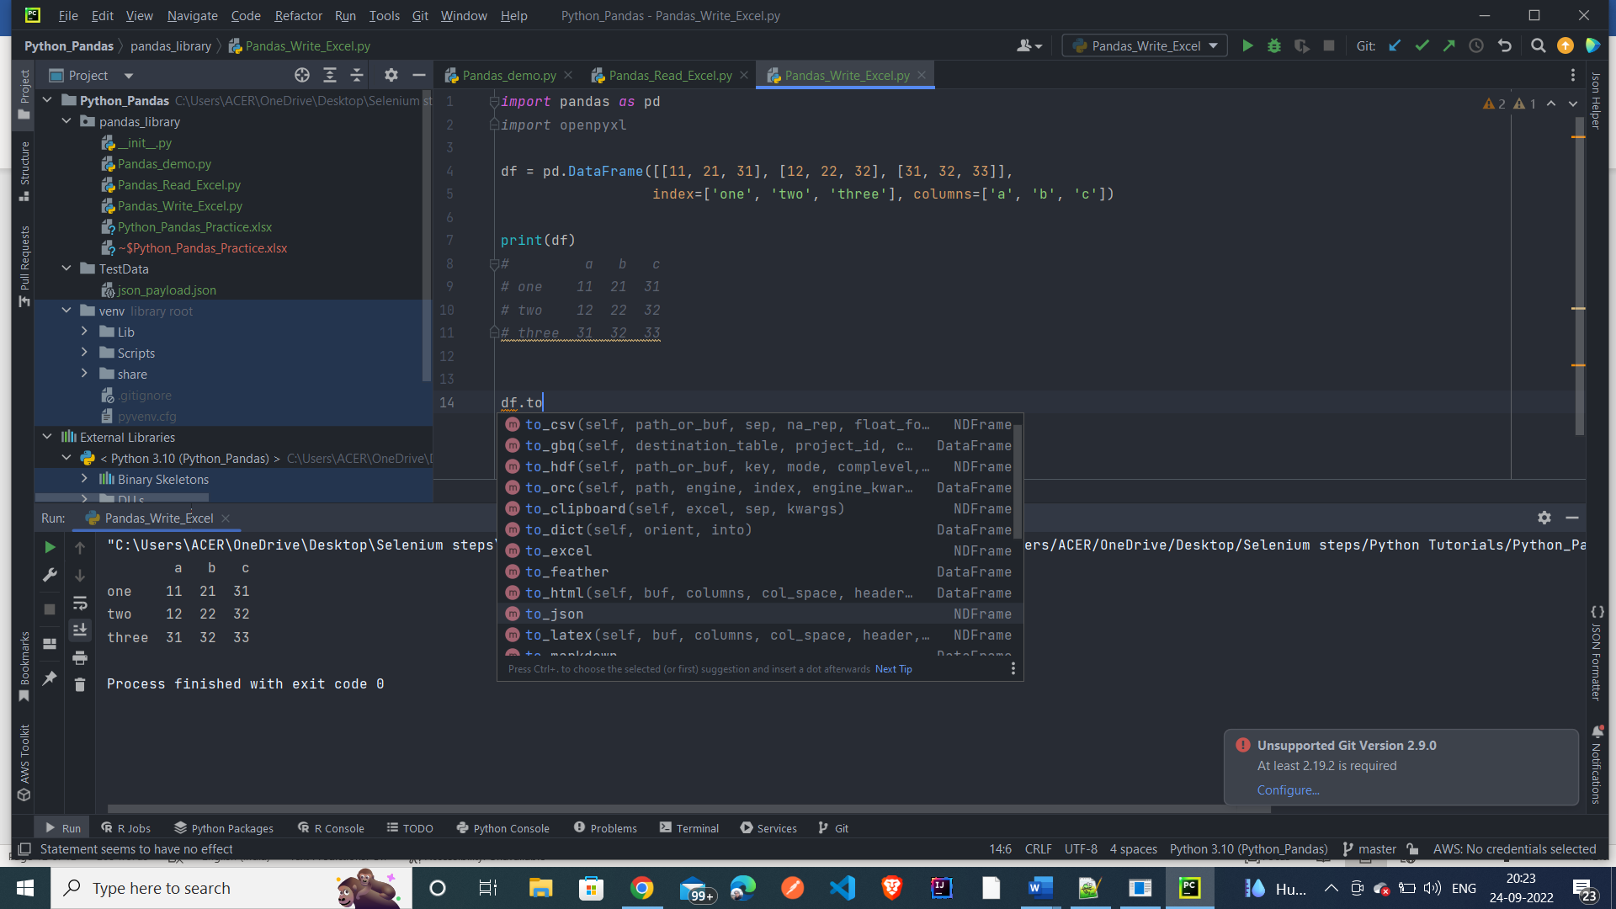

This new excel will be saved inside the package name

New Excel file got created

We can see the new excel is having the Sheet name updated – having the new values updated

Lets create another df -data frame and write it into another sheet

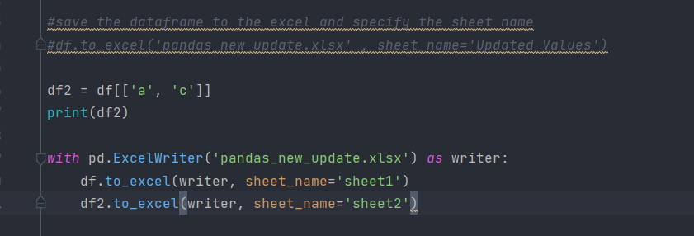

With block can also be used to write the DataFrames into multiples Sheets – it will write into the different sheets

We can see two different sheet is created with Sheet 1 and Sheet 2 having different values

Append to an existing file

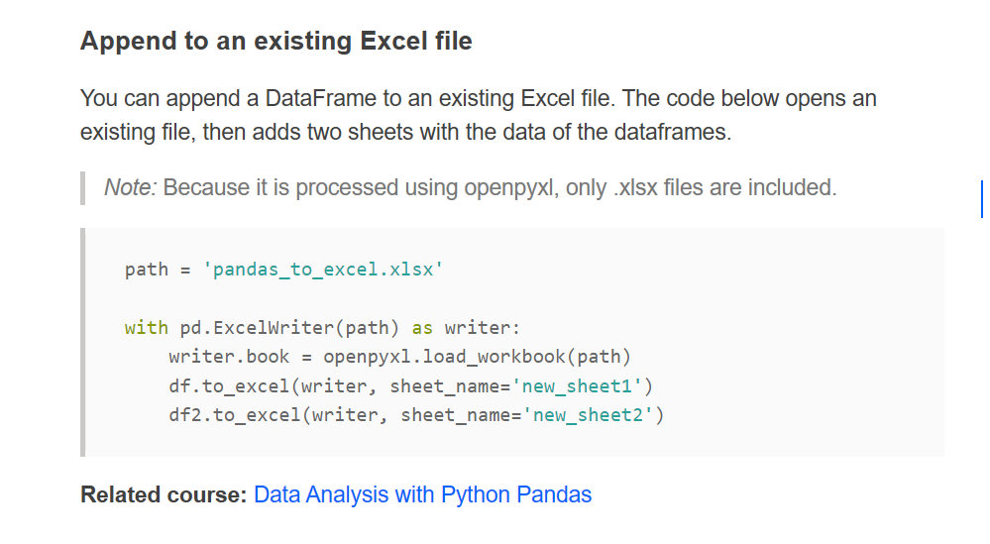

Pandas – Web Scrapping

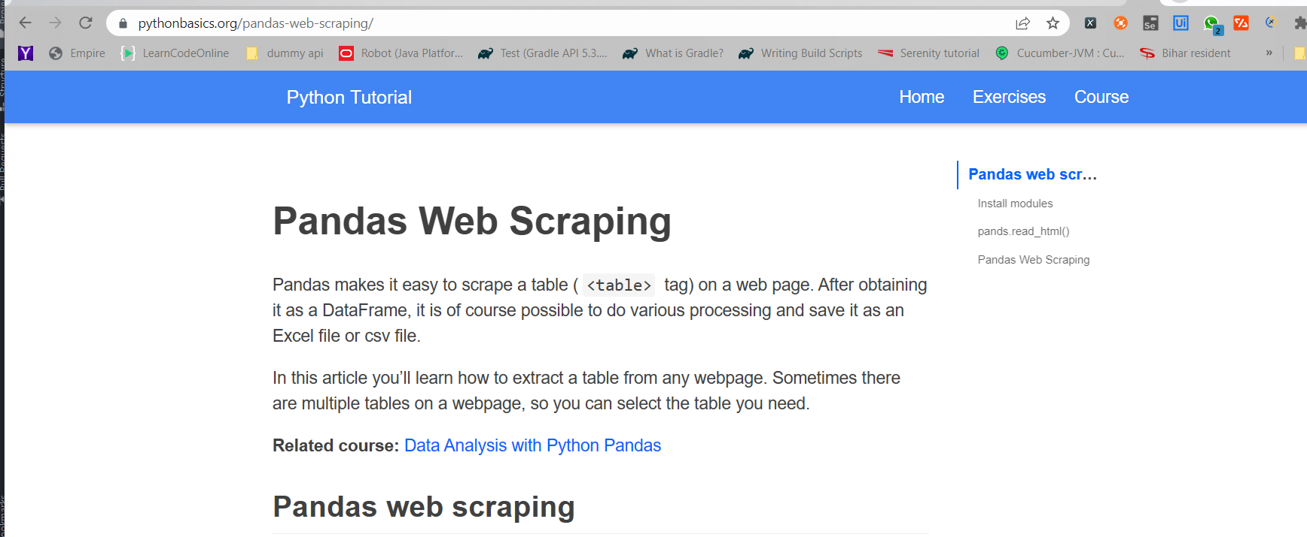

Install the following library

pip install lxml html5lib beautifulsoup4

It will get the webtable extract from the url

We can save it inside the excel

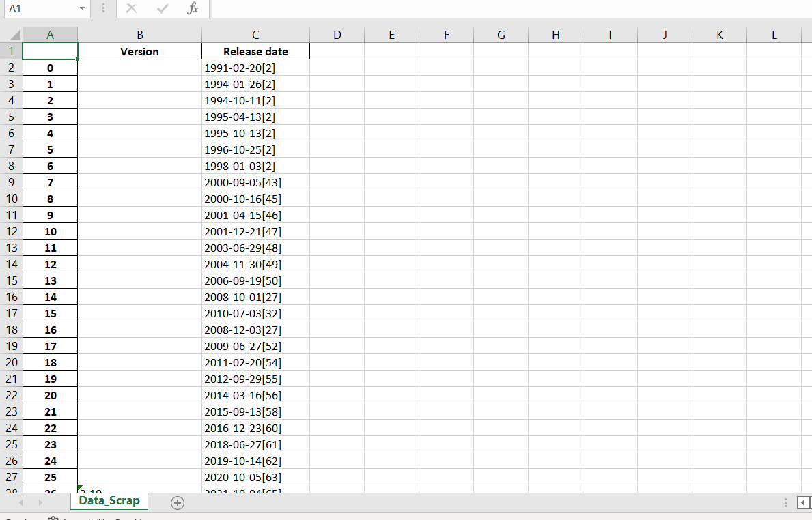

It saved inside the Excel

Lets load the json from the url and save it inside the excel

The Response will be saved inside the json file

After reading the json – save it inside the csv file

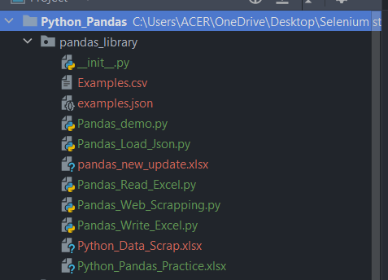

Csv file is created

**Pandas – Plot for creating the graphs**

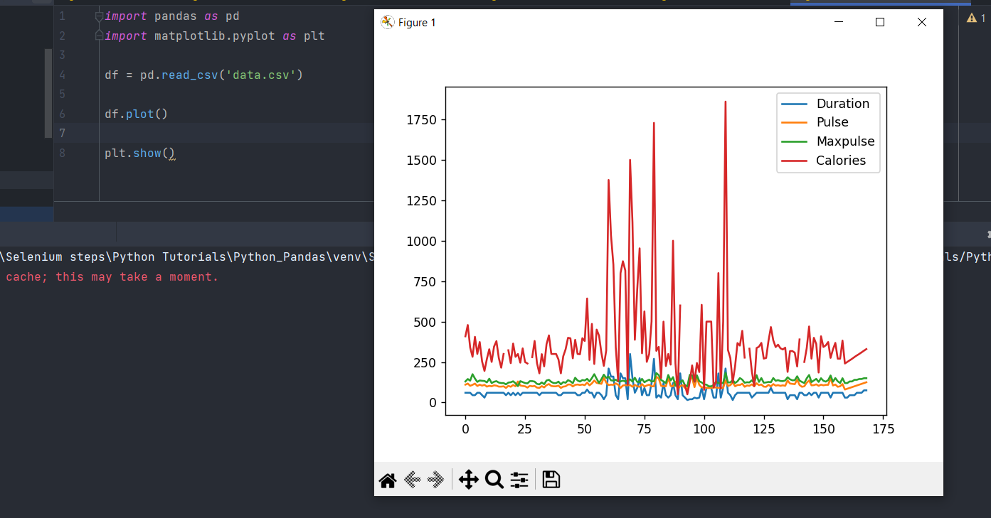

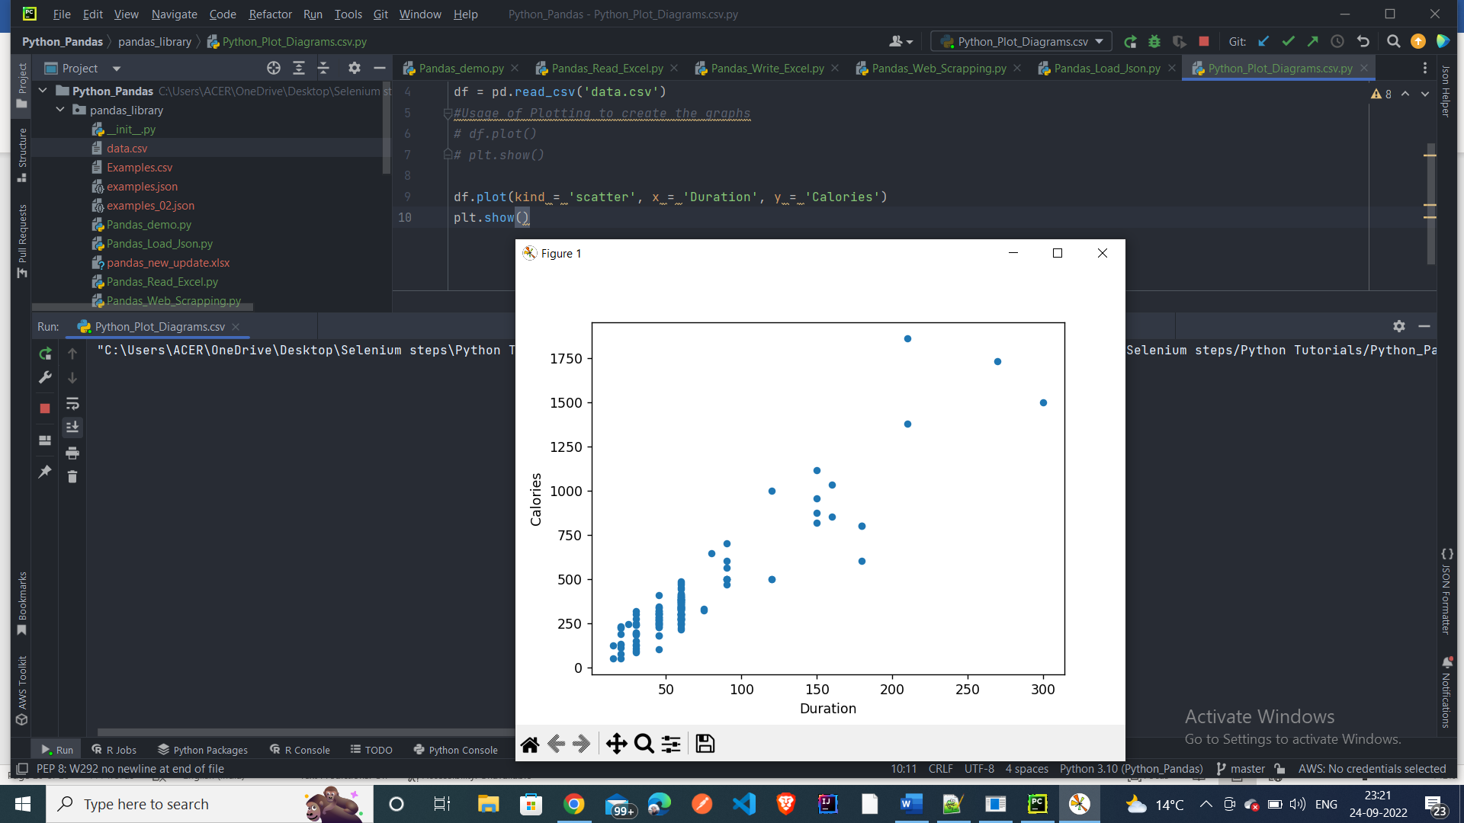

Create the bar graph

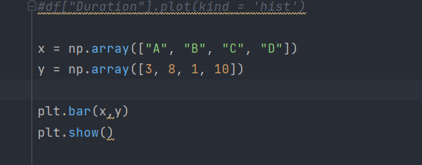

Output :-

**Pandas – Data Analysis**: -

Let’s import the csv using the pandas library: -

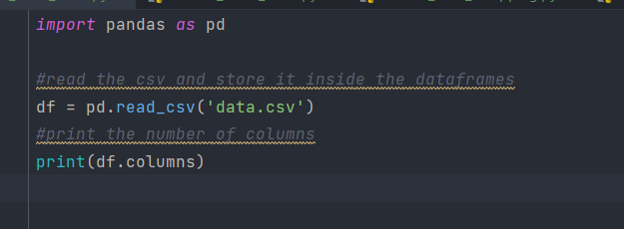

Print the columns – **column names**

To have the data info

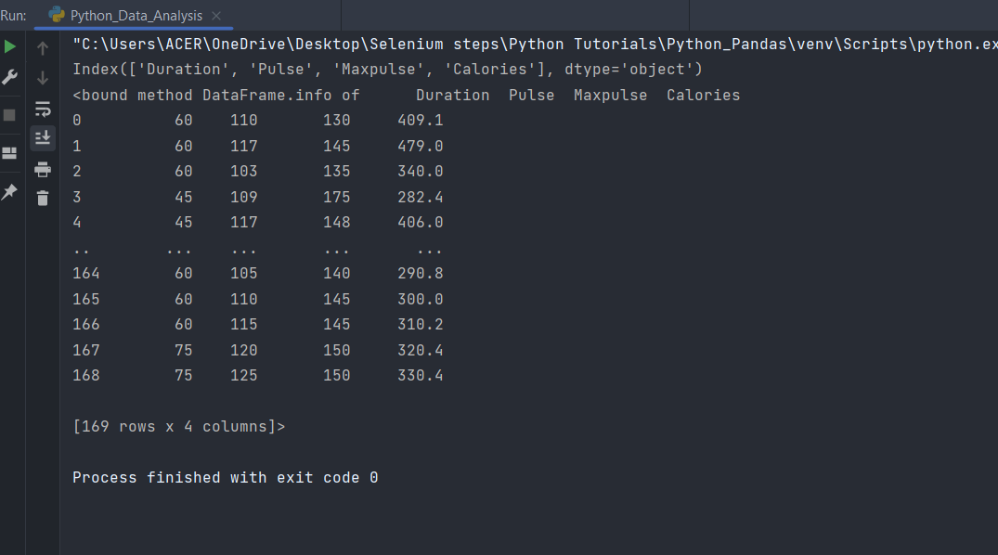

**Describe method** will talk about the max, mean, count of the data

Output: -

Group by – **get the max value of the column**

Output

**CSV File Output**: -

Max Calories with respect to Pulse is printed as output

To get the occurrence of particular value from the column

Output: -

Inside this Output if we want to get the Calories value – 390

Output

