Python – Serialisation and Deserialization concepts

Python Serialisation Concepts: -

Serialisation Concepts: -

**Convert Python Dictionary Object to JSON String**is called Serialisation.

**Converting JSON Object to Python Dictionary Object** is called Deserialization.

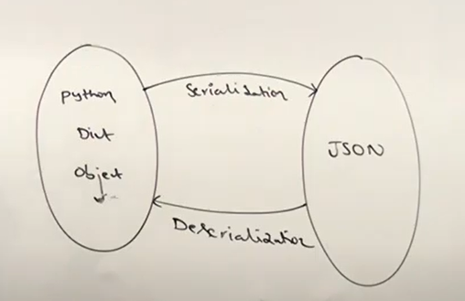

**SimpleJSONPackage Instalaltion** :-

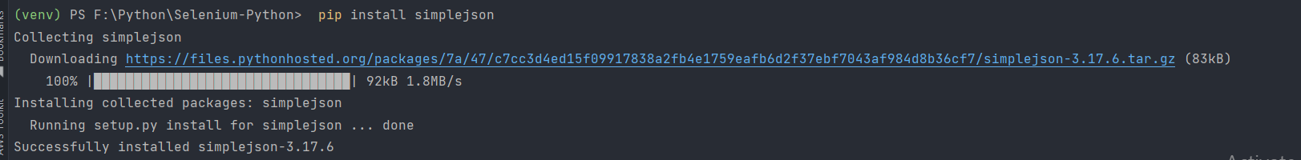

For doing **Serialisation** in Python – JSON Module contains **two functions – dumps() and dump() – method**.

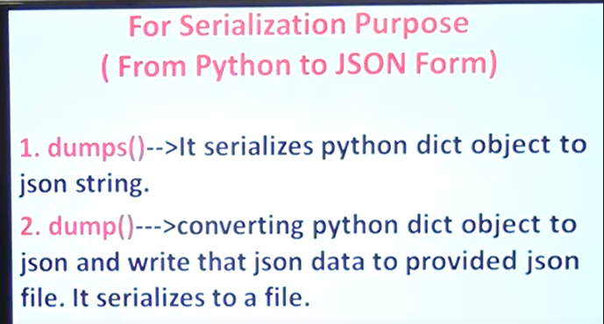

For doing **Deserialization** in Python – JSON Module contains **two functions – loads () and load() method**.

Serialisation – **dumps() – method** = dumps method is used to convert the **Python Dictionary Object to Json String** .

Serialisation – **dump – method** = dump method is used to convert the **Python Dictionary Object to File System Object**. – (to write the Python Dict Object to File System – to external file).

Deserialization – loads () method is there which **converts Json String to Python Doctionary Object**.

Deserialization – load() methos is used to **convert from File – to Python Dictionary Object**.

Python – **Serialisation concept** –

Create a dictionary object: -

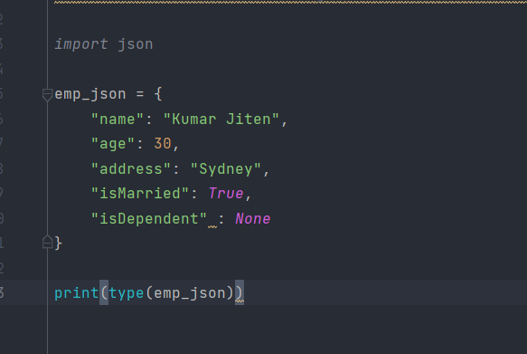

Converting **Python Dict Object to String Object**: -

With the help **of loads method we can easily achieve it**:-

We can see the values in **the dict object – for Boolean value True is changed to true – and None is changed to null – for empty payload value**

Now if we want the output with more **spaces – with indent = 4 spaces**:-

**Output** = It will give **proper format json response with the spaces defined**: -

Now if we give one property – sorted keys value as true – it will sort the JSON Key object :-

Output :- It is sorted alphabetically ordered

With the help of **load function** – we can **convert python dict object to string** and store it inside some specific file: -

Output: - we can see that python dict object to file – inside the file this json value will get stored :-

Emp.json file is created with proper json values

**Deserialization Concepts**: -

Convert **the Json Response to Python Dict Object**: -

With the help **of loads method we can easily convert the Json Response to the Python Dict Object**

Output :-

We can see the different is Married – true is changed to Boolean value True as per the Dict object and null is changed to None for empty values

With the help of load function, we can load the string json from external file – stored and then convert to dictionary object

Output :-

