**Python – Exception Handling Tutorial**: -

<https://docs.python.org/3/tutorial/errors.html?highlight=errors%20exceptions>

**Errors and Exceptions**: -

**Exceptions**: - Errors detected during **execution are called *exceptions* and are not unconditionally fatal: you will soon learn how to handle them in Python programs**. Most exceptions are not handled by programs, however, and result in error messages as shown here:

All Exceptions in calls is **part of the Main – Exceptions class** and the **Exception class is subclass or child class of Base Exception class**.

Let’s try out the examples: -

Open the file in the Read Only Mode using the **open function available default**: -

By **default, r is for the reading the file content**: -

Read **the file line by line – and print the result**: -

Now let’s give the invalid file name – then it will throw an exception error saying that file not found Exception: -

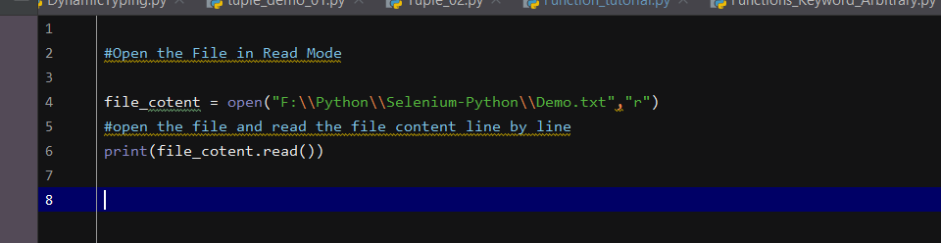

**Exception** – **FileNotFoundError – Exception is being seen**.

Now let’s handle the exception by **creating a try -except block and and handle the exception using the except keyword**: -

Now if we **give the wrong path – exception will be handled, and it will print the statement under the except block**: -

Now let’s try to **catch the type of exception – which we want to catch and print the name of the Exception**: -

We are creating **an object err and trying to store the exception inside the err object**: -

Output: - This will print the **exception and show the type of the Exception as Err No 2 – File not found**: -

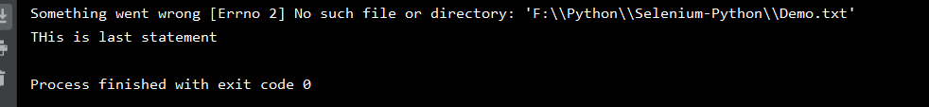

Now let’s try another example –

Let’s **input one number and another number and divide the number** – divide the number will give the result as type error as number given as input is not converted to integer and float

Exception thrown: -

Now let’s write the code under **the try block and let’s handle the exception**: -

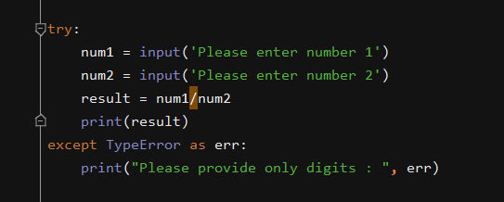

Output: -

If we **convert the num1 to Integer and num2 to Integer then the Exceptions will be handled** :-

Now if we **give the second number as zero**, then it will throw **ZeroDivisionError Exception**:

**Handling multiple exceptions in the code**: -

Output: -

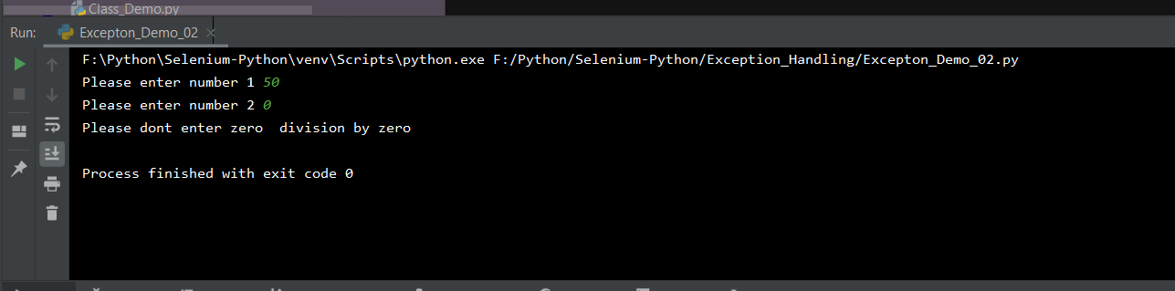

If we give in except **block as Exception** – then it will **handle all types of Exception** – as all the **Exceptions like Type Error, Value Error are child class of Exception**: -

Usage of **finally keyword** – it will always **be executed – whatever the condition is given**: -

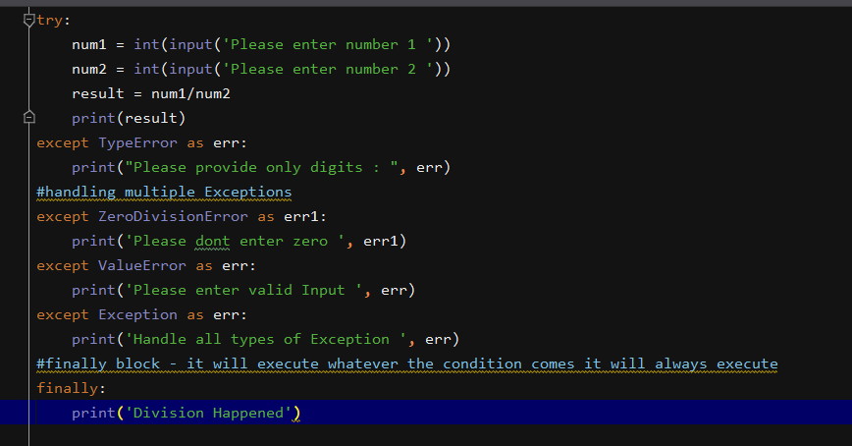

Output:-

If we give any invalid **input, then also- finally block will get executed**: -

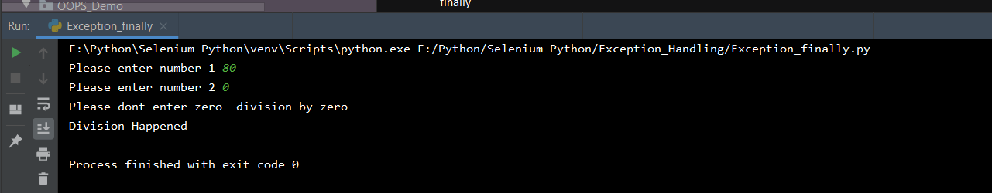

**Else Block** – if we add the else block it will **only execute when there is no exception**: -

Output: -

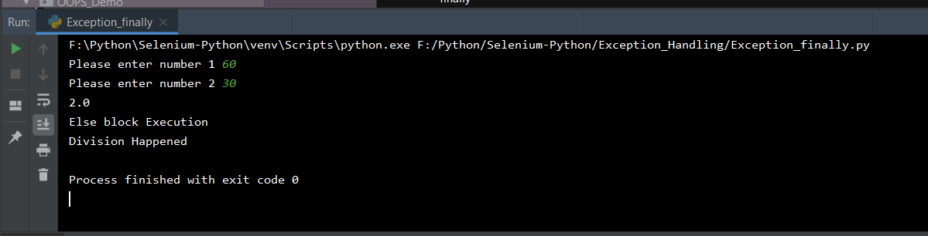

**Raise** keyword – It is used to throw any particular type of exception, where we can throw any exception type

If we enter any number as zero – **it will throw Assertion error**

