**Python -zip functionality**: -

Python Docs Link - <https://docs.python.org/3/library/functions.html#zip>

Zip – class from the python built in package: -

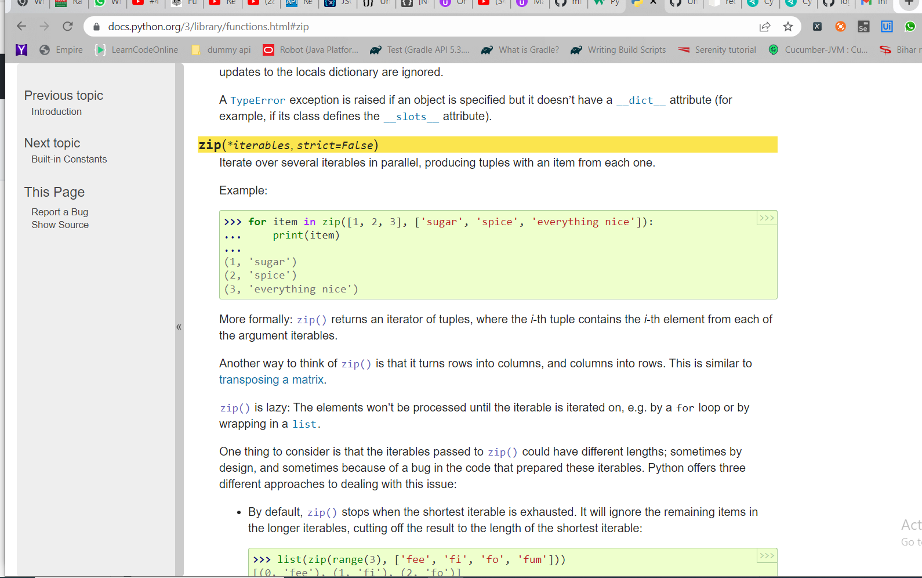

**Zip function will iterate over the two list and create combinations of tuples** –

Here we can see [1,2,3] is one list and [‘sugar’, ‘spice’, ‘everything nice’] is another list – when we use the zip function – it will combine the two list and give one combined result as :-

(1, 'sugar')

(2, 'spice')

(3, 'everything nice')

If we type – built-ins method – it will show all the packages available inside it :-

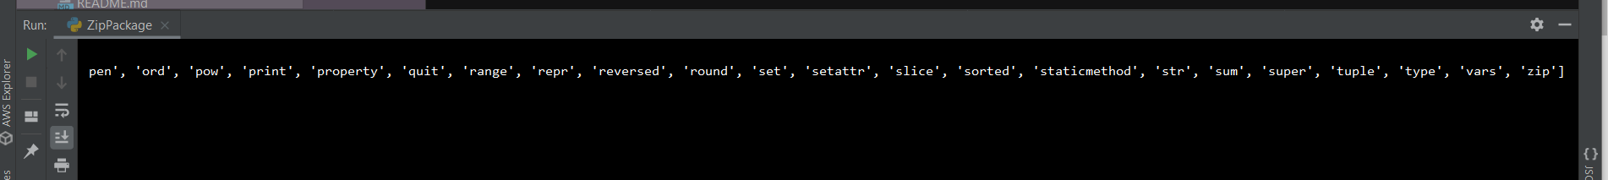

Zip – **class available inside the built in package**: -

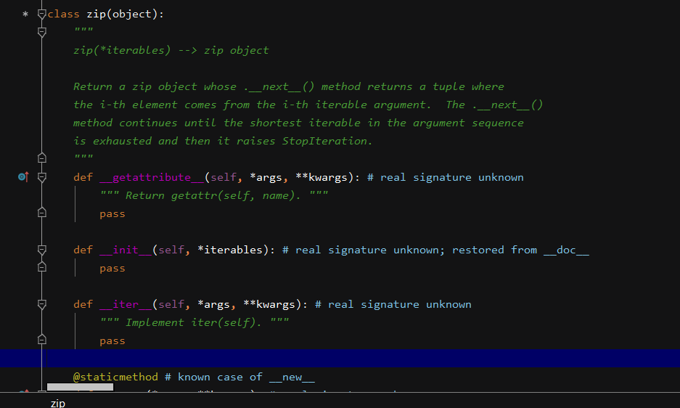

Create two list – and then use the **zip class – to combine the list of tuples and form a tuple of elements combined**: -

Output – It will give the **two list names – combined as tuple**

Suppose if we add an additional element inside the list – and in the second list – we don’t add any additional element – then it **will not form the combined tuple**: -

We added **one extra element inside the tuple** – but it will not form the combined tuple when we use the zip function: -

Kumar **will be ignored – as there is no element associated to it found inside the second list**: -



Now try to create a single list – still the zip function will work – if we don’t give any other list

**Output**: -



Now try to combine more **than one list – having three list as whole**

Output: -

Now do the same thing with the help of sets – to combine three sets and converting to list

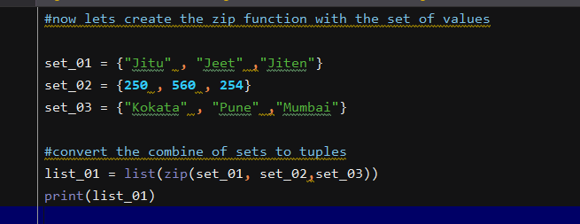

**Unpacking the tuples – Unpacking the Zip** and tuples and assigning to three different variables:-

**Output**: - Print all the variables – which will give separate values – for unzip – we use * keyword

Output :-

