When we run the jobs through Jenkins – it downloads the whole gradle project into a separate folder under the Jenkins folder at the following location :-

C:\Users\ACER\.jenkins\jobs\Gradle Build Selenium\htmlreports\GRADLE_20REPORT

From the original workspace it downloads the project at the following location

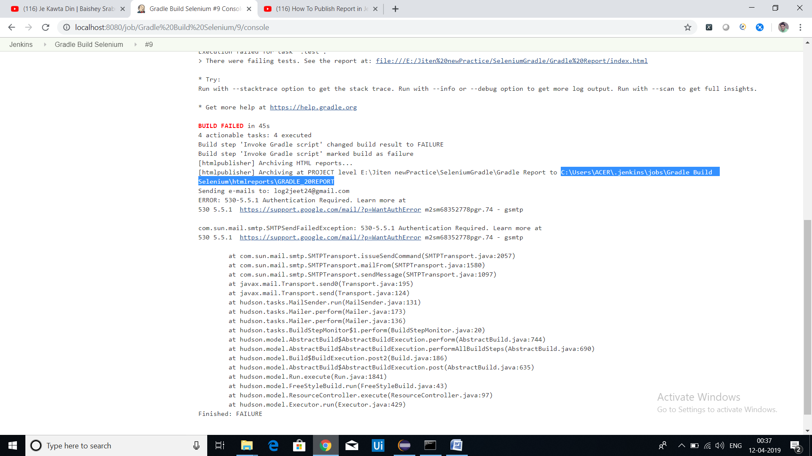

To publish report – first download the Html Publisher plugin add in through Jenkins and then edit the job by clicking on Add post build actions > Add HTML Report >

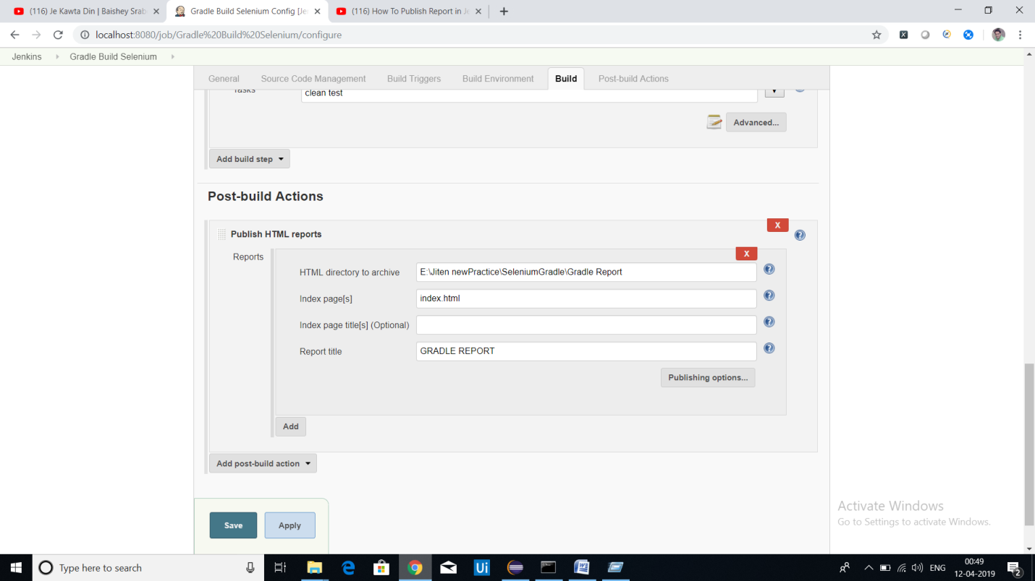

After giving the path – gradle report will generate after adding the report

