Read the twilio message otp code

Create Account on twillio.io – username – [log2jeet24@gmail.com](mailto:log2jeet24@gmail.com)

Password – Ajiten#1990000

After creating password – write the following lines of code

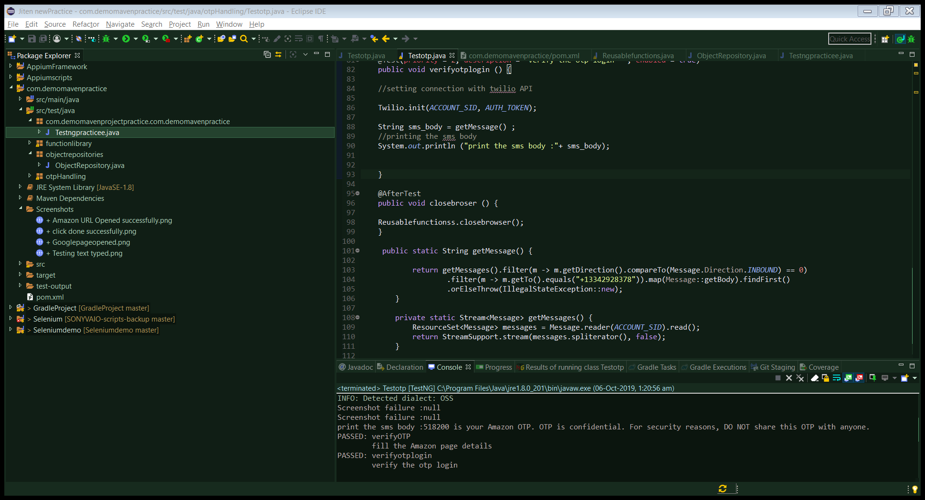

It will take the otp from the following number registered

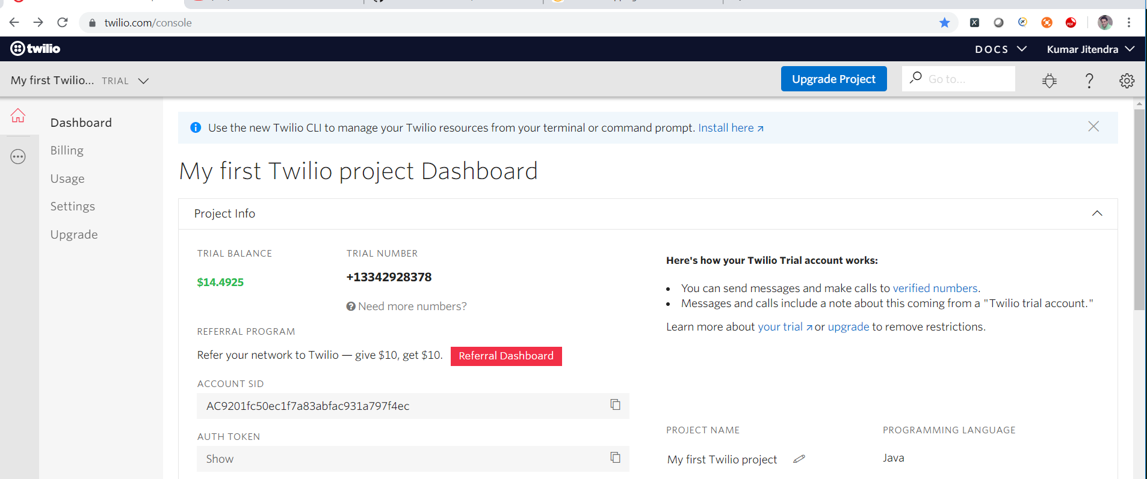

Go to usage section to see the otp code

Click on standard inbound sms

518200 is the otp password

Same we have retrieved in the eclipse console

