Install – docker tool box – as we cannot install docker desktop due to limitation for installation of windows 10 pro software.

Download docker toolbox from the following shared url path :-

<https://github.com/docker/toolbox/releases>

download docker toolbox version – 19.03

Open docker toolbox

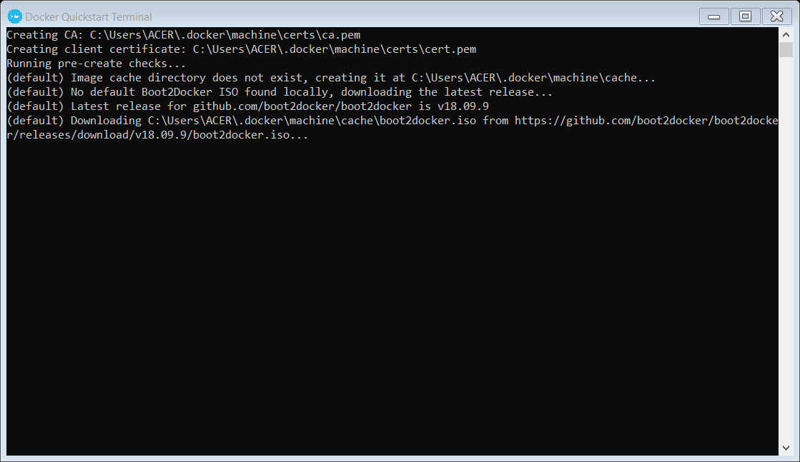

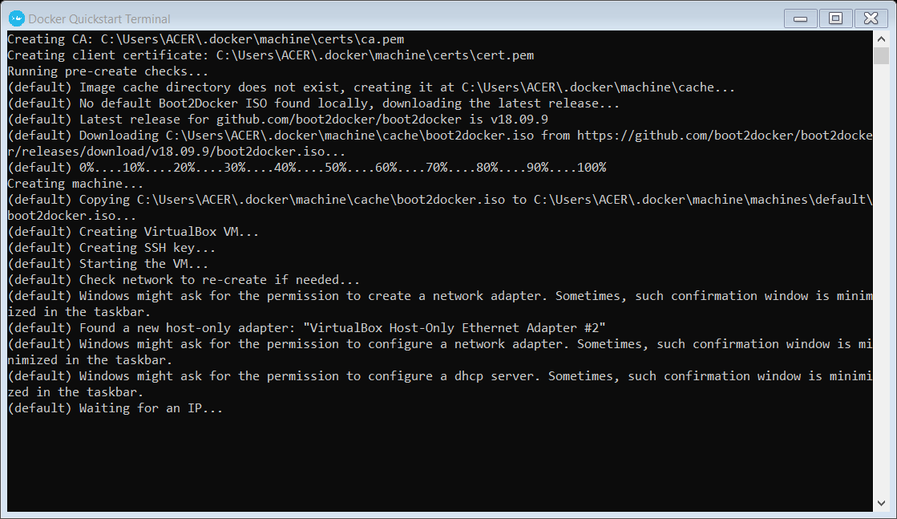

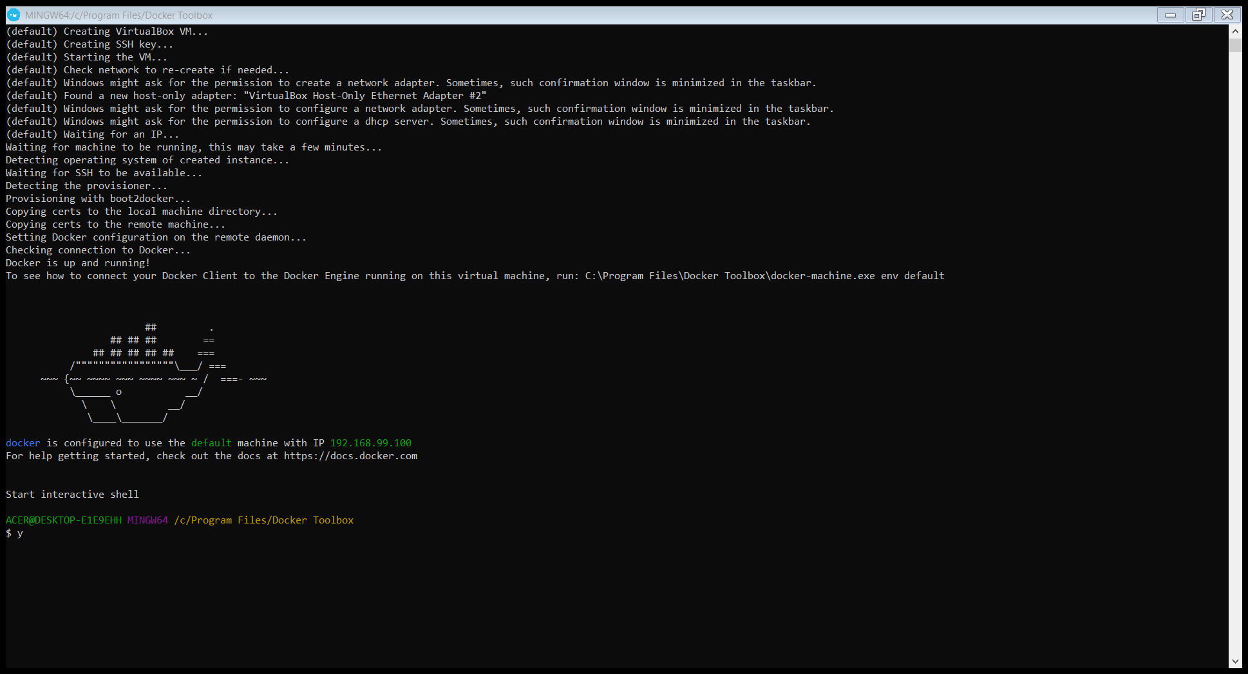

Docker installed successfully

Docker version

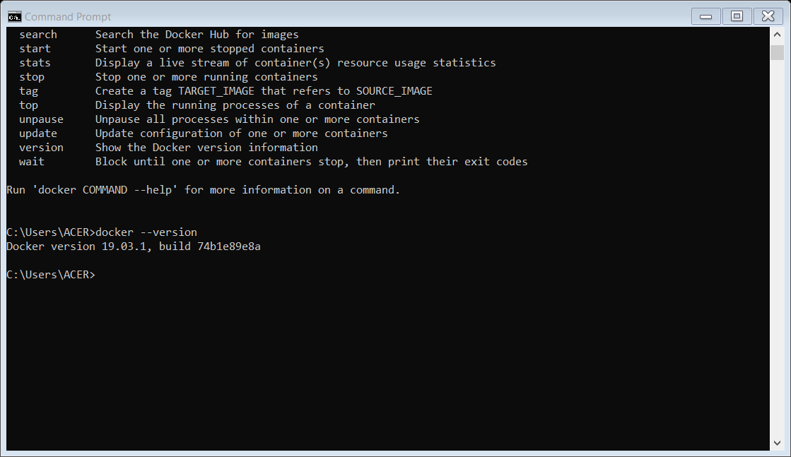

Docker toolbox

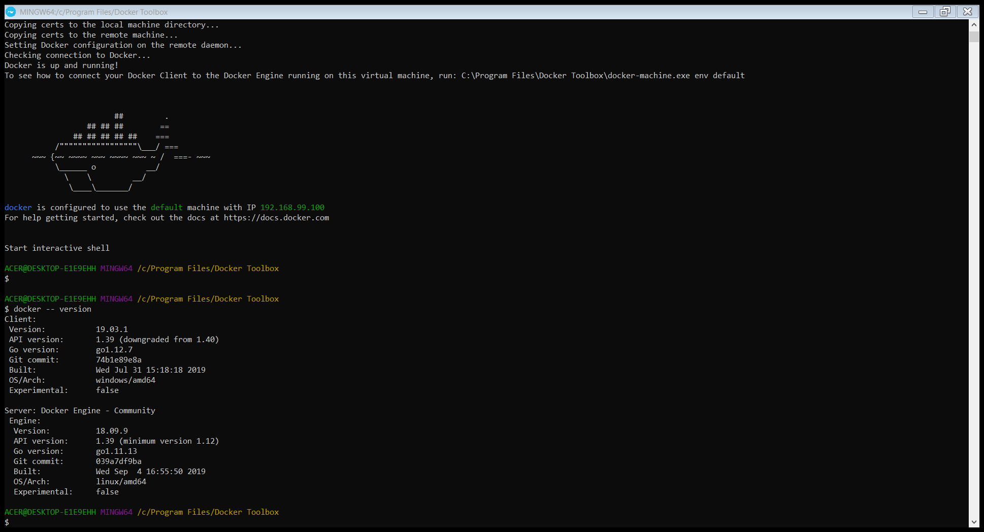

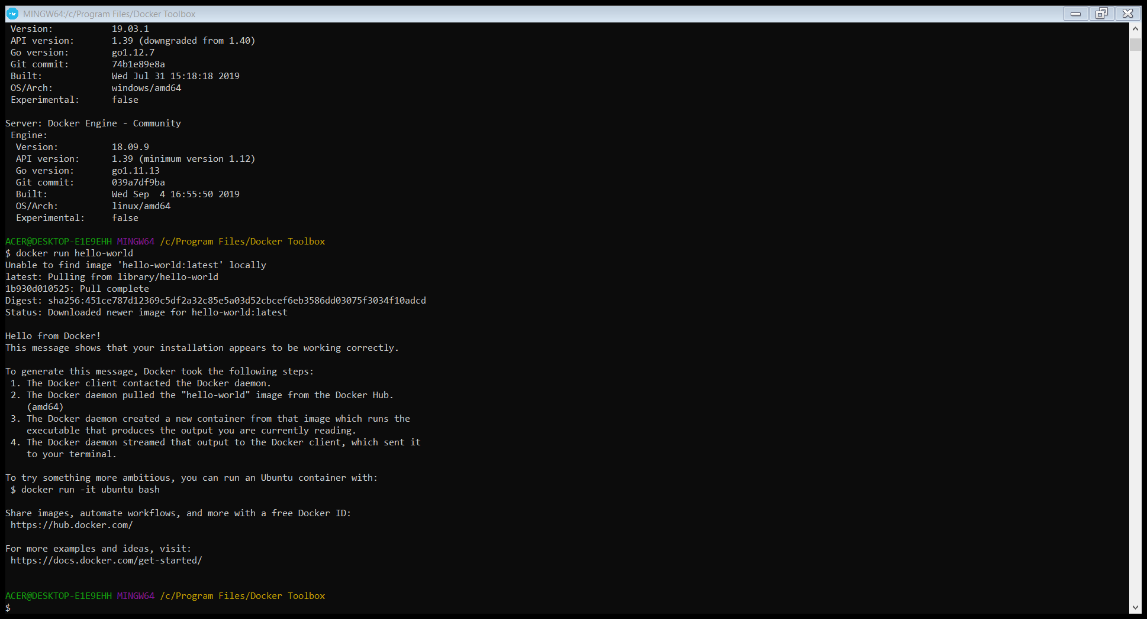

Create a docker repository

