To configure Jenkins master slave connection make sure to make both the settings

Control panel > java >JNLP File/MIME Association >Always allow

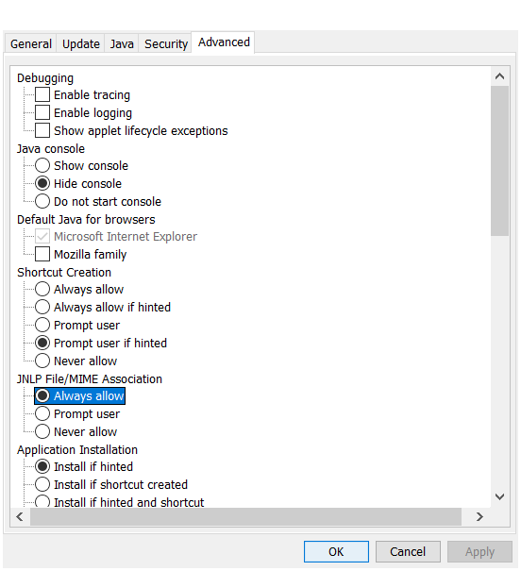

Go to Jenkins > Manage Jenkins > Global Security Settings > TCP Port of JNLP agents is selected as fixed with port number as 5902.

Go to manage Jenkins > click on manage nodes section >one master will be seen

Click on new node and give node name and select permanent Agent

Click ok

* Name of the slave node
* Description of the node
* No of executors (Tip: Keep min 2)
* Root Directory: Where the node details and the slave workspace will be saved
* Labels: Provide the slave node where the Jenkins build should run
* Usage: It is suggested to keep utilizing the node as much as possible or as appropriate.
* Launch method: If there's no special request, then keep it as Java web start or as appropriate.
* Availability: It is suggested to keep this slave online as much as possible or it can be given based on your need

Change launch method to : let jenkins control this windows service

Username – log2jiten24

Password – Ajiten#1990

Click on save

Launch the Jenkins slave machine

Change settings

