Create new .bat file through notepad

Create new project through Jenkins

Give the path of the location

**Step 3:** In the General tab, click on the Advanced option and select 'Use custom workspace' and give the details of your desired work space folder.

**Step 4:** Select the drop down 'Add build step' under Build option and select 'Execute windows batch command'. Once done, enter the data given below and click on Apply and then on Save.

**Step 5:** Click on **Build Now** option for executing the build. Once completed click on **#1** and then click on **Console Output** to see the result console.

New project item created

Click on build now

Create new pull request through branch to master

Git command – git push origin : demojenkins

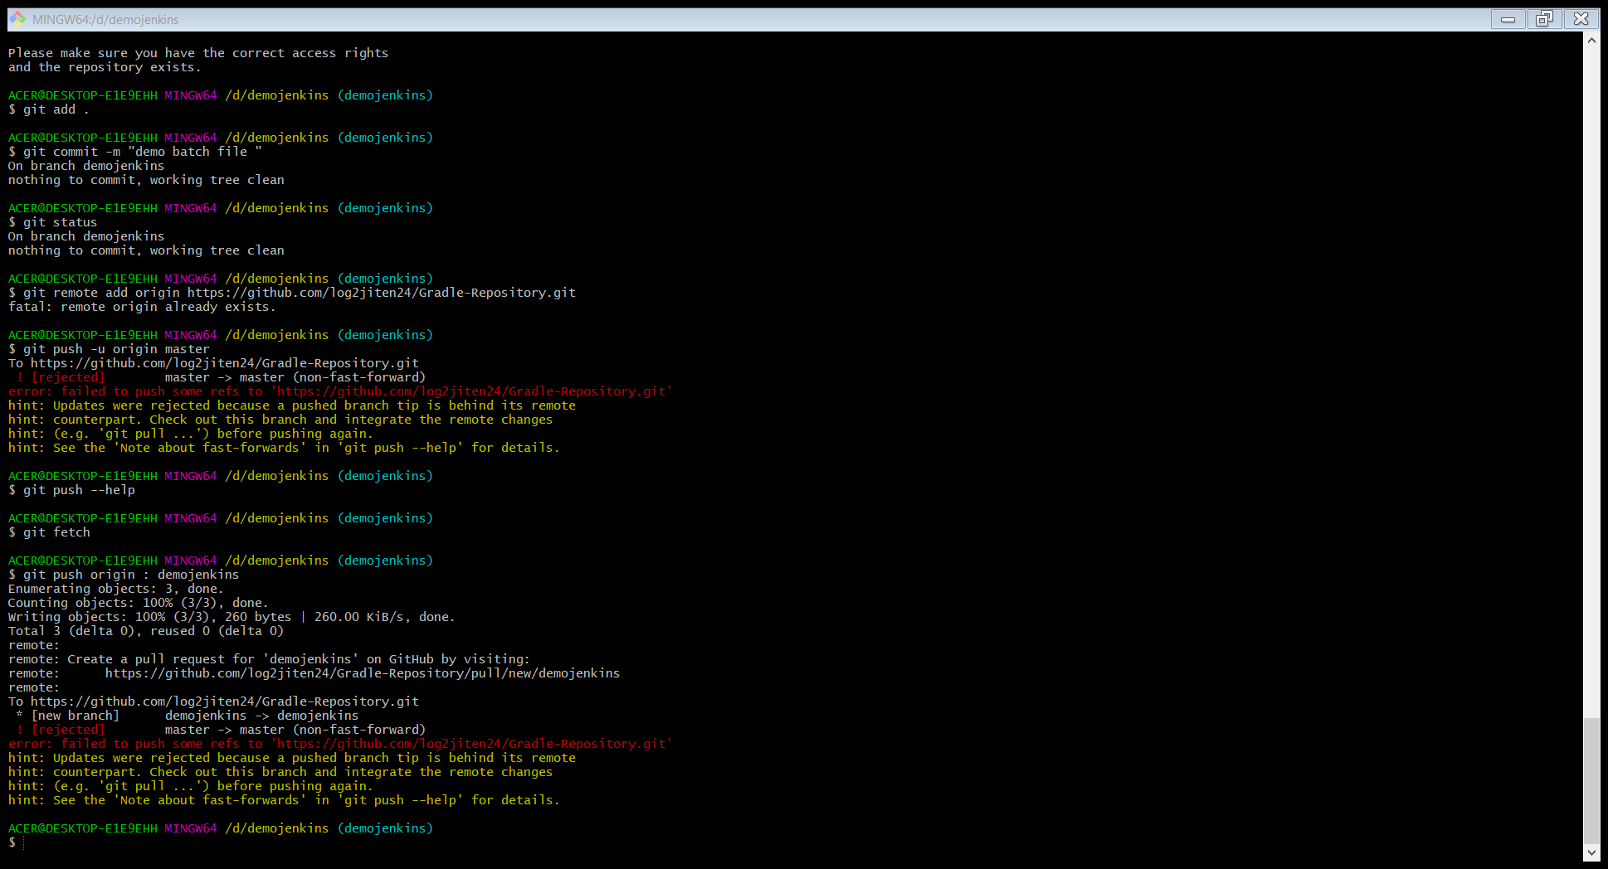

Pull request will be created at gut hub repository

Click on new pull request

Create pipelines- create multiple jobs and schedule them

Open the Jenkins workspace

