Global Product Inventory Management Dashboard
Project Overview:
This project presents a Power BI dashboard for Global Product Inventory Management. The dashboard transforms raw global product data into meaningful insights using interactive KPIs, charts, tables, and slicers.
The dashboard helps users analyze product inventory, stock quantity, product categories, product prices, and product ratings in an interactive and easy-to-understand format.
Objectives:
Analyze global product inventory using Power BI
Monitor the total number of products and stock quantity
Analyze products based on different categories
Compare category-wise stock quantities
Monitor average product price and product ratings
Identify inventory patterns across product categories
Provide interactive product filtering
Present product information through meaningful visualizations
Support effective inventory management and decision-making

Tools Used
Microsoft Power BI
Power Query
DAX
Microsoft Excel / CSV
GitHub
Dataset
Dataset Name: Global Product.csv
Dataset Columns Name:
Product ID
Product Name
Product Category
Product Description
Price
Stock Quantity
Warranty Period
Product Dimensions
Manufacturing Date
Expiration Date
SKU
Product Tags
Color/Size Variations
Product Ratings
Key Features:
Interactive inventory dashboard
Total product monitoring
Total stock quantity monitoring
Product category analysis
Product price analysis
Product rating analysis
Category-wise inventory analysis
Product distribution analysis
Interactive product filtering
Inventory details table
Visual comparison of stock levels
Dashboard Visualizations
1. KPI Cards
The dashboard contains five important KPI cards:
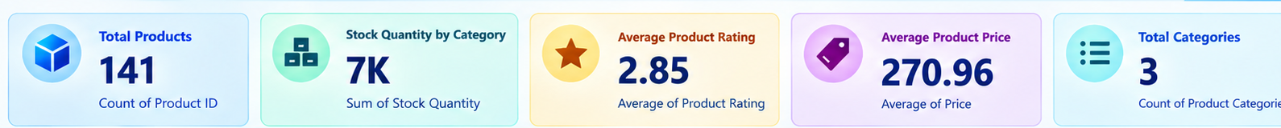

Total Products – 141
Total Stock Quantity – 7K approx.
Average Product Rating – 2.85
Average Product Price – 270.96
Total Categories – 3
These KPIs provide a quick overview of the overall product inventory.
2. Stock Quantity by Category – Column Chart
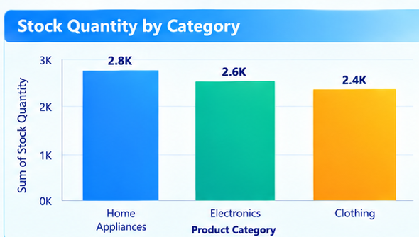
Fields Used:
X-axis → Product Category
Y-axis → Stock Quantity
Aggregation → Sum
This chart compares the total stock quantity available in each product category.
Categories:
Home Appliances
Electronics
Clothing
Purpose:
It helps users easily compare stock levels between different product categories.
3. Product Count by Category – Donut Chart
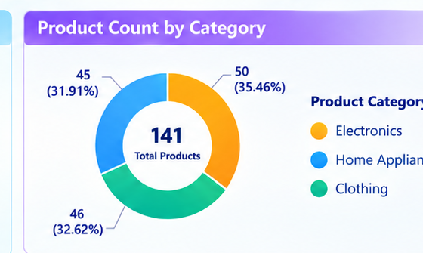
Fields Used:
Legend → Product Category
Values → Product ID
Aggregation → Count
This chart shows how the total number of products is distributed across different categories.
For example, the dashboard shows:
Electronics – 50 products
Clothing – 46 products
Home Appliances – 45 products
Purpose:
It helps users understand the product distribution and category-wise share.
4. Inventory by Category – Line Chart
Fields Used:
X-axis → Product Category
Y-axis → Stock Quantity
Aggregation → Sum
This chart represents the inventory level across different product categories.
The dashboard shows approximately:
Home Appliances – 2.6K
Electronics – 2.4K
Clothing – 2.3K
Purpose:
It helps identify the inventory pattern across product categories.
Note: Here the line chart is being used for category comparison. It is not a time-based trend because Product Category is on the X-axis.
5. Stock Quantity by Product Category – Treemap
Fields Used:
Group → Product Category
Values → Stock Quantity
Aggregation → Sum
This treemap represents stock quantity using different-sized blocks.
Purpose:
The size of each block represents the stock quantity of that category. A larger block indicates a higher stock level.
It provides a quick visual comparison of:
Home Appliances
Electronics
Clothing
Interactive Slicer
Product Name Slicer
Field Used:
Product Name
The slicer allows users to select a particular product and interactively filter the dashboard.
For example, selecting Smartphone filters the dashboard to show information related to that product.
Inventory Details Table:
The dashboard also contains an Inventory Details table.
Fields Used:
Product Category
Price
Product Rating
This table provides detailed information about the product categories and their corresponding values.
Project Files:
Global_Product_Inventory_Management_Dashboard.pbix – Power BI project file
Global Product.csv – Dataset used for analysis
Dashboard.png – Dashboard preview
Dashboard Preview
The dashboard provides an interactive view of global product inventory information. It combines KPI cards, column charts, donut charts, line charts, treemaps, slicers, and tables to present product and inventory information clearly.
The dashboard allows users to monitor total products, stock quantity, product categories, average price, average rating, and category-wise inventory.
Conclusion
This project demonstrates how Power BI can be used to transform raw global product data into meaningful visual insights. The dashboard provides an interactive platform to monitor inventory, analyze product categories, compare stock quantities, and understand product price and rating information.
Overall, the Global Product Inventory Management Dashboard helps users understand product inventory data and supports effective inventory analysis and management.

