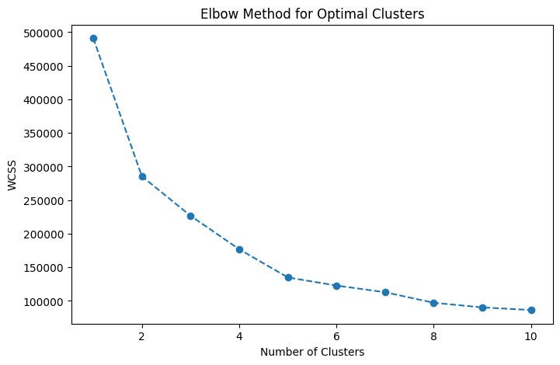
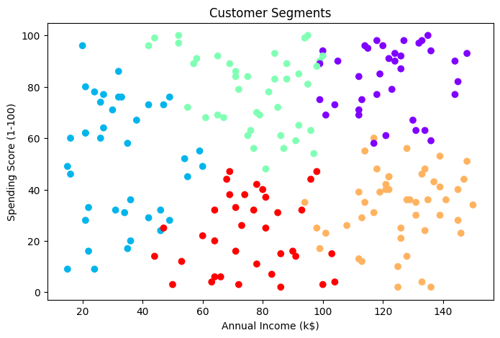
CustomerID Gender Age Annual Income (k$) Spending Score (1-100) \
0 1 1 21 100 3
1 2 1 59 120 96
2 3 0 52 78 70
3 4 1 18 83 7
4 5 1 23 55 45
Cluster
0 4
1 0
2 2
3 4
4 1

