2/4/2022

Audit File Tutorial

The ‘Audit File’ contains 3 main sections which are required for the SAF-T file; the Header, MasterFiles & GeneralLedgerEntries. The structure of these 3 components can be found in the “File Structure” folder. For now, we will focus on the Header_Structure file. However, the process is the same for the other 2 files. For now, we will get a feel of how the file looks.

Open the “File Structure” folder to view the various sub-structures under the ‘Audit File’

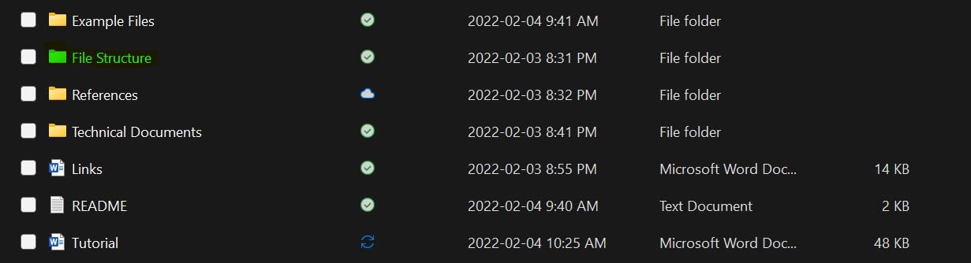

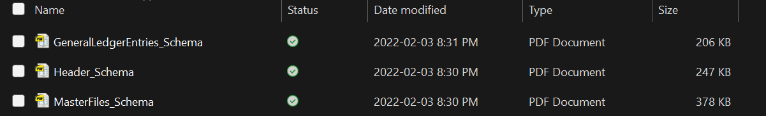

Open the “Header_Structure” file. When we zoom in, we can see the Header, MasterFiles and GeneralLedge structures under the Audit File structure (follow the lines while zoomed in).

(For viewing purposes, the right-most image shows how the PDF correlates to the XML file)

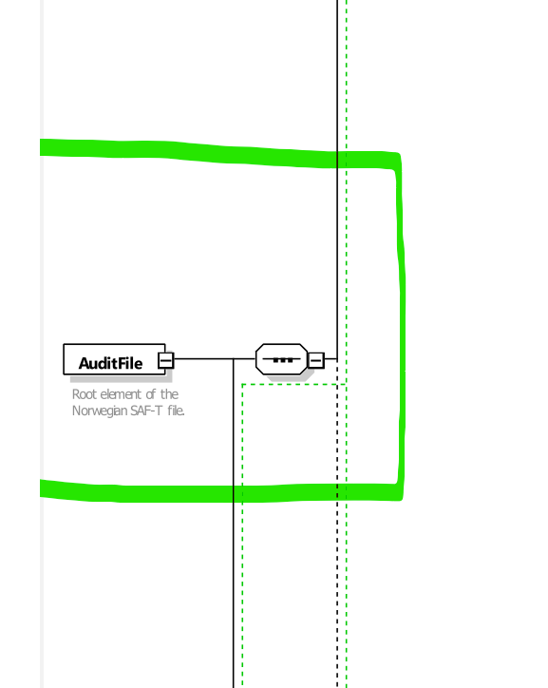

To determine which fields are mandatory (M) and optional (O), we can use the document called “norwegian-saf-t-financial-data---technical-description” which can be found in the “Technical Documents” folder. For this example, we will focus on the PersonNameStructure.

Zoom into the highlighted zone.

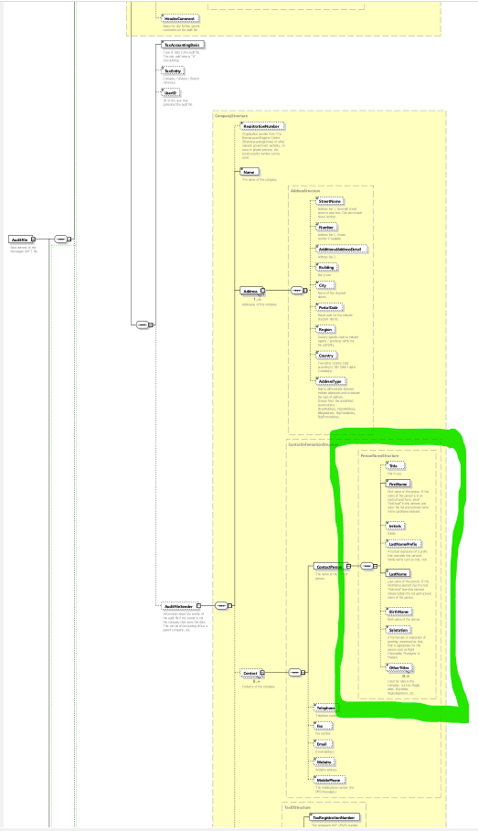

Copy the name of the structure which can be found in the top left of the dashed box. Please note a dashed box contains a cluster of fields.

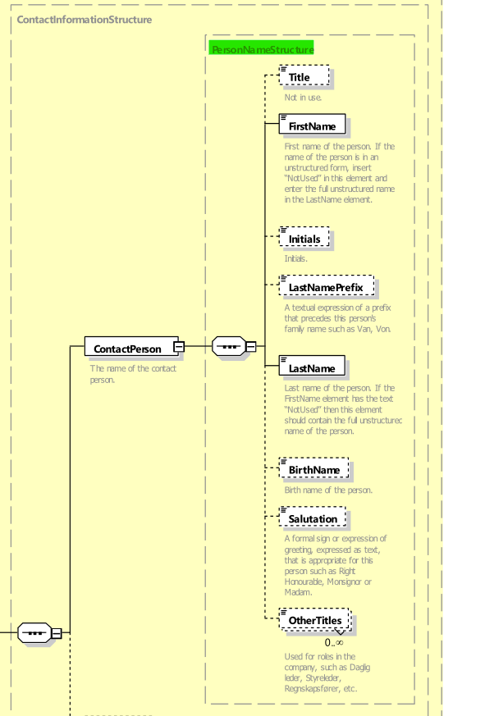

Open the “norwegian-saf-t-financial-data---technical-description” file which can be found in the “Technical Documents” folder.

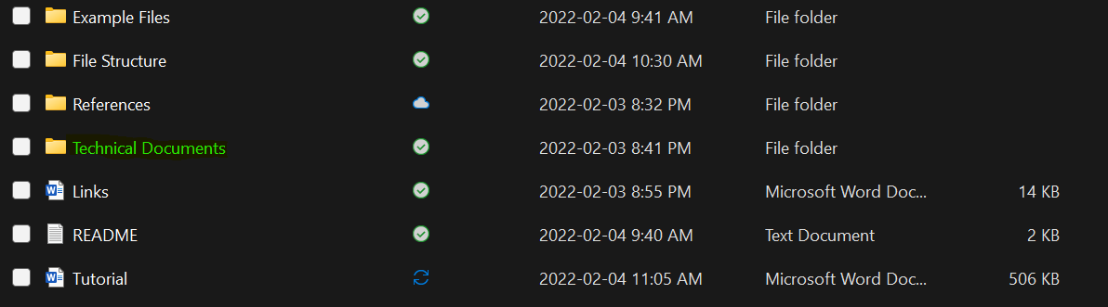

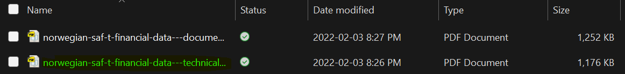

Search for the “PersonNameStructure” in your PDF viewer.

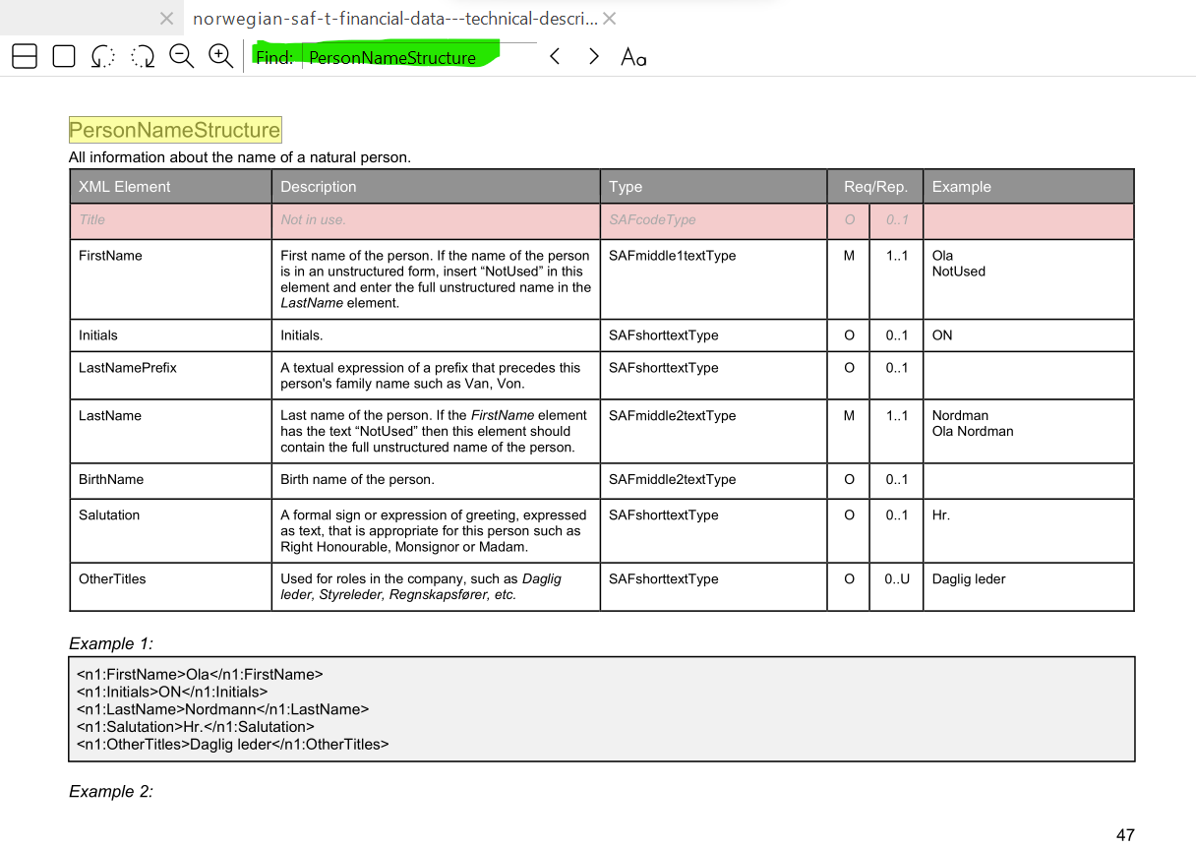

To see which fields are mandatory (M), look for the rows that have an ‘M’ under the “Req” column. Below we can see that the “PersonNameStructure” requires the FirstName and LastName XML elements while the other XML elements are optional (O).

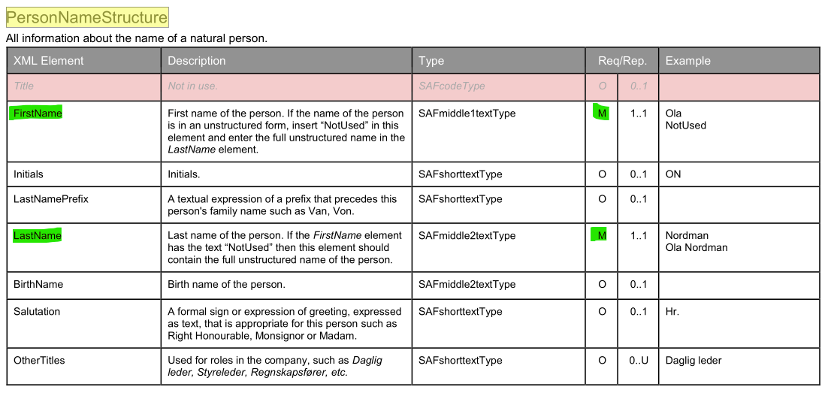

Example XML files can be found under the “Example Files” folder.



