Logan Stum

Customer Service Chatbot
SWENG 837

Contents
1. Problem Statement and Requirements 3
1.1 Business Requirements 3
1.2 Non-Functional Requirements 3
2. UML Diagrams 4
2.1.1 UML Use Case Diagram 4
2.1.2 Justification 4
2.2.1 UML Domain Model 5
2.2.2 Justification 5
2.3.1 UML Class Diagram 6
2.3.2 Justification 6
2.4.1 UML Sequence Diagrams 7
2.4.2 Justification 7
2.5.1 UML State Diagram 8
2.5.1 Justification 8
2.6.1 UML Activity Diagram (Swimlane) 9
2.6.2 UML Activity Diagram (Swimlane) 9
2.7.1 UML Component Diagram 10
2.7.2 Justification 10
2.8.1 Cloud Deployment Diagram 11
2.8.2 Cloud Deployment Diagram 11
2.9.1 Skeleton Classes and Tables Definition 12
2.9.2 Justification 14
2.10.1 Design Patterns 15
2.10.2 Justification 15

1. Problem Statement and Requirements

1.1 Business Requirements
Problem: Traditional customer service systems often fail to deliver real-time, personalized, and scalable support. Customers face long wait times and inconsistent service quality.
Solution: A Generative AI-powered chatbot that utilizes natural language processing (NLP) and machine learning to provide intelligent, instant customer support and personalized recommendations.
Target Users:
- Customers needing 24/7 support
- Support agents for escalated cases
- Business analysts for monitoring and reporting
Business Goals:
- Reduce operational costs
- Improve customer experience
- Enable scalability and 24/7 coverage

1.2 Non-Functional Requirements
Performance:
- Sub-second response for 90% of queries
- Scale to 10,000 concurrent users
Security:
- OAuth2 authentication
- Data encryption (AES-256)
- Role-based access control (RBAC)
Maintainability:
- Modular architecture
- Extensive documentation
- Unit and integration tests with >80% coverage
Other:
- Cloud-native on AWS
- Multi-language support

2. UML Diagrams
The following UML diagrams illustrate the core elements of the system. Please paste each generated UML diagram in the corresponding section below.

2.1.1 UML Use Case Diagram

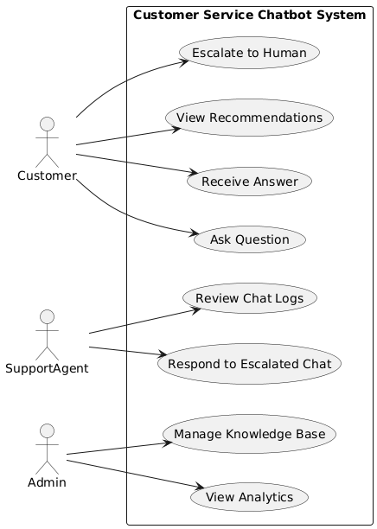

2.1.2 Justification
The Use Case Diagram is essential for capturing the high-level functional scope of the Generative AI-powered Customer Service Chatbot. It visually identifies all actors, including customers, support agents, and administrators, and the ways in which they interact with the system. By mapping out actions such as sending a query, receiving recommendations, escalating issues, and managing the knowledge base, the diagram ensures that all stakeholders share a unified understanding of system capabilities. This makes it easier to validate requirements early, reducing the likelihood of costly changes later in development.

2.2.1 UML Domain Model

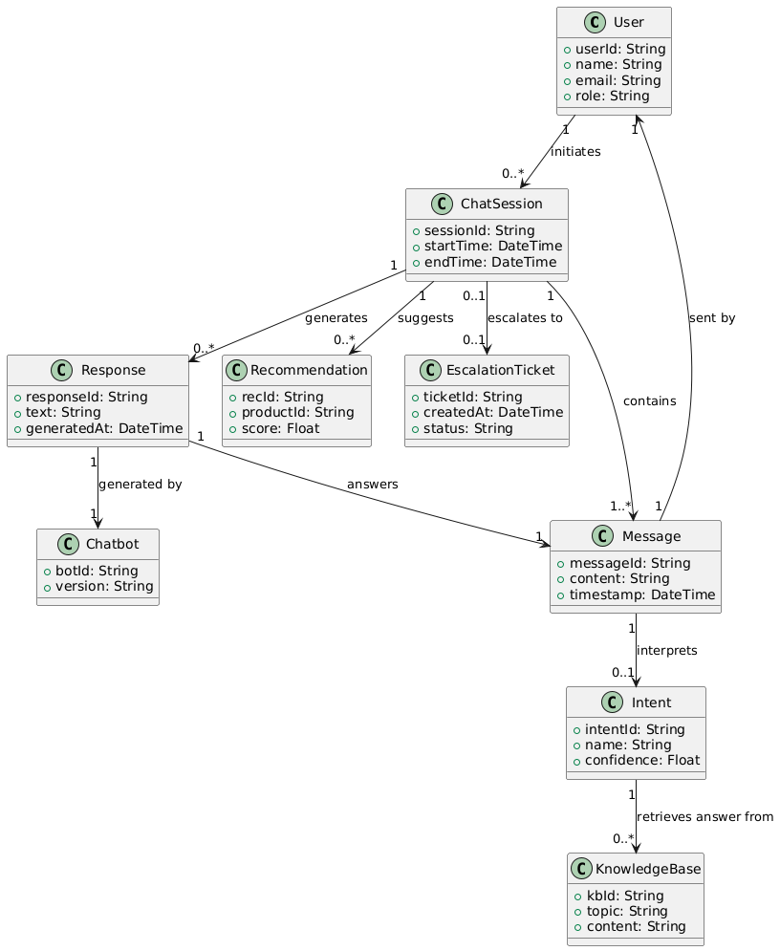

2.2.2 Justification
The Domain Model provides a conceptual blueprint of the system’s problem space, focusing on key business entities like User, ChatSession, Message, Intent, and Recommendation. It shows their attributes, relationships, and multiplicity, which helps developers, analysts, and testers align on the terminology and data structures used throughout the project. For the chatbot, it clarifies how conversations are structured, how intent recognition links to responses, and how recommendations and escalations fit into the broader workflow. This abstraction is critical for separating business logic from implementation details.

2.3.1 UML Class Diagram

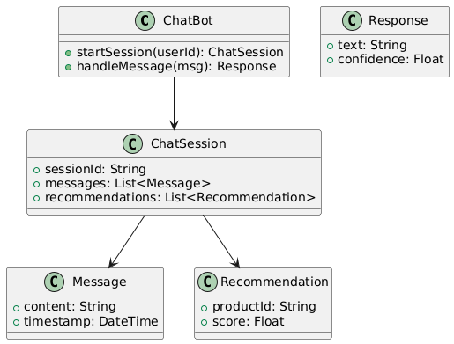

2.3.2 Justification
The Class Diagram translates the domain model into a software-centric view, detailing the attributes and methods that each class will expose. For the chatbot system, it defines core components such as Chatbot, ChatSession, and NLPService, and illustrates how they interact in code. This is vital for developers because it guides the creation of consistent, modular, and maintainable classes while aligning with object-oriented principles. It also serves as a reference point for implementing SOLID and GRASP patterns within the codebase.

2.4.1 UML Sequence Diagrams

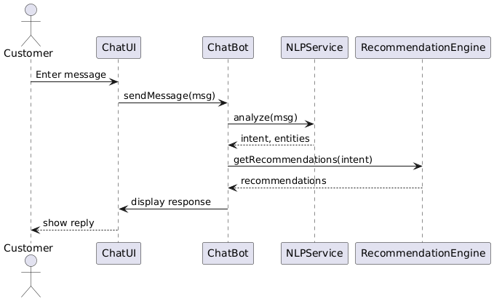

2.4.2 Justification

Sequence Diagrams detail the runtime flow of messages and interactions between objects for specific use cases, such as handling a user query or generating a recommendation. In the chatbot system, they illustrate how a message moves from the UI to the NLP service, then through the recommendation engine, and finally back to the user. This step-by-step breakdown is crucial for identifying integration points, ensuring correct message ordering, and highlighting potential bottlenecks in response time. It also makes external dependencies and service calls explicit for implementation planning.

2.5.1 UML State Diagram

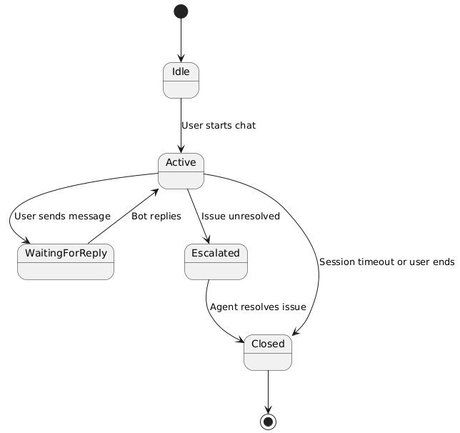

2.5.1 Justification

The State Diagram models the lifecycle of important system elements, such as a chat session or escalation ticket. In the chatbot’s case, it shows transitions from Idle to Active, WaitingForReply, Escalated, and Closed. This visual representation ensures that all stakeholders understand the valid states an object can occupy and the events that trigger transitions. It helps developers design state management logic and ensures testers can verify correct behavior across all state changes.

2.6.1 UML Activity Diagram (Swimlane)

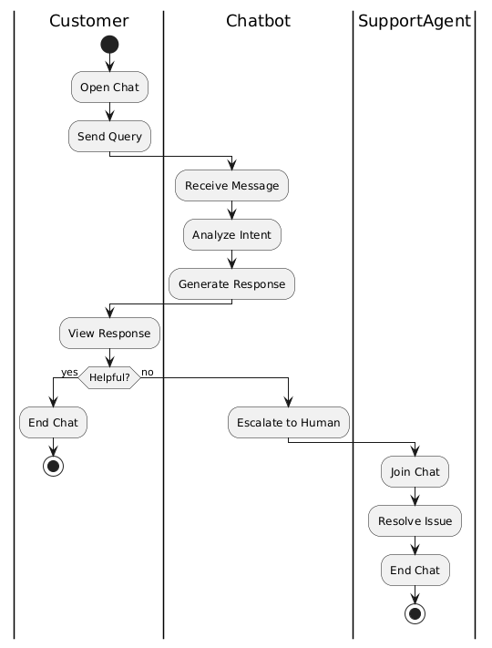

2.6.2 UML Activity Diagram (Swimlane)

The Activity Diagram, with swimlanes, maps out the flow of actions and responsibilities across different actors in a process. For this chatbot, it captures the end-to-end workflow of handling a customer query, from initial message to either a resolution or escalation to a support agent. By highlighting which actor performs each action, the diagram clarifies responsibility boundaries and reveals opportunities to streamline processes. It also helps in identifying parallel processing opportunities, such as concurrent intent analysis and recommendation retrieval.

2.7.1 UML Component Diagram

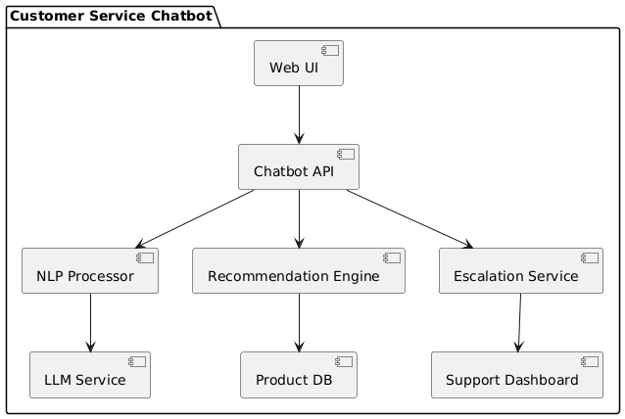

2.7.2 Justification
The Component Diagram provides a high-level architectural view of the chatbot system, showing major modules like the Chatbot API, NLP Processor, Recommendation Engine, and Escalation Service. This is particularly important for ensuring the architecture is modular and that each component has clear, well-defined interfaces. For stakeholders, it communicates how the system is logically divided, while for developers, it highlights where integration and communication points exist, enabling independent development and easier maintenance.

2.8.1 Cloud Deployment Diagram

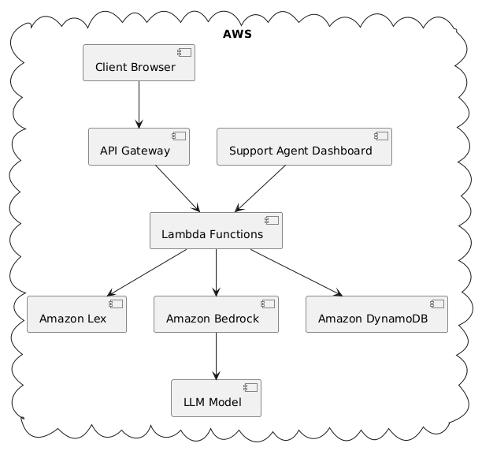

2.8.2 Cloud Deployment Diagram
The Cloud Deployment Diagram demonstrates how the chatbot system will be deployed on AWS, showing services like Amazon Lex, Bedrock, DynamoDB, and Lambda connected via API Gateway. This diagram justifies cloud resource choices and illustrates how the system achieves scalability, security, and fault tolerance. It also helps DevOps teams plan for infrastructure provisioning, load balancing, and monitoring, ensuring that the architecture supports the system’s performance and availability goals.

2.9.1 Skeleton Classes and Tables Definition
Below are the core skeleton classes for the chatbot system:
class User {
String userId;
String name;
String email;
String role; // CUSTOMER, AGENT, ADMIN
}
class ChatSession {
String sessionId;
User user;
List<Message> messages;
List<Recommendation> recommendations;
LocalDateTime startTime;
LocalDateTime endTime;
}
class Message {
String messageId;
User sender;
String content;
LocalDateTime timestamp;
Intent intent;
}
class Intent {
String intentId;
String name;
float confidenceScore;
}
class Recommendation {
String recId;
String productId;
float relevanceScore;
}
class KnowledgeBase {
String kbId;
String topic;
String answer;
}
class Chatbot {
ChatSession startSession(User user);
Message handleMessage(String input);
List<Recommendation> generateRecommendations(Intent intent);
void escalateToHuman(ChatSession session);
}
The proposed database schema includes the following tables:

Table: Users
Columns
user_id (PK)
name
email
role

Table: ChatSessions
Columns
session_id (PK)
user_id (FK)
start_time
end_time

Table: Messages
Columns
message_id (PK)
session_id (FK)
user_id (FK)
content
timestamp
intent_id (FK, nullable)

Table: Intents
Columns
intent_id (PK)
name
confidence_score

Table: Recommendations
Columns
rec_id (PK)
session_id (FK)
product_id
relevance_score

Table: KnowledgeBase
Columns
kb_id (PK)
topic
answer

2.9.2 Justification
The Skeleton Classes and Tables Definition section provides a bridge between the conceptual design and the implementation phase of the chatbot system. By outlining the main classes, their attributes, and key methods, this section ensures that developers have a clear starting point for coding while maintaining consistency with the domain and class diagrams. For the chatbot, classes like ChatSession, Message, and Recommendation directly correspond to core functionalities such as managing conversations, processing messages, and delivering personalized suggestions. Similarly, the relational database schema ensures persistent and structured data storage for user profiles, chat histories, intents, and recommendations. This dual view — object-oriented classes for in-memory operations and database tables for persistence — supports both the runtime efficiency and long-term maintainability of the system.

2.10.1 Design Patterns

GRASP Principles
- Controller: Chatbot class manages control flow.
- Creator: ChatSession creates and manages its Messages and Recommendations.
- Information Expert: Each class is responsible for its own data and behavior.

SOLID Principles
- Single Responsibility: Each class focuses on one concern.
- Open/Closed: Extend behavior (e.g., recommendation logic) via Strategy pattern.
- Liskov Substitution: Interface-based programming for interchangeable components.
- Interface Segregation: NLP and Recommendation services follow separate interfaces.
- Dependency Inversion: Components depend on abstractions, not concrete classes.

GoF Design Patterns
- Strategy: Multiple recommendation algorithms can be swapped.
- Observer: Escalation events can notify support dashboards.
- Factory: MessageFactory to standardize creation with NLP preprocessing.
- Facade: Chatbot class simplifies access to NLP, DB, and escalation components.
- Adapter: Wrap external APIs (e.g., Bedrock) into internal interfaces.

Microservices Patterns
- API Gateway: Handles routing and aggregation for the frontend.
- CQRS: Separation of read-heavy analytics from command services.
- Service Discovery: Optional use of AWS App Mesh or registry system.

2.10.2 Justification
The Design Patterns section justifies the architectural and coding best practices used to ensure the chatbot’s design is modular, scalable, and easy to maintain. Patterns from GRASP, SOLID, and GoF have been applied to solve common design problems in a standardized way, while microservice patterns ensure the system can scale and integrate with cloud-native services. For example, the Strategy pattern in the RecommendationEngine enables swapping algorithms without altering the rest of the codebase, while the Observer pattern allows escalation events to notify support dashboards in real-time. The use of the Facade pattern simplifies complex interactions between NLP, database, and escalation services, making the Chatbot API easier to use and test. These patterns collectively promote flexibility, separation of concerns, and adherence to industry best practices, reducing technical debt and improving the system’s adaptability to future enhancements.

