Logan Shea

Linux Administration

**Grep Command**

**What is Grep?**

* Grep is a powerful search command in Linux/Unix based systems. Grep can find specific words, numbers, or match specific patterns in a file.

1. **Command – “grep Lane GrepLab”**

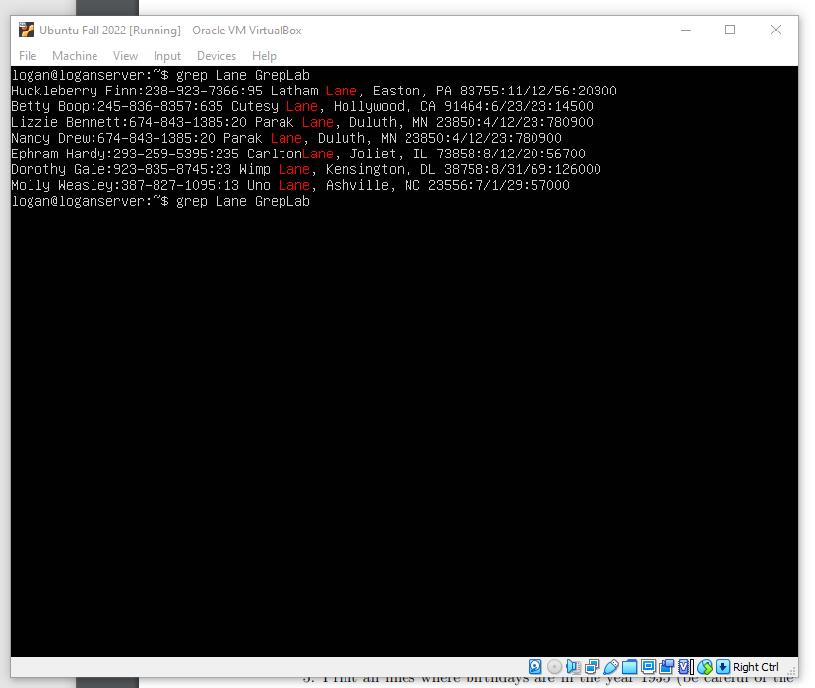

* The grep command searches for a particular string or pattern given by the user. Enter the pattern you are searching for in between ‘grep’ and the file you are searching through. In this example we are just searching for the word ‘Lane’ in the file ‘GrepLab’.

1. **Command – grep -I “^[H]” GrepLab**

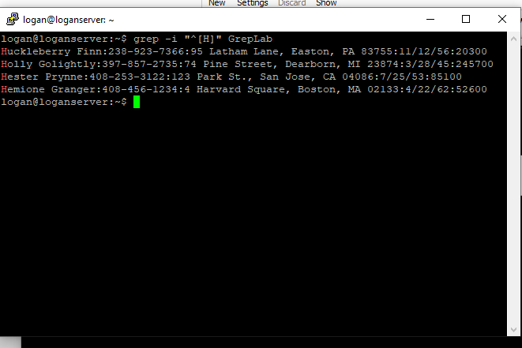

* This command searches for lines that end with ‘000’. When adding a ‘$’ to the end of the pattern you are searching at the end of a line. Whereas previously we used ‘^’ to search at the beginning of a line.

1. **Command – grep “000$” GrepLab**

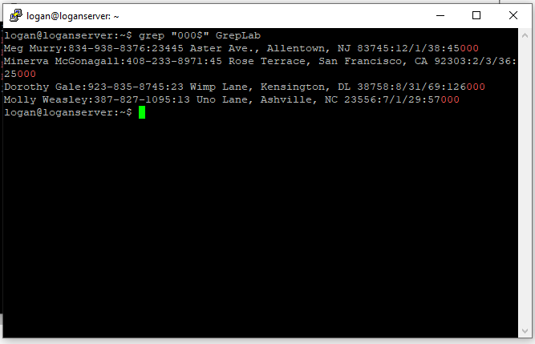

* This command searches for lines that end with ‘000’. When adding a ‘$’ to the end of the pattern you are searching at the end of a line. Whereas previously we used ‘^’ to search at the beginning of a line.

1. **Command – “grep -v 408 GrepLab”**

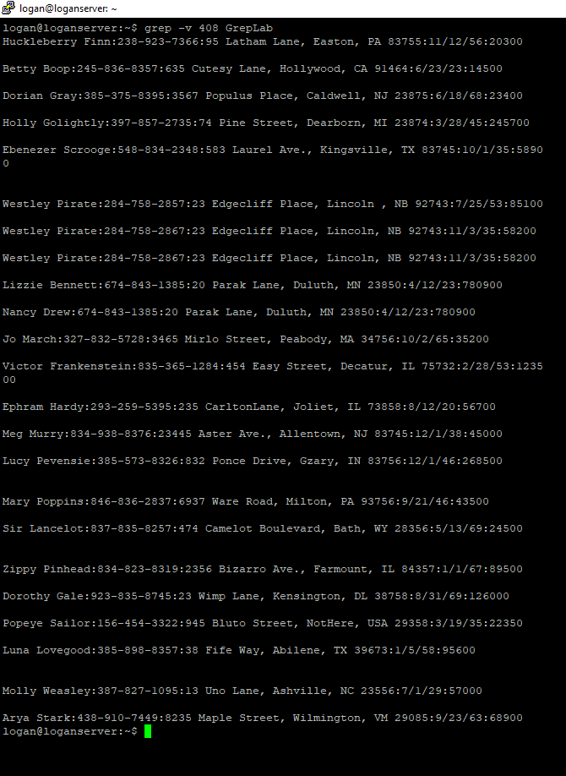

* This command finds all lines that do not contain a 408. The -v option will print out all lines that do not match the pattern given by the user.

1. **Command – grep -E ‘[0-9]+/[0-9]/35’ GrepLab**

* This command format is used to find all the people on the file that are born in the year 1935. The format is a little tricky, starting with grep again, use the -E (case sensitive) flag to treat the ensuing pattern as an extended regular expression. An Extended Regular Expression is a variation of regular expressions that identifies a specific set of strings to match. So, adding the -E to the grep command is telling the system to search for the pattern of a traditional date format MM/DD/YY, ‘[0-9]+/’ searches for any number followed by a ‘/’ like how the date format is written. And we end the pattern with a ‘/35’ because we want to search for the year 1935.

1. **Command – grep -E ‘[8]+[0-9]+[0-9]+-[0-9]+[0-9]+[0-9]+-[0-9]+[0-9]+[0-9]+[0-9]’ GrepLab**  
   A screenshot of a computer

   Description automatically generated

* To find each phone number with an area code that begins with an 8, use another Extended Regular Expression (grep -E). By identifying the number [8] at the beginning of the pattern, this searches for any number that begins with an 8. Following the 8, +[0-9] searches for any digit between 0 and 9 because we are just looking for all phone numbers that start with 8. Keep in mind to place a ‘-‘ after every third number like you see in a traditional phone number format. (EX: 603**-**555**-**7777).

1. **Command – grep -E ‘[A-Z]+[a-z]+ [a-z]+ [a-z]+ [a-z]+ [A-Z]’ GrepLab**

* Again, using the -E flag, identify the pattern we want to search with. To search for all lines with an uppercase letter start with grep -E ‘[A-Z] to search for any uppercase letter. Following ‘[A-Z]’ with +[a-z] searches for any lowercase letter. When finished with the four lowercase letters, leave a space and add the last part of the pattern - [A-Z]’ to search for the last uppercase letter.

1. **Command – grep -E ‘:([0-9]{2}|[0-9]{3}) [A-Z]’ GrepLab**

* The command used to find all addresses that begin with a two- OR three-digit number, or any other specific pattern such as this, is going almost always to use the -E flag. Every address in this file is prefaced with a semicolon ‘:’, so this is a good place to start the pattern for consistency purposes. To find a two-digit address, use [0-9]{2} in the pattern. The brackets {2} appended to [0-9] indicates to the system to search for any two-digit number. This identifier helps save time as opposed to typing out [0-9]+[0-9], or [0-9]+[0-9] [0-9] to search for a three-digit number. Add a space towards the end of the expression and use [A-Z] to search for the street name. [A-Z] searches for any capital letter like with the beginning of all street names.

1. **Command – grep -E ‘MA|IN’ GrepLab**

* Using the pattern ‘MA|IN’, this identifies which two states they command is searching for. Because the states are formatted in their abbreviations, we can use them in the pattern to search for people who reside in these two states.

1. **Command – grep -v -E ‘Street|St’ GrepLab**

* This time, preceding our normal ‘-E’ option is a ‘-v’, which tells the system to avoid the ensuing pattern, or in this case two words, searched for by grep. To avoid searching for addresses that are not on a ‘Street’, or ‘St’, use those two words in the pattern like this ‘Street|St’. This will tell the system to search for all lines that do not contain these words.