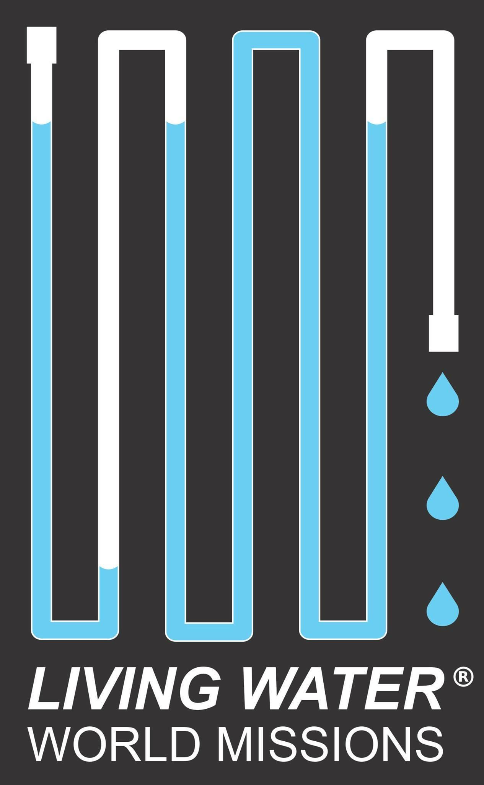

**Guatemala Installation Trip Information**

**2022**

Non-refundable payment of $250.00 is REQUIRED TO RESERVE your spot along with a COMPLETED application form.

**WHAT IS INCLUDED**

* Flights from/to LAX (unless you are booking your own)
* 3-star hotels (or best available in some areas), DOUBLE occupancy
* Breakfast, lunch, & dinner each day
* Airport transfers, Comfortable bus
* English speaking, knowledgeable guides
* Tips, service charges, site entry fees, and VISAS/border fees where needed

**WHAT ISN'T INCLUDED**

Snacks, Personal expenses, credit card transaction fee if final payment is made with credit card, Single occupancy room, Global Entry/TSA Pre-Check (optional)

**WHO CAN TRAVEL**

Anyone who can manage their travel and time independently is welcome. No specific age restrictions. We welcome anyone from any church or location to join us. Please see application form regarding additional team member requirements. Minors must be accompanied by a parent or designated adult. It is highly encouraged for team members to be vaccinated for all recommended immunizations, including for COVID-19.

**SAFETY**

We had NO safety issues on any previous trips. Travel advisories are monitored and, if our in-country itinerary has to be adjusted, it will be. Please see application form regarding CDC recommended vaccinations for travel. Once available all team members will be required to provide proof of vaccination for COVID-19.

**VISAS AND PASSPORTS**

All travelers will need a passport that expires at least 6 months AFTER we arrive home.

**GLOBAL ENTRY/TSA PRE-CHECK**

You can use them if you have them. They will only help you get through U.S. Customs faster, not internationally.

Mobil Passport App = Highly recommended! (Free)

**ROOMMATES**

If you do not have a roommate to travel with, we assign you one among other solo travelers.

**LUGGAGE**

ONE 22" max wheeled bag and a backpack/tote. See the separate Packing Guidelines. You do not need much gear for this trip. You must be able to carry your own luggage.

You may also be assigned a team bag that may weigh up to 50lbs (with rollers) that you will be responsible for at airports.

**HOTELS**

The best hotels in the area will be provided and most are 3-star (standards for

these countries are a little less than U.S. but all are clean and comfortable).

Wi-Fi is available in most hotels. Laundry/ironing facilities may be arranged through hotel services for a fee.

**FOOD/DRINKS**

In Guatemala health standards are not what we are used to. Water and anything washed in water should not be consumed without risk of illness. Your guide will explain what we can and cannot eat. There is plenty of edible food in all countries. Coffee is boiled and drinkable. Bottled water is available on all buses and it is recommended that you use only bottled water.

**BATHROOMS**

In Guatemala, public bathrooms are not to what we are accustomed and toilet paper is available but not provided. Sanitation is not good so expect different toilet practices. During in-country travel, rest stops will be planned as our vehicles do not have toilets.

**TERRAIN**

Team activities require a lot of WALKING, up to 3 miles per day. Most of the walking is NOT on level/paved surfaces. Be prepared to walk on gravel, sand, dirt, concrete, and up/down throughout the day.

**WHAT TO WEAR**

Dress is casual and it will be quite warm (80-90's F). Appropriate lightweight pants, short sleeve shirts, and casual knee length dresses are OK. Women will need to have a shawl or sweater to cover shoulders in some of the churches. You will need a light jacket for some evenings and lightweight hiking shoes/ Layers are good and hats/sun protection are recommended. Women should take a cross-body type purse. All backpacks and gear can be safely left on the bus during travel days. Passports should be kept with you. Per government and airline requirements, team members will need to wear face masks during travel and while with the team.

**MONEY**

There are opportunities to shop and credit/debit cards are accepted in most areas (not by street vendors). Most areas will accept American dollars so you do NOT have to get foreign currency unless you want to do so. ATMs and banks are prevalent. Please alert your bank and/or credit card company of your travel plans prior to the trip to be sure you can use your cards abroad. Suggested cash: $300

**PHONE SERVICE OPTIONS**

Check with your cell phone carrier for options where you are traveling. You do not need an international plan if you will only use Wi-Fi where available. WhatsApp or Viber can be used for free calls/texts if your contacts also have the app.