 | X.Link XL-ZB(LR)IO-44  User manual

IIOT Device node, 1 Modbus RTU channel over RS485, 1 Modbus RTU channel over Zigbee Mesh, 4 digital output, 4 digital input

Overview

The I-IoT device is a compact and reliable industrial data acquisition and control module designed for automation and remote monitoring applications. It operates with a wide input voltage range of 8–28 VDC, ensuring stable performance in various industrial environments.
The device features one RS-485 interface supporting Modbus RTU communication and one Zigbee 2.4 GHz wireless interface, providing both wired and wireless connectivity for flexible network integration.
It is equipped with 4 optically isolated digital inputs and 4 optically isolated digital outputs, offering enhanced protection against electrical noise and signal interference. A DIP switch is provided for easy configuration of the Modbus device address, simplifying installation and field setup.
This combination of robust hardware design isolated I/O channels, and versatile communication options makes the device ideal for industrial automation, smart monitoring, and IoT gateway applications.

Contents
Overview 1
1 Features 3
2 Specifications 3
3 Applications 4
4 Pin Configuration and Functions 5
5 Modbus Register 6
6 System requirements 8
7 Configuration software 9
8 Dimensions 10
9 Ordering information 11
10 Related products 11

Features
- High-performance MCUs based on Arm® Cortex® -M33 core with 256 Kbytes of Flash memory and 272 Kbytes of SRAM
- 8-Mbytes Quad-SPI (Winbond) Flash Memory
- Real Time Operating System
- 1 - Zigbee® mesh 2.4 GHz
- 1 - RS485 channel up to 115200 bps
- Switch Modbus address selection
- 4 - Optically Isolated Digital Input
- 4 - Optically Isolated Digital Output
- 1 - USB type C configuration
- Firmware Over-the-Air (FOTA)
- Led indicator. 1-Led power, 1-Led status, 1-Led link

Specifications
 |  | MIN | MAX | UNIT
Voltage range | Power voltage | 8 | 28 | V
 | Isolated digital input voltage | 8 | 28 | V
 | Isolated digital output voltage | 8 | 28 | V
Current range
 | Isolated digital input current | 0.1 | 2 | A
 | Isolated digital output current | 0.1 | 2 | A
MTBF |  |  | 250000 | h
Temperature |  | -40 | 85 | °C
Humidity |  | 10 | 80 | %

Applications

- Remote Machine control and monitoring
- Remote Counter
- Remote Tower lamp control
- Industrial Automation
- Smart monitoring
- Remote IO, Remote sensor.

Pin Configuration and Functions
1 | Power -
 | Power +
 | RS485 - A
 | RS485 - B
 | Modbus Address Selection
 | USB Configuration
 | Button
 | Antennal
2 | Led power
 | Led status
 | Led link
3 | Isolate Power -
 | INPUT 0
 | INPUT 1
 | INPUT 2
 | INPUT 3
 | INPUT 4
 | OUTPUT 0
 | OUTPUT 1
 | OUTPUT 2
 | OUTPUT 3
 | Isolate Power +

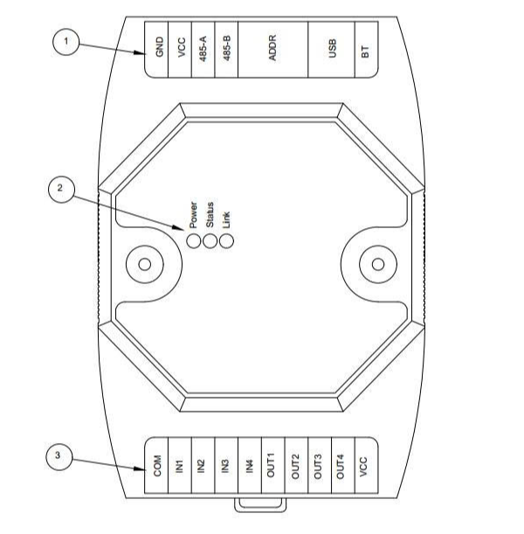

Modbus Register
Address | Size | Type | R/W | Units | Descriptions
10000 | 1 | Coil Register | R/W | bit | Output 0
10001 | 1 | Coil Register | R/W | bit | Output 1
10002 | 1 | Coil Register | R/W | bit | Output 2
10003 | 1 | Coil Register | R/W | bit | Output 3
10004 | 1 | Coil Register | R/W | bit | Output 4
10005 | 1 | Coil Register | R/W | bit | Output 5
10006 | 1 | Coil Register | R/W | bit | Output 6
10007 | 1 | Coil Register | R/W | bit | Output 7
10008 | 1 | Coil Register | R/W | bit | Reset counter 0
10009 | 1 | Coil Register | R/W | bit | Reset counter 1
10010 | 1 | Coil Register | R/W | bit | Reset counter 2
10011 | 1 | Coil Register | R/W | bit | Reset counter 3
10012 | 1 | Coil Register | R/W | bit | Reset counter 4
10013 | 1 | Coil Register | R/W | bit | Reset counter 5
10014 | 1 | Coil Register | R/W | bit | Reset counter 6
10015 | 1 | Coil Register | R/W | bit | Reset counter 7
20000 | 1 | Discrete Register | R | bit | Input 0
20001 | 1 | Discrete Register | R | bit | Input 1
20002 | 1 | Discrete Register | R | bit | Input 2
20003 | 1 | Discrete Register | R | bit | Input 3
20004 | 1 | Discrete Register | R | bit | Input 4
20005 | 1 | Discrete Register | R | bit | Input 5
20006 | 1 | Discrete Register | R | bit | Input 6
20007 | 1 | Discrete Register | R | bit | Input 7
30000 | 16 | Holding register | R/W | Integer | Setup input mask for output 0 set level  0x00 : output 0 off  0x01 : I0 trigger -> O0 On  0x02 : I1 trigger -> O0 On  0x04 : I2 trigger -> O0 On  0x08 : I3 trigger -> O0 On  0x03 : I0 & I1 trigger -> O0 On  …
30001 | 16 | Holding register | R/W | Integer | Setup input mask for output 1 set level
30002 | 16 | Holding register | R/W | Integer | Setup input mask for output 2 set level
30003 | 16 | Holding register | R/W | Integer | Setup input mask for output 3 set level
30004 | 16 | Holding register | R/W | Integer | Setup input mask for output 1 set level
30005 | 16 | Holding register | R/W | Integer | Setup input mask for output 2 set level
30006 | 16 | Holding register | R/W | Integer | Setup input mask for output 3 set level
30007 | 16 | Holding register | R/W | Integer | Setup input mask for output 3 set level
30008 | 16 | Holding register | R/W | Integer | Set timer0 period (ms)
30009 | 16 | Holding register | R/W | Integer | Set timer1 period (ms)
30010 | 16 | Holding register | R/W | Integer | Set timer2 period (ms)
30011 | 16 | Holding register | R/W | Integer | Set timer3 period (ms)
30012 | 16 | Holding register | R/W | Integer | Set Output mask when timer 0 trigger
30013 | 16 | Holding register | R/W | Integer | Set Output mask when timer 1 trigger
30014 | 16 | Holding register | R/W | Integer | Set Output mask when timer 2 trigger
30015 | 16 | Holding register | R/W | Integer | Set Output mask when timer 3 trigger
30012 | 16 | Holding register | R/W | Integer | Set Output mask when timer 4 trigger
30013 | 16 | Holding register | R/W | Integer | Set Output mask when timer 5 trigger
30014 | 16 | Holding register | R/W | Integer | Set Output mask when timer 6 trigger
30015 | 16 | Holding register | R/W | Integer | Set Output mask when timer 7 trigger
40000 | 8 | Input register | R | string | Serial number
40016 | 16 | Input register | R | Integer | Counter 0
40017 | 16 | Input register | R | Integer | Counter 1
40018 | 16 | Input register | R | Integer | Counter 2
40019 | 16 | Input register | R | Integer | Counter 3
40020 | 16 | Input register | R | Integer | Timer 0 counter
40021 | 16 | Input register | R | Integer | Timer 1 counter
40022 | 16 | Input register | R | Integer | Timer 2 counter
40023 | 16 | Input register | R | Integer | Timer 3 counter

System requirements

- Windows® OS (XP, 7, 8 and 10), Linux® or MacOS™
- USB Type-A to Type-C cable
- USB Driver

Configuration software
- Software : X.LinkConfig

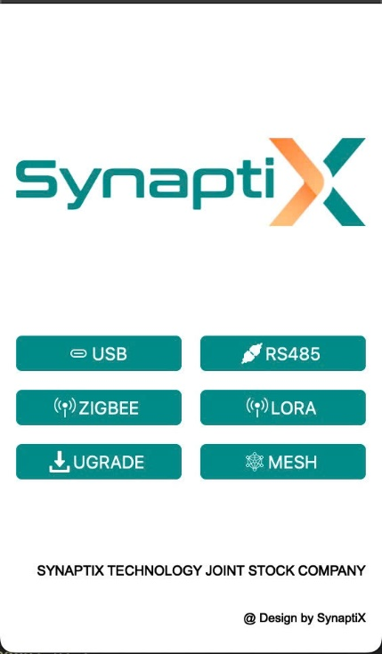
Main Selection Page

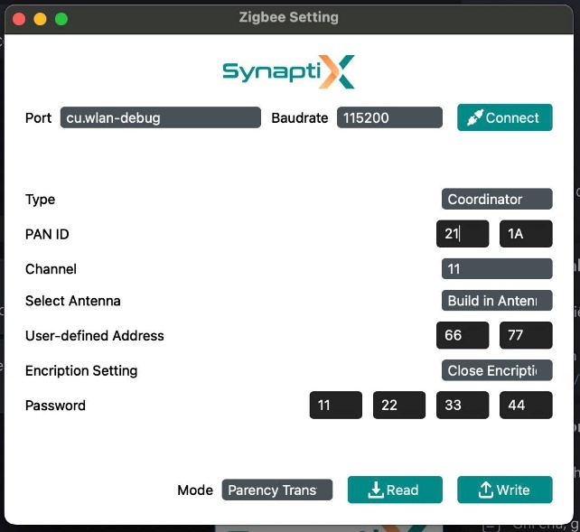
Zigbee Parameter Configuration Page

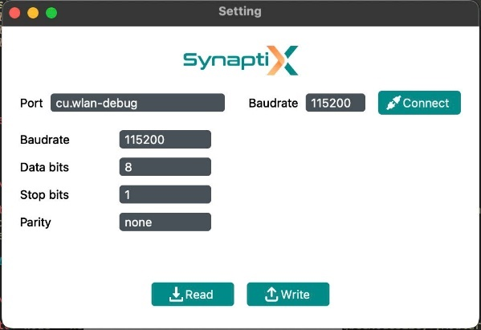
RS485 Configuration Page

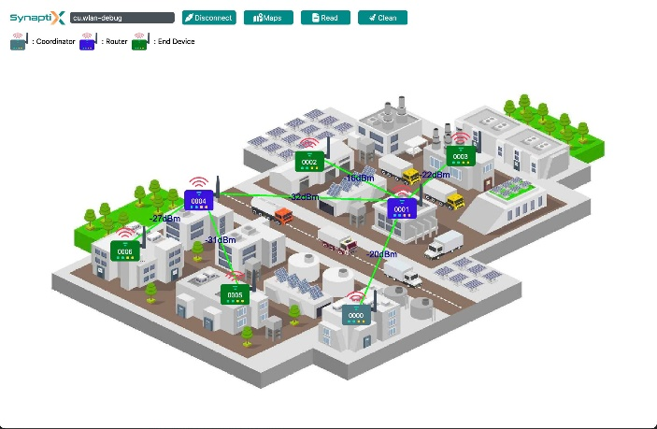
Checking Signal Device Page (Only using with Gateway)

Dimensions
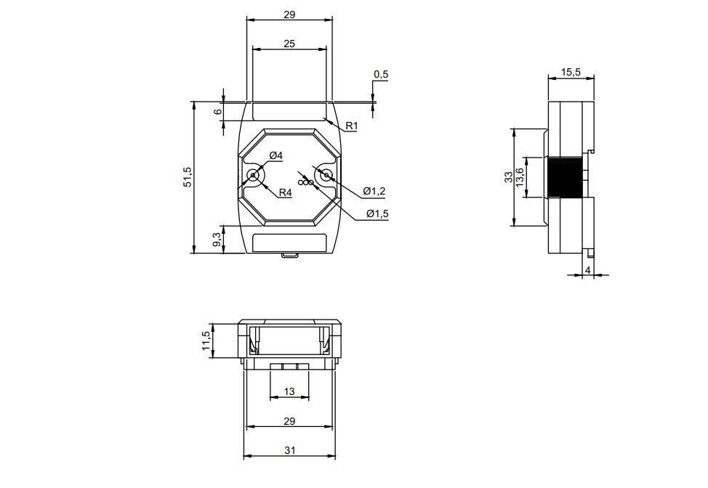

Ordering information

Part number | RS-485 | Zigbee | LORA | Isolated Digital Input | Isolated Digital Output
XL-ZBIO-44 | Yes | Yes |  | 4 CH | 4 CH
XL-ZBIO-8I | Yes | Yes |  | No | 8 CH
XL-ZBIO-8O | Yes | Yes |  | 8 CH | No
XL-ZBIO-420I | Yes | Yes |  | 2 CH | 6 CH
XL-LRIO-44 | Yes |  | Yes | 4 CH | 4 CH
XL-LRIO-8I | Yes |  | Yes | No | 8 CH
XL-LRIO-8O | Yes |  | Yes | 8 CH | No
XL-LRIO-420I | Yes |  | Yes | 2 CH | 6 CH

Related products
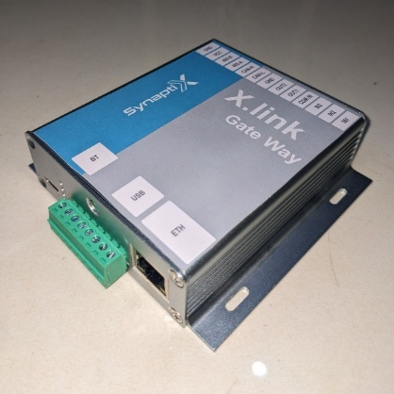
XLink- Gateway: X.Link-GW-ZB485
XL can operate in pairs for parallel transmission and reception as a way to eliminate physical wired connections, or operate in a mesh network to aggregate data from multiple nodes via Zigbee or Lora networks before transmitting it to a server via Ethernet.
XL-Gateway is a gateway that converts data on Zigbee/Lora networks using various protocols such as Modbus RTU, Bacnet, etc., to a server/cloud via Rest API, MQTT, etc.


Innovating Industrial IoT Solutions
_________________________________________________________________________
SYNAPTIX TECHNOLOGY JSC
Email : info@synaptix-io.com
Phone : +84-972141491
 Website : http://synaptix-io.com
Location : 2nd Floor, PZ4 Building, Vinhomes Smart city, Hanoi City

