SERVICE DESCRIPTION DOCUMENT
Security Engineering Wiki
https://logan23info.github.io
Field | Detail
Service name | Security Engineering Wiki
Service owner | Logan (logan23info)
Document version | 1.0
Date issued | 8 August 2026
Classification | Public
Service tier | Tier 3 — Non-critical / informational
Review cycle | Annual, or on material architecture change
Purpose of this document
This Service Description Document (SDD) defines the scope, architecture, components, operational model, and support arrangements for the Security Engineering Wiki. It is the authoritative reference for anyone operating, maintaining, auditing, or consuming the service.

Table of Contents

1. Service Overview

1.1 Service description
The Security Engineering Wiki is a publicly accessible, read-only knowledge platform that documents security engineering practice across fourteen domains. It provides approximately ninety reference pages covering threat modelling, application security, cloud security, detection engineering, AI and LLM security, cryptography, privacy engineering, regulatory compliance, incident response, operational technology security, and security metrics.
The service is delivered as a statically generated website. There is no application server, database, or user session state. Every page is pre-rendered at build time and served as immutable HTML, CSS, and JavaScript assets.

1.2 Business purpose
- Provide a single, version-controlled reference for security engineering practice.
- Reduce time-to-answer for engineers, auditors, and SOC analysts seeking authoritative guidance.
- Demonstrate practitioner capability through published, working reference material.
- Serve as a reusable asset for threat modelling sessions, control design, and audit preparation.

1.3 Service consumers
Consumer group | Primary use | Access method
Software engineers | Secure design patterns, OWASP remediation guidance | Anonymous web (HTTPS)
Security engineers | Maturity ladder, detection engineering, architecture baselines | Anonymous web (HTTPS)
SOC analysts | SIEM use cases, Sigma rules, response playbooks | Anonymous web (HTTPS)
Auditors / GRC | Compliance mappings, controls and evidence catalogue | Anonymous web (HTTPS)
AI / ML engineers | LLM threat modelling, prompt injection defence | Anonymous web (HTTPS)
OT / ICS engineers | Purdue model, ICS threat modelling, ATT&CK for ICS | Anonymous web (HTTPS)
Search engines | Indexing and discovery | robots.txt, sitemap.xml, RSS

1.4 Scope
In scope:
- Public delivery of the static wiki content over HTTPS.
- Content authoring, review, version control, and publication workflow.
- Build and deployment automation.
- Supporting infrastructure defined as code.
Out of scope:
- User accounts, authentication, or personalisation — the service is entirely anonymous.
- Collection, storage, or processing of personal data.
- Third-party tools linked from the site (for example the DevOps RCM utility), which are separately owned and operated.
- Any transactional, financial, or safety-critical function.

2. Solution Architecture

2.1 Architecture diagram
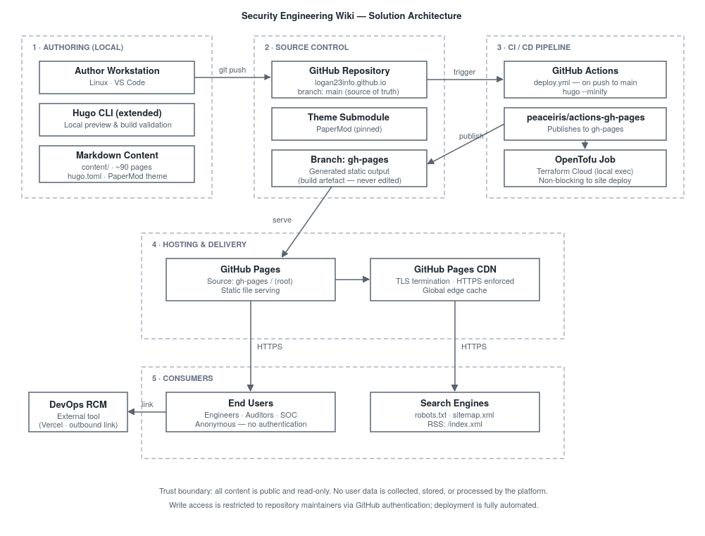
Figure 1 — End-to-end solution architecture, from authoring through to consumption.

2.2 Architectural principles
Principle | Rationale | Implementation
Static-first | Eliminates server-side attack surface and runtime failure modes | Hugo pre-renders all pages; no runtime code executes on the server
Everything as code | Content and infrastructure are reviewable, versioned, and reproducible | Markdown in Git; infrastructure in OpenTofu
Automated delivery | Removes manual deployment error and ensures repeatability | GitHub Actions builds and publishes on every merge to main
Immutable artefacts | The deployed output is never edited in place | gh-pages branch is generated output only; force-orphan publish
Least privilege | Limits blast radius of credential compromise | Scoped CI credentials; dedicated IAM principal for infrastructure
Fail-safe deployment | A failure in ancillary jobs must not block content publication | Infrastructure job decoupled from the site deployment job

2.3 Data flow
1. An author edits Markdown content and configuration locally, validating the build with the Hugo CLI.
2. Changes are committed and pushed to the main branch of the GitHub repository.
3. The push triggers the GitHub Actions workflow, which checks out the repository and its pinned theme submodule.
4. Hugo generates the complete static site with minification enabled.
5. The generated output is published to the gh-pages branch as an orphan commit.
6. GitHub Pages serves the gh-pages branch through its global CDN with TLS enforced.
7. Consumers retrieve pages anonymously over HTTPS. No request data is retained by the service.

3. Component Inventory
The service comprises the following logical components. Each is described in detail in Section 4.
Component | Type | Function | Ownership
Hugo (extended) | Build tooling | Static site generation | Service owner
PaperMod theme | Presentation layer | Layout, navigation, responsive design | Third party (pinned)
Markdown content | Data | ~90 reference pages | Service owner
hugo.toml | Configuration | Site config, navigation, taxonomy | Service owner
Custom CSS | Presentation layer | Typography, cards, badges, tables | Service owner
GitHub repository | Source control | Version control and audit trail | Service owner
GitHub Actions | CI/CD | Automated build and publication | Service owner
GitHub Pages | Hosting | Static delivery and TLS termination | GitHub (managed)
OpenTofu | IaC | Declarative infrastructure definition | Service owner
Terraform Cloud | State backend | Remote state storage and locking | HashiCorp (managed)
AWS S3 | Infrastructure | Content backup bucket | Service owner

4. Component Descriptions

4.1 Hugo static site generator
Hugo is the build engine. It reads Markdown source files and configuration, applies the theme's templates, and emits a complete static website. The extended edition is required because the theme depends on SCSS compilation.
Key characteristics:
- Build time is typically under two seconds for the full site.
- Output is deterministic — the same input always produces the same output.
- Generates supporting artefacts automatically: sitemap.xml, RSS feeds, and taxonomy pages.
- Version consistency between the local environment and CI is important; divergence has previously produced build behaviour differences.

4.2 PaperMod theme
PaperMod provides the presentation layer: page layouts, navigation rendering, responsive behaviour, light and dark mode, table of contents generation, breadcrumbs, and search indexing hooks. It is included as a pinned Git submodule so that upstream changes cannot alter the site unexpectedly.
Operational note:
The theme resolves navigation menu entries against page titles. Menu entry names must therefore be unique and must not collide with any generated taxonomy term. Ambiguous names cause the build to fail. Menu entries are configured with explicit page references to reduce this risk.

4.3 Content layer
All content is authored in Markdown with YAML front matter. Content is organised into three top-level sections.
Section | Path | Content
Wiki | /wiki/ | Fourteen domains, approximately 90 reference pages
Threat Modelling | /threat-modelling/ | Methodology landing page and practitioner guidance
Posts | /posts/ | Long-form articles and narrative explanations
Structural conventions:
- Section pages use _index.md to create branch bundles; index.md would render child pages unreachable.
- Front matter declares title, date, description, tags, categories, showToc, and layout.
- Cross-references between pages use absolute site-relative paths.
- Every page terminates in a related-pages card grid to support lateral navigation.

4.4 Configuration (hugo.toml)
A single configuration file governs site behaviour: base URL, theme selection, navigation menu, taxonomies, markup rendering, minification, and homepage content. It is the highest-risk file in the repository — a syntax error or an ambiguous menu name will fail the entire build.

4.5 Custom styling
Custom CSS extends the theme without modifying it, ensuring theme updates remain safe to apply. It provides the card grids, severity badges, coloured table headers, and typography used throughout the wiki.

4.6 Source control
The GitHub repository is the authoritative source of truth. The main branch holds source content; the gh-pages branch holds generated output and is never edited directly. Generated output is excluded from the main branch via .gitignore to keep diffs meaningful.

4.7 CI/CD pipeline
A GitHub Actions workflow executes on every push to main. It performs checkout including submodules, installs the pinned Hugo version, builds with minification, and publishes the result to gh-pages.
Design decisions:
- The site deployment job does not depend on the infrastructure job, so an infrastructure failure cannot block content publication.
- Publication uses an orphan commit strategy, guaranteeing the deployed branch always reflects the current build exactly.
- Credentials are supplied as repository secrets and are never present in source.

4.8 Hosting and delivery
GitHub Pages serves the site from the gh-pages branch root. TLS is enforced, certificates are managed automatically, and content is distributed through GitHub's global edge cache. No infrastructure is operated directly by the service owner for content delivery.

4.9 Infrastructure as code
OpenTofu declares the supporting AWS resources, principally an S3 bucket used for content backup with versioning and lifecycle management. State is stored remotely in Terraform Cloud with locking to prevent concurrent modification. The workspace operates in local execution mode so that credentials supplied by the CI pipeline are available to the provider.

4.10 External dependencies
Dependency | Provider | Purpose | Failure impact
GitHub Pages | GitHub | Hosting and CDN | Site unavailable
GitHub Actions | GitHub | Build and deploy | Cannot publish changes
Terraform Cloud | HashiCorp | IaC state backend | Infrastructure changes blocked; site unaffected
AWS S3 | Amazon | Backup storage | Backup unavailable; site unaffected
PaperMod | Open source | Theme | Build failure if submodule unavailable
DevOps RCM | Third party | Linked companion tool | Broken outbound link only

5. IT Operations

5.1 Service levels
This is a Tier 3 informational service. Availability depends on the GitHub Pages platform; no independent availability commitment is offered.
Measure | Target | Notes
Availability | Best endeavours, aligned to GitHub Pages | No contractual SLA offered
Publication time | Under 5 minutes from merge to live | Typical pipeline duration is 2–3 minutes
Build duration | Under 30 seconds | Typical duration is under 2 seconds
Recovery time objective (RTO) | 4 hours | Redeploy from source
Recovery point objective (RPO) | 0 | All content is version controlled
Support hours | Best endeavours | Single maintainer

5.2 Standard operating procedures
Publishing a content change
- Pull the latest main branch.
- Author or amend Markdown content under the appropriate section.
- Validate locally with a minified build; confirm zero errors.
- Commit with a descriptive message and push to main.
- Confirm the pipeline completes successfully and verify the published page.
Changing site configuration or navigation
- Confirm any new menu name does not match an existing page title, tag, or category.
- Validate the build locally before pushing — configuration errors fail the entire site build, not a single page.
- Deploy during a period when a failed build can be promptly corrected.

5.3 Monitoring
Signal | Source | Response
Build failure | GitHub Actions run status | Inspect log, correct, re-push
Deployment failure | GitHub Pages deployment status | Check for stuck deployment; re-run or wait
Site unavailable | Manual or external uptime check | Verify GitHub status page; escalate to GitHub if platform-wide
Broken links | Periodic manual review | Correct references and republish

5.4 Known operational risks
Risk | Impact | Mitigation
Ambiguous navigation menu name | Complete build failure | Validate locally; use explicit page references; avoid names matching taxonomy terms
Hugo version drift between local and CI | Build succeeds locally but fails in CI | Pin the Hugo version in the workflow
Incorrect section file naming | Child pages return 404 | Always use _index.md for section pages
Stuck GitHub Pages deployment | New content not published | Cancel the blocking deployment; re-trigger
Generated output committed to source | Large, noisy diffs; merge conflicts | Exclude build output via .gitignore
Theme submodule unavailable | Build failure | Submodule pinned; vendor the theme if required

5.5 Backup and recovery
The complete service is reconstructible from source. The Git repository provides full history and is replicated across every clone. The S3 bucket provides an additional content copy with versioning enabled.
Recovery procedure:
- Clone the repository including submodules.
- Confirm the pinned Hugo version is installed.
- Build locally to validate integrity.
- Push to main to trigger republication, or publish manually if the pipeline is impaired.

5.6 Change management
Change type | Example | Control
Standard | Content addition or correction | Local build validation; direct push
Normal | New section, navigation change | Local validation; verify no taxonomy collision; monitor pipeline
Significant | Theme upgrade, pipeline change, Hugo version change | Test in a branch; validate full build; verify sample pages post-deploy

6. Security

6.1 Security posture
The static architecture removes the majority of conventional web application risk. There is no server-side execution, no database, no authentication, and no user input processing. The residual attack surface is limited to the supply chain and the publication pipeline.
Control area | Position
Authentication | Not applicable — anonymous public read-only service
Personal data | None collected, stored, or processed
Transport security | HTTPS enforced; TLS certificates managed by the platform
Server-side execution | None — all content is pre-rendered static assets
Write access | Restricted to repository maintainers via GitHub authentication
Secrets management | Repository secrets; no credentials in source
Dependency management | Theme pinned as a submodule; Hugo version pinned in CI
Audit trail | Complete Git history of every content and configuration change

6.2 Residual risks
- Supply chain: compromise of the theme submodule or a CI action could inject content. Mitigated by version pinning.
- Account compromise: compromise of the maintainer's GitHub account would permit unauthorised publication. Mitigated by platform authentication controls.
- Platform dependency: availability is wholly dependent on GitHub Pages, and is accepted for a Tier 3 service.

7. Roles and Responsibilities
Role | Responsibilities
Service owner | Overall accountability; content authorship and quality; configuration and pipeline maintenance; incident response; periodic review
GitHub (platform provider) | Hosting availability; CDN and TLS; CI/CD runner infrastructure; platform security
HashiCorp (Terraform Cloud) | State backend availability and integrity
Amazon Web Services | S3 durability and availability for backup storage
Content consumers | No obligations — anonymous read-only access

7.1 Support model
Support is provided on a best-endeavours basis by a single maintainer. Defects and content corrections are raised through GitHub issues on the service repository. There is no formal escalation path or guaranteed response time.

8. Appendices

Appendix A — Content domain index
Domain | Approx. pages | Coverage
Foundations & maturity | 11 | STRIDE, DREAD, PASTA, attack trees, red/purple teaming, zero trust, supply chain
OWASP Top 10 | 11 | All 2021 categories with remediation code and detection
Secure architecture | 6 | Microservices, API, secrets, containers, Kubernetes
Cloud security | 6 | AWS, GCP, Azure baselines; misconfiguration top 10; threat model
Detection engineering | 6 | SIEM use cases, Sigma rules, metrics, alert tuning, playbooks
AI & LLM security | 5 | OWASP LLM Top 10, prompt injection, AI threat modelling, red teaming
Cryptography | 6 | Fundamentals, PKI, TLS, key management, post-quantum
Privacy | 5 | GDPR engineering, DPIA, privacy by design, data subject rights
Compliance | 6 | GDPR, PCI-DSS, ISO 27001, SOC 2, DORA
Incident response | 7 | IR plan, five playbooks, post-incident review
OT / ICS security | 5 | Purdue model, ICS threat modelling, ATT&CK for ICS, network security
Security metrics | 4 | KPIs, board reporting, risk appetite
Advisory & assurance | 5 | Test of design, implementation, operating effectiveness; controls catalogue
Tools & templates | 6 | Threat Dragon, Threagile, registers, checklists

Appendix B — Glossary
Term | Definition
Static site generator | Tooling that renders source content into fixed HTML files at build time rather than per request
Branch bundle | A Hugo content directory using _index.md, allowing it to contain child pages
Orphan commit | A commit with no parent history, used to replace a branch's contents entirely
Taxonomy term | An auto-generated page grouping content by tag or category
Submodule | A pinned external Git repository embedded within the primary repository
RTO / RPO | Recovery Time Objective; Recovery Point Objective

Appendix C — Document control
Version | Date | Author | Change
1.0 | 8 Aug 2026 | Logan | Initial issue
Next scheduled review: August 2027, or earlier upon material change to architecture, hosting, or scope.

