Proposal for a part-time clinical contract
Logan DuBose, MD
Transition to a contract of 35 to 38 weeks a year, two clinic days a week at 15 clocked hours and $40 per hour, beginning June 1, 2028, while maintaining the current hourly arrangement until then to demonstrate sufficient demand and financial viability. Schedule provided a quarter in advance.
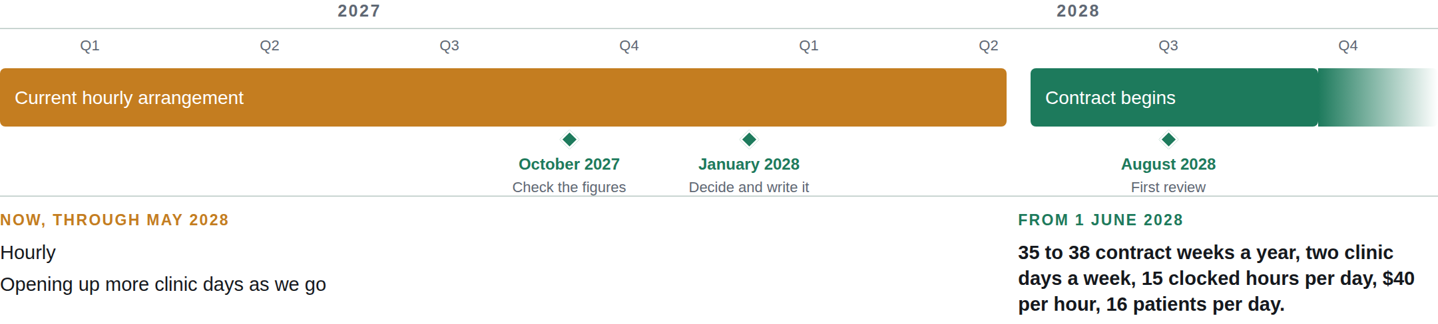
AN EXAMPLE YEAR
