CS136 Lab Section 1

Logan Behnke & Joseph Danciu

February 28, 2017

**Sudoku - Lab 05**

**Problem Statement:**

In this lab we were tasked to write the backend of a sudoku game. We need to work with 2d array of character.

**Planning:**

We started by looking over the UML diagram. Then started coding the 2d array. Next we started the logic for the rows. After figuring out the row we used the same technique for the columns. Finally we moved on to the squares. We used the same technique for the squares.

**Implementation and Testing:**

Running Application:

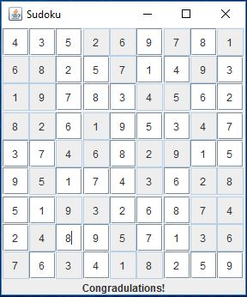

Testing:

**Reflection & Refactor:**

By the end of this project we have learned how to use 2d arrays.

[Link to the github page](https://github.com/loganBehnke/Sudoku-CS136L/)