CSA1503-Cloud computing and big data analytics
Experiment 15
Title: Create and Restore a Snapshot of a Virtual Machine
Aim
To create a snapshot of a Virtual Machine and restore it to the previous state.
Procedure
- Start the Virtual Machine.
- Install any software or create a sample file.
- Go to VM → Snapshot → Take Snapshot.
- Enter a snapshot name.
- Click Take Snapshot.
- Make changes inside the VM (delete files or install another application).
- Go to VM → Snapshot → Snapshot Manager.
- Select the previously created snapshot.
- Click Go To or Restore.
- Verify that the VM returns to its previous state.
Output
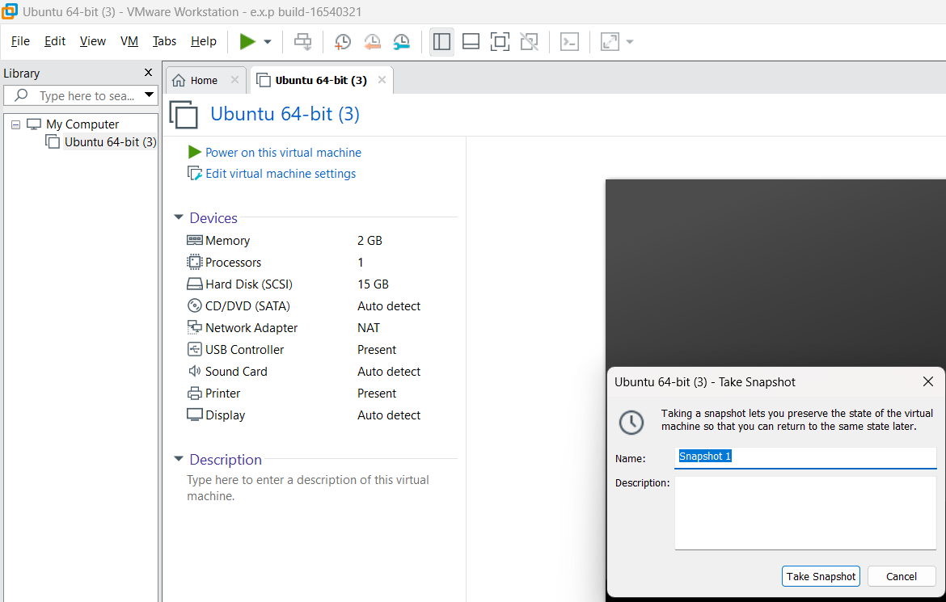
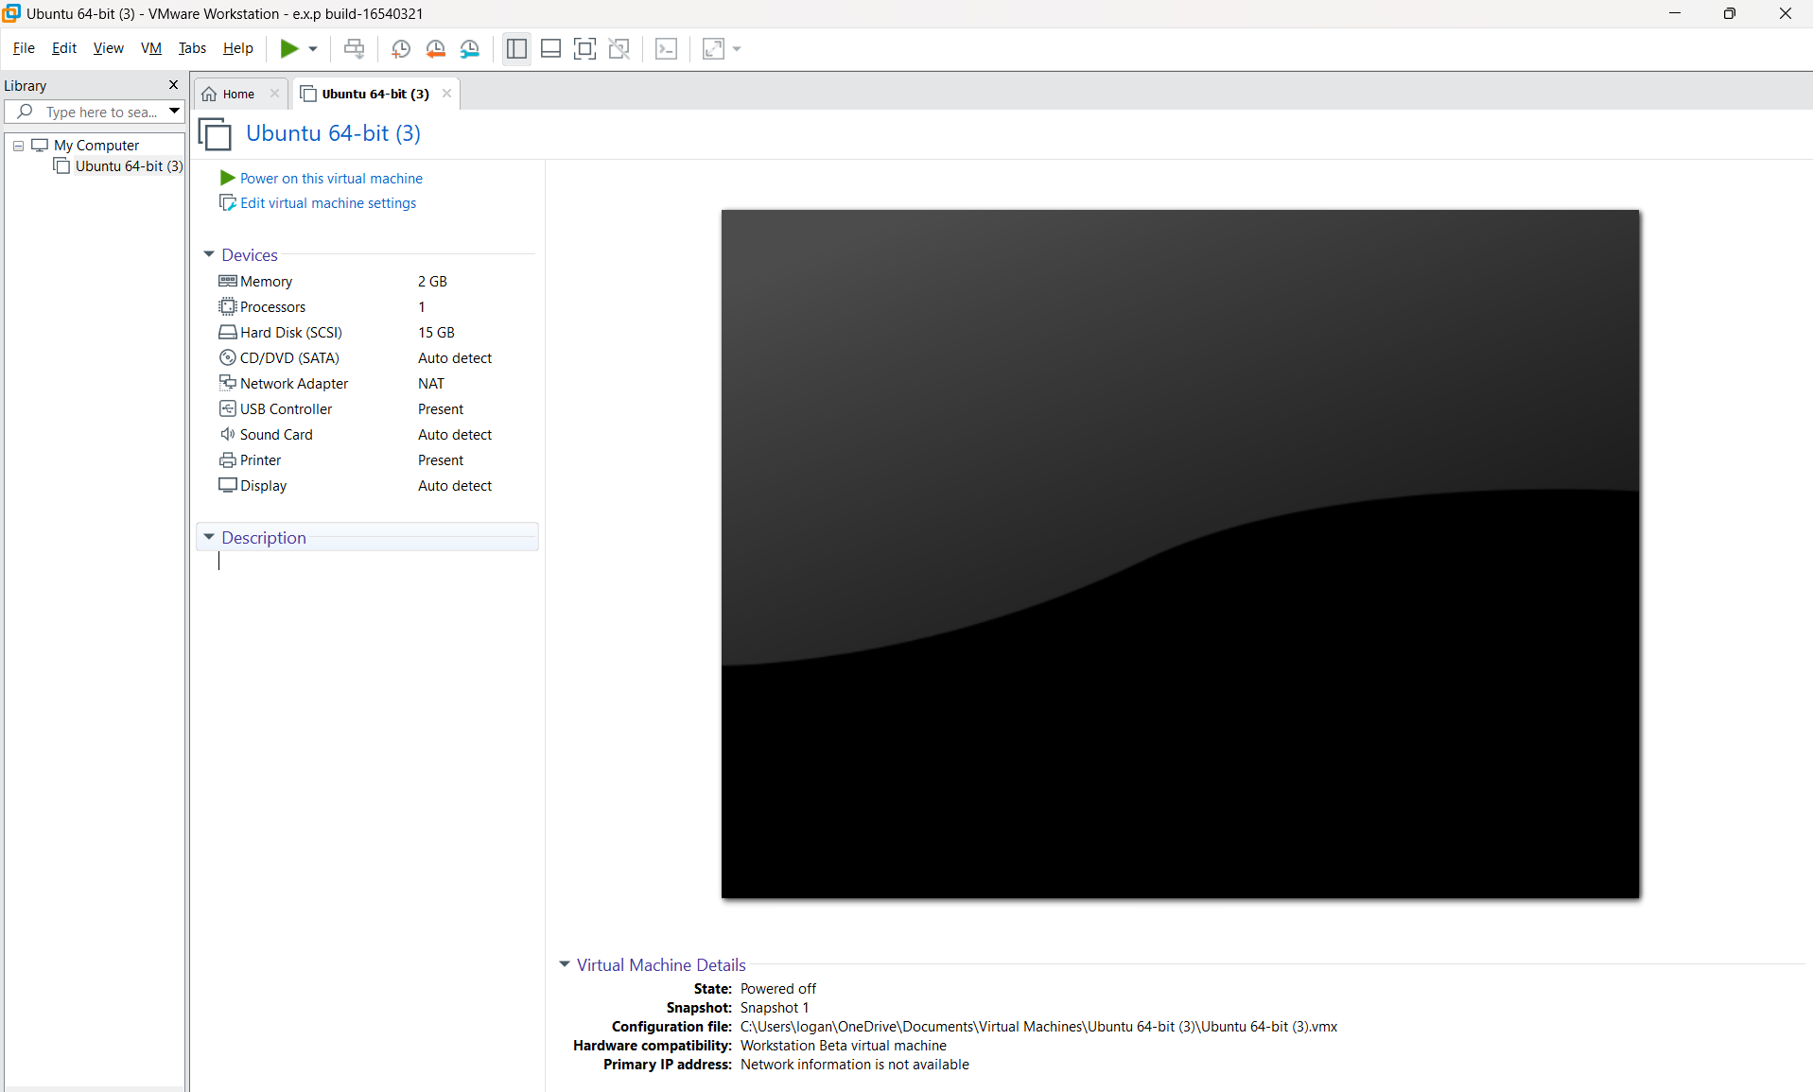
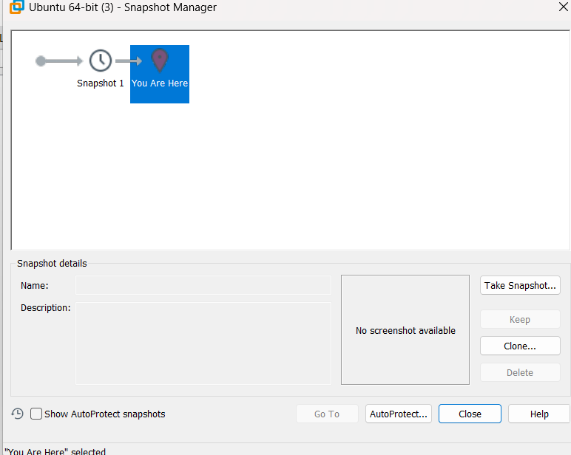
Result
The snapshot was created successfully, and the Virtual Machine was restored to its previous state without errors.

