CSA1503-Cloud computing and big data analytics
Experiment 16
Title: Clone a Virtual Machine
Aim
To create a clone of an existing Virtual Machine and verify its functionality.
Procedure
- Shut down the Virtual Machine.
- Select the VM in VMware Workstation.
- Click VM → Manage → Clone.
- Select the snapshot or current state.
- Choose:
  - Full Clone (or)
  - Linked Clone
- Enter the clone name and destination.
- Click Finish.
- Power on the cloned VM.
- Log in and verify that it functions independently.
Output
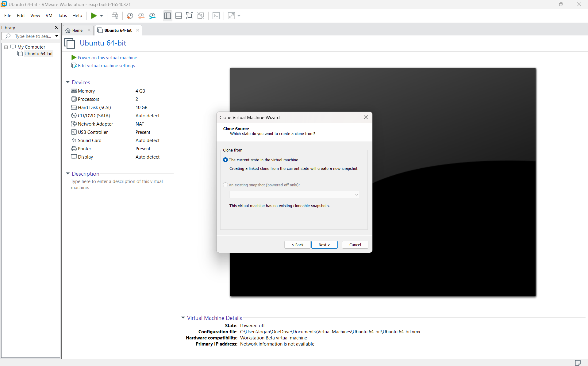
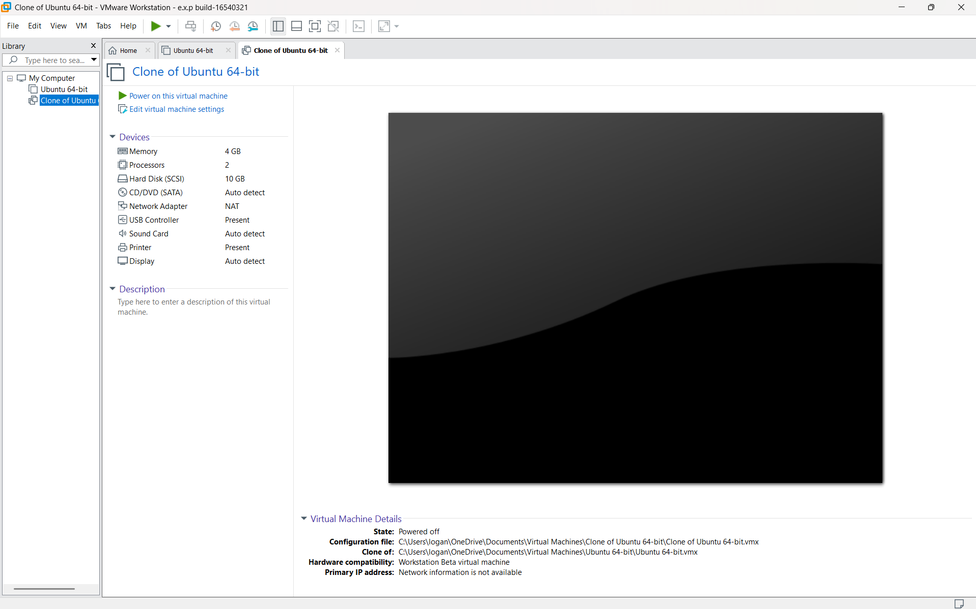

Result
A clone of the Virtual Machine was successfully created and operated independently.

