Experinent-13
Title: Create a Virtual Machine with 1 CPU, 2GB RAM and 15GB Storage
Aim
To create a Virtual Machine using VMware Workstation with 1 CPU, 2GB RAM, and a 15GB virtual hard disk.
Procedure
- Open VMware Workstation.
- Click Create a New Virtual Machine.
- Select Typical Installation.
- Choose the Linux ISO image.
- Enter the VM name.
- Allocate 15GB virtual disk space.
- Click Customize Hardware.
- Set: Processors: 1 ,Memory: 2048 MB (2GB)
- Save the settings.
- Finish the VM creation.
- Power on the VM and install Linux.
Output
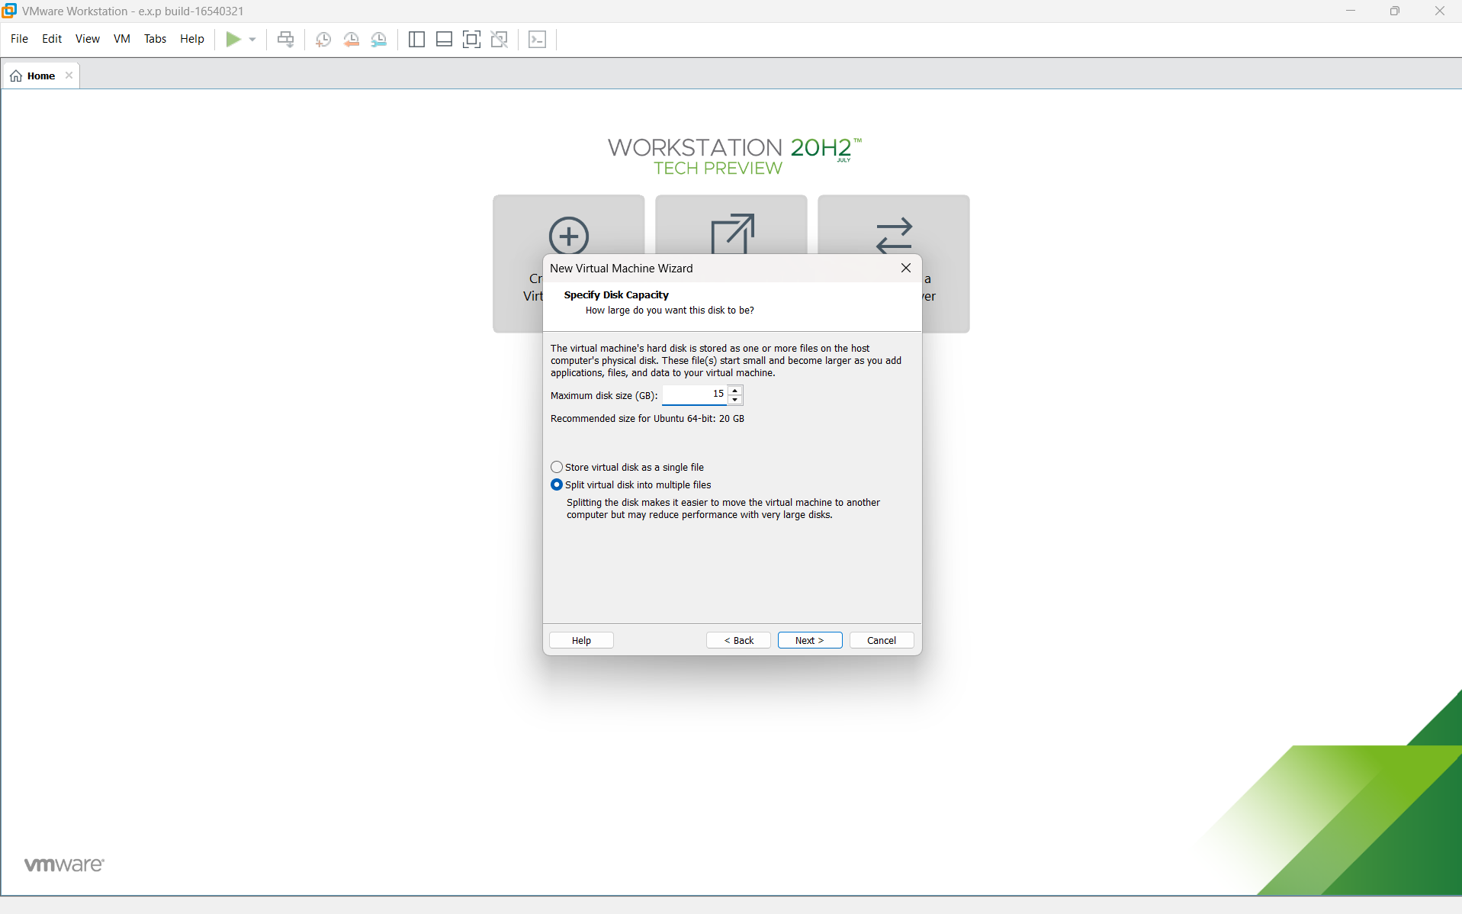
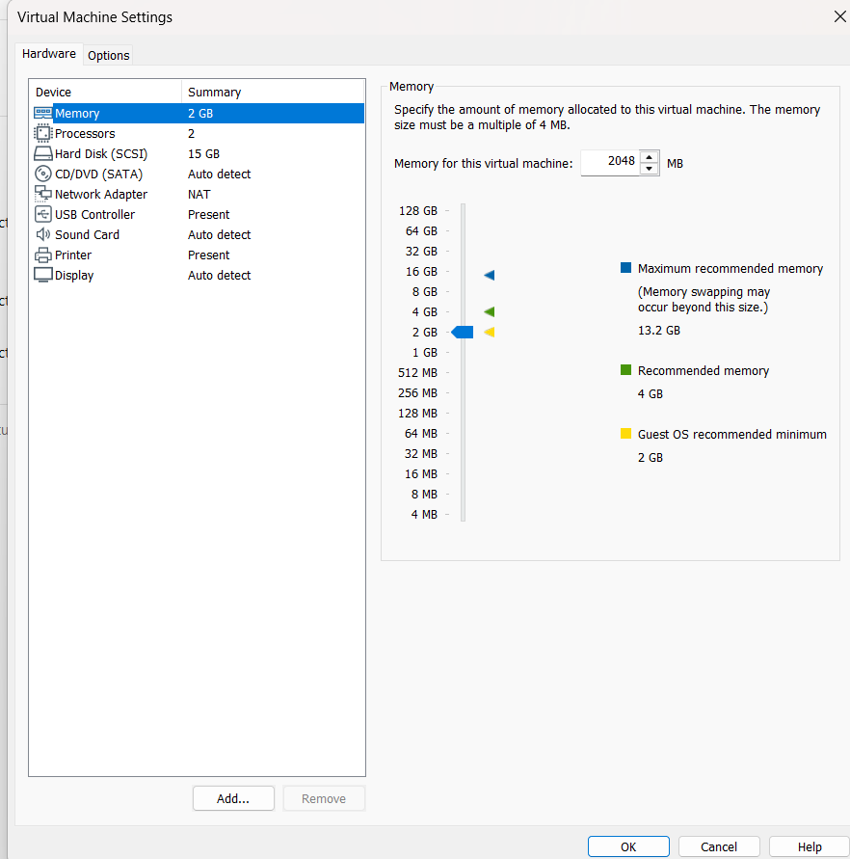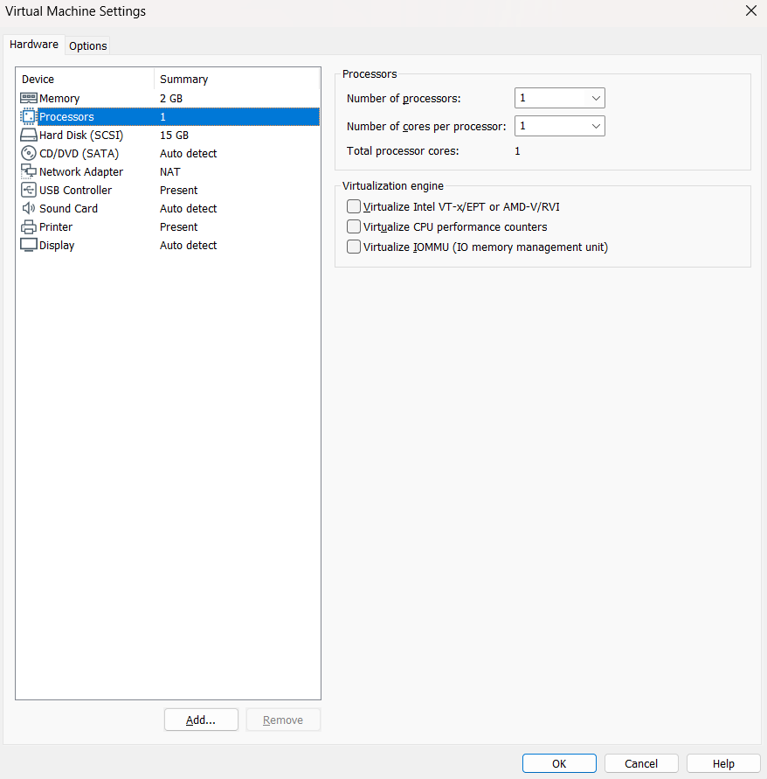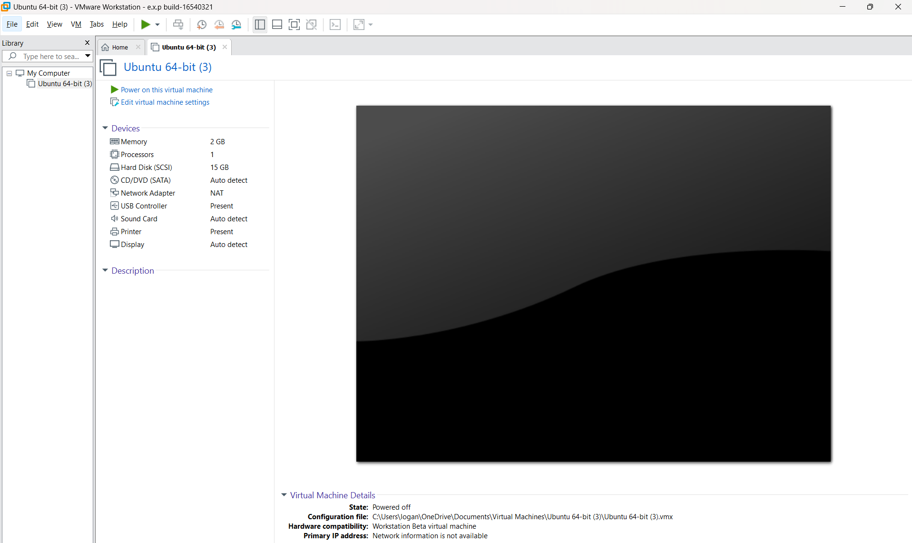Result
A Virtual Machine was successfully created with 1 CPU, 2GB RAM, and 15GB virtual storage, and the operating system was installed successfully.

